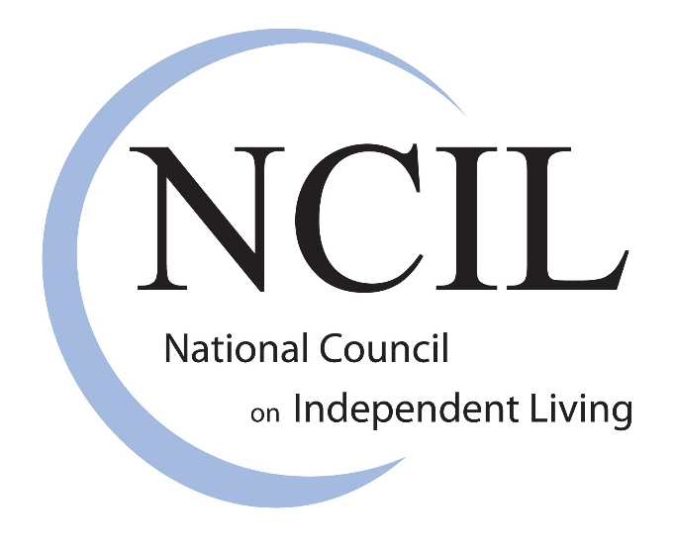

Funding Options for Transition and Diversion During COVID-19: A Fact Sheet for CILs
Contents

CARES Act 2
Category B 3
No Wrong Door 5
Changes to Medicaid Funding 6
Money Follows the Person 7

COVID-19 has hurt disabled people. Centers for Independent Living (CILs) have been trying to help disabled people survive during the pandemic. CILs have been helping disabled people leave institutions and move to their own homes. Helping disabled people leave institutions is called transition. CILs have also helped people to stay in their homes with the support they need. Helping people stay in their own homes is called diversion.

Some federal programs have made money available to support this work of CILs. There are many different ways CILs can get money from the federal government to work with disabled people during the pandemic. This fact sheet talks about these options. It also talks about how CILs can use this money. All the options give CILs money to support disabled and aging people in the community. CILs can use this money to move people out of institutions and support people in their own homes.

The information below is about five different funding sources:

- CARES Act money
- Category B money
- No Wrong Door money
- Changes to Medicaid funding
- Money Follows the Person money

CARES Act

The CARES Act is a federal law. Its full name is the Coronavirus Aid, Relief, and Economic Security Act. The CARES Act passed in March 2020. The CARES Act gave money to disability and aging programs. This included $85 million for Part C CILs. (Part C CILs are CILs that receive federal funding.)

CARES Act funding was provided through the Administration for Community Living (ACL). (ACL is part of the US government. They run a lot of aging and disability programs.)

CILs must use CARES Act money to pay for services related to the pandemic. These services include keeping people out of institutions (transition). They also include moving people in institutions into their own homes (diversion). ACL provided a “frequently asked questions” document. They provided more examples of how the money can be spent, including:

- Accessible housing: Disabled people can have trouble finding housing. Housing isn’t always accessible. People don’t always have money to pay for housing. CILs can use CARES Act funding to address this in different ways. They can help people with disabilities try to find housing. They can advocate for more accessible and affordable housing. They can help people make their current housing more accessible.

- Food: Many disabled people living in the community have had trouble getting food during the pandemic. CILs can use CARES Act money to help disabled people get food. This can include giving people gift cards to grocery stores. It can include working with other groups to organize food drop-offs. It can include working to make food pantries accessible.

- Advocacy in medical settings: Disabled people are often treated unfairly in medical settings. Medical settings include places like doctor's offices or hospitals. This is happening even more because of COVID-19. People think that disabled people don’t deserve equal medical treatment. CILs can use CARES Act money to fight for equal medical treatment.

- Technology: During the pandemic, many people use technology differently. For example, people may use Zoom to hold meetings online. CILs can use CARES Act money to serve consumers better using technology. They can spend the money on things like:
  - technology, like a new computer or software for online meetings
  - training to help people understand how to use the technology

- COVID-19 related supplies: CILs can use CARES Act money for the health and safety of staff and consumers. This can include supplies like masks and gloves. This can also include personal care items like:
  - toilet paper
  - soap
  - hand sanitizer

- Salaries, wages, and leave: CARES Act money can pay for some staff salaries and benefits. CILs can hire staff people to help move people out of institutions. CILs can hire staff people to help people stay out of institutions. CILs can hire staff people to make sure disabled people leaving hospitals go back to their homes.

CILs got their CARES Act money from ACL last year. They got them the same way they get their regular federal money. CILs have until September 30, 2022 to spend their CARES Act money.

Category B

Category B funding is a type of funding from the Federal Emergency Management Agency (FEMA). FEMA is part of the US government. They help the country prepare for emergencies and disasters. They also help the country respond when an emergency or disaster happens.

Category B is part of FEMA’s big Public Assistance grant program. Category B helps governments and other groups respond to disasters and emergencies. State, local, territorial, and Tribal (SLTT) governments are eligible. (State governments are the governments of the States in the US. Local governments are governments of local areas. These are usually counties and cities/towns. Territorial governments are the governments of US territories. The US territories are:
- American Samoa
- Guam
- the Northern Mariana Islands
- Puerto Rico
- the US Virgin Islands

Each federally recognized tribe of Native American people has its own Tribal government.

CILs can use Category B money to move people to non-congregate settings. This includes moving people out of institutions. Non-congregate settings are places where each person or household has some privacy. This includes places like:
- Hotels
- Motels
- Dormitories

CILs can use Category B money on related costs, like:
- Meals
- Utilities, like power or water
- Changes to your home, like building a ramp to get into your house
- Medical equipment, like wheelchairs or walkers
- Other medical supplies
- Hygiene items
- Personal assistance services. Personal assistants are people who help you do things. Some of the things they can help with include:
- showering
- getting dressed
- eating
- managing medications
- communicating
- accessing programs or services

The SLTT governments control the money through emergency response agencies. CILs get money through their local emergency response agencies. A CIL might need to work with more than one agency. CILs can use the money until the COVID-19 emergency is over.

Category B money is paid by reimbursement. Reimbursement means CILs pay for everything with their own money first. Then, they tell FEMA what they spent the money on. They ask to be paid back with Category B money. FEMA has not said when they will pay CILs back.

No Wrong Door

No Wrong Door (NWD) systems are groups of organizations that help disabled people in a particular state. NWD systems improve access to services for older adults and disabled people.

In 2020, ACL funded grants to help NWD systems respond to COVID-19. Grants are amounts of money that are used for a specific purpose. The grants helped organizations in NWD systems work together. This helped them serve people better. This also helped them improve services. This included moving people out of institutions. ACL provided a “frequently asked questions” document with more examples. Other examples of how this money could be spent include:

- COVID-19 related supplies, like masks or gloves
- Making virtual services better
- Assistive technology
- Helping people get food, including food delivery
- Help with paying rent
- Improving the ability to give people the information they need
- Creating more services for people who are socially isolated
- Coming up with new services
- Coming up with new ways to provide services
- Staff costs
- Helping caregivers
- Help with getting a job

ACL decides what types of NWD projects they will fund every year. They also decide how long the projects will last. This grant funding was available to States and territories. States gave the funding to the NWD organizations in their State. The length of this grant was 12 months.

Changes to Medicaid Funding

- Appendix K:
Appendix K was created by the Centers for Medicare and Medicaid (CMS). (CMS is part of the federal government. They are responsible for the country’s major public healthcare programs. This includes Medicaid, Medicare, and other programs.) Appendix K lets States quickly change their Home and Community Based Services (HCBS) programs in an emergency.

CMS released a COVID-19 Appendix K template. This gives examples of how States can change their HCBS programs. The examples include:

  - changing who is eligible for services
  - adding more services
  - paying providers more money.

States can make other changes. These changes are in response to the COVID-19 pandemic. The changes will only last for a short time.

- Families First:

In March 2020, Congress passed the Families First Coronavirus Response Act. This law gave States more money for their Medicaid programs during the pandemic. This money is not connected to specific activities. States must not cut Medicaid coverage while this increase is in place. States get more money until the pandemic ends.

- American Rescue Plan Act:

In March 2021, Congress passed the American Rescue Plan Act (ARPA). This law gave States more Medicaid funding for Home and Community Based Services (HCBS). States don’t need to use this money if they don’t want to. States must use this funding to make HCBS better. They can also use it to give HCBS to more people in their Medicaid program. This increase is in place through March 30, 2022.

All three of these changes make more money available in State Medicaid programs. This money can support HCBS. This includes supporting people to move out of institutions. CILs access this funding the same way they already access Medicaid funding in their State. CILs can ask their states to give the money to programs to move people out of institutions or stay in their own homes.

Money Follows the Person

Money Follows the Person (MFP) is a Medicaid demonstration program. (Medicaid demonstrations allow States to try new things when serving people who use Medicaid. Demonstrations are supposed to improve their programs. Demonstrations can also help States serve people better.) MFP is one of the longest-running Medicaid demonstration programs. It has been available since 2005. States use MFP to help move people from institutions to their own homes. They also use it to improve the long term services and supports (LTSS) system in the State. MFP can help more people get home and community based services.

In December 2020, a law called the Consolidated Appropriations Act was passed. This law extended MFP through September 2023. MFP makes HCBS available for people moving out of institutions. MFP money can also pay for services that aren’t usually paid for by Medicaid. This can include services that the State doesn’t cover in their HCBS plan. It can also include more services that they will usually approve. It can also include services that only happen once. CILs in States with MFP can use the money to move people out of institutions during the pandemic.

In some States, the MFP program has stopped. CMS is allowing those States to re-apply to get the program going again.

