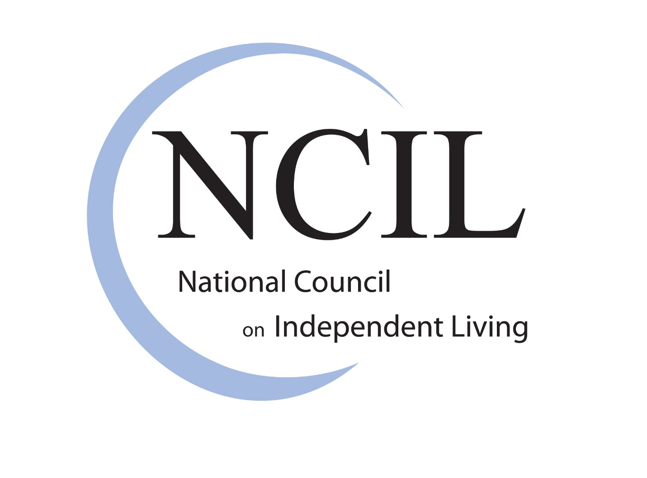

Advocacy Priorities

Summer 2022

Rehabilitation Act and Independent Living Funding 4
Independent Living Funding 4
Long Term Service and Supports (LTSS) 6
Ending the Institutional Bias 6
Electronic Visit Verification (EVV) 8
Housing 8
Fair Housing 9
Visitability / Universal Design 9
Homelessness 9
Public Housing 10
Chemical, Electrical, and other Environmental Sensitivities 10
Civil Rights and the Americans with Disabilities Act 11
ACCESS (ADA Compliance for Customer Entry to Stores and Services) Act 11
Guardianship 12
Freedom and Right to Emancipation from Exploitation (FREE) Act 13
Guardianship Accountability Act 13
Transportation 14
Air Travel 14
Private Transportation 14
Amtrak & High-Speed Rail 15
Websites and Reservations Systems and Mobile Apps 15
Self-Driving Cars 15
Non-Emergency Medical Transportation (NEMT) 15
Healthcare 15
Expanding Coverage 15
Prohibiting Healthcare Discrimination 16
Chronic Pain and Opioids 16
Opposing Assisted Suicide 17
Employment / Social Security 18
COVID Recovery 18
Removing Barriers to Employment for Older Workers 18
ABLE Age Adjustment Act 19
Competitive Integrated Employment 19
SSI Restoration Act 20
Emergency Preparedness 20
REAADI for Disasters Act 20
Disaster Relief Medicaid Act 21
Voting Rights 22
Voting Accessibility 22
Fighting Voter Suppression 22
Executive Order 14019: “Promoting Access to Voting” 23
Mental Health 23
Mental Health and Violence 23
Forced “Treatment” 24
Institutionalization 24
Education 25
Individuals with Disabilities Education Act (IDEA) 25
Restraint and Seclusion of Students 26
The Keeping All Students Safe Act 26
College Accessibility for Students with Disabilities 26
Technology 26
Assistive Technology Act 27
Violence and Abuse 28
Veterans 29
Veterans Health Administration (VHA) 29
Veterans Benefit Administration (VBA) 29
Veteran Homelessness Prevention 30
Veterans and Centers for Independent Living 30
Civilian Health and Medical Program of the Department of Veterans Affairs (CHAMPVA) 30

Rehabilitation Act and Independent Living Funding

Independent Living Funding

The National Council on Independent Living is requesting that Congress support our “Drive 5 for 5” to:

- Increase funding for the Independent Living Program to $500 million. For Fiscal Year 2023, NCIL requested a total funding amount of $250 million (an increase of $131.8 million) as an incremental step toward the $500 million.
- Fully fund the core transition services:
  - Fund the institutional transition requirement for Centers for Independent Living (CILs) by mandating 5% of Money Follows the Person funding as direct base funding through the Administration for Community Living (ACL);
  - Fund the diversion from institutional placement requirement; and
  - Fully fund the youth transition requirement by mandating 5% of Title I funds as direct base funding through ACL.
- Provide new designated funding to Statewide Independent Living Councils (SILCs) at a minimum amount of $250,000 per SILC to ensure capacity to fulfill SILC duties and authorities. This was included in the $250 million request stated in #1 above.
- Provide 5 million to NCIL for the development of the first national hotline directed and operated by people with disabilities to assess the needs of the disability community in crisis, with priorities given to BIPOC (Black, Indigenous, and other people of color) communities.
- Due to the on-going challenges of people with disabilities receiving post-employment support and services, NCIL requests 5% of Title I post-employment funding shall be provided to CILs as direct funding through the Administration for Community Living (ACL).

Congress provided CILs $85 million in the CARES Act. These funds were to respond to the COVID-19 pandemic. We have seen CILs make a huge impact in their communities with this money.

However, that funding was only available to some CILs, and it was time-limited. Additionally, that funding was not enough to meet the increasing demand for IL services. The Independent Living Program needs more funding so CILs can provide services to everyone who needs them.

CILs are unique organizations run by and for people with disabilities. They provide the core services and many other services to meet the needs of individuals and their communities. That often includes filling gaps left by other providers. CILs provide services to people with all types of disabilities, of all ages, and at all income levels.

For many years, all CILs were required to provide four services. These “core services” were:

- Advocacy: CILs support people to take action about things that are important to them. CILs also take action about things important to the disability community.
- Independent Living Skills Training: This helps people develop skills. These skills help people live more independently and have more control over their lives.
- Information and Referral: CILs answer people’s questions and direct them to information or services.
- Peer Counseling: This involves people with disabilities supporting each other. Sometimes this is done one-on-one. Sometimes this is done in groups.

In 2014, the Workforce Innovation and Opportunity Act (WIOA) passed into law. This law required CILs to provide three new core services:

- Institutional Transition: CILs help people with disabilities move from institutions to the community.
- Diversion: CILs help people who live in the community stay in the community.
- Youth Transition: CILs help youth with disabilities transition out of high school to college or the workplace.

The Independent Living network is committed to providing all the core services. We have always believed the new core services are vital to achieving full inclusion. The COVID-19 pandemic has further proven how important they are. People with disabilities in congregate settings have been infected and died from COVID-19 at very high rates. Moving people into the community is more important than ever.

However, CILs have not been given any additional funding for the new core services. The CARES Act funding has allowed CILs to help people get out of dangerous congregate settings during the pandemic. It has helped CILs keep people with disabilities safe in their homes and communities. But without more permanent funding, there is no way CILs can carry out the new core services fully or effectively.

CILs believe all people with disabilities are valuable. They help people facing all sorts of discrimination. They believe people with disabilities should be able to participate in their communities. The IL Program has improved and changed how services are delivered to people with disabilities.

Statewide Independent Living Councils (SILCs) are partners in developing the plan for the state’s Independent Living network and services. Designated funding for SILCs would ensure the capacity to fulfill all their duties and authorities. The SILCs should work together with the CILs to figure out how to address needs that are not being met and provide direction through the plan to begin to meet those needs. Additional funding for the IL Program would help states put those plans into action.

The Independent Living Movement is founded on the belief that people with disabilities, regardless of form, share a common history and struggle. Independent Living philosophy emphasizes consumer control; the idea that people with disabilities are the best experts on their own needs, having crucial and valuable perspective to contribute and deserving of equal opportunity to decide how to live, work, and take part in their communities, particularly in reference to services that affect their day-to-day lives and access to independence.

Long Term Service and Supports (LTSS)

Ending the Institutional Bias

A lot of death and illness from the COVID-19 pandemic occurred in congregate settings. Congregate settings include:

- state hospitals
- psychiatric institutions
- group homes
- developmental centers
- detention centers
- intermediate care facilities (ICFs)
- nursing facilities
- day habilitation centers
- prisons
- jails
- homeless shelters
- and more.

The deaths in these facilities are avoidable. They happen because of discrimination.

The deaths in long-term care settings are the result of the institutional bias. The institutional bias makes people who need long term services and supports (LTSS) move into congregate settings to get the help they need.

The federal government has created an institutional bias in Medicaid. States are required to pay for long term care in institutions. Offering the same services in community settings is optional. Home and community based services (HCBS) are underfunded. And even funding for HCBS can still be spent on smaller congregate settings.

The institutional bias exists outside of Medicaid, too. Medicaid is the only payer for many community-based LTSS. Other payers, like Medicare and private insurance companies, will not pay for them at all.

Too many people are harmed by the institutional bias. Too many disabled people have no way to pay for the community-based services and supports they need. Too many people do not have control over their supports and services.

Black, indigenous, and other people of color (BIPOC) are especially harmed by the institutional bias. These communities have been harmed by the lack of community supports and services. They face higher rates of institutionalization and segregation.

BIPOC also make up a majority of the direct care workforce. During the pandemic, they have worked without enough protection, like masks and gloves. Disabled BIPOC and their communities have died at very high rates during the COVID-19 pandemic.

NCIL wants all people with disabilities to be valued equally. We want disabled people to be able to participate fully in their communities. The institutional bias must end.

We need Congress to:

- Significantly increase funding for HCBS;
- Ensure HCBS support individual choice and control;
- Support the direct care workforce with higher wages, benefits, and workplace protections. This must be well-thought out to include workers for people with coverage across payment systems (Medicaid, Medicare, and private pay); and
- Pass permanent reauthorization of the Money Follows the Person program, which must include CIL base funding.

Electronic Visit Verification (EVV)

Electronic Visit Verification (EVV) is an electronic system in-home workers must use to report when they are working and what they are doing at work. NCIL is working to stop the harm EVV is causing. We want the Centers for Medicare & Medicaid Services to rescind their guidance on EVV prohibiting the use of web-based portals using dual verification. Their guidance says States cannot use web-based timesheets (like California was using) that don’t track a person’s location. We believe this violates people’s privacy. We have national data that clearly shows that any fraud in the program is statistically insignificant.

We are also working with Congress. Congress is working on the 21st Century Cures Act 2.0. We want the bill to require that GPS and biometrics will not be allowed in EVV. GPS is technology that allows the tracking of someone’s location. Biometrics are personal characteristics that can be used to identify someone. Examples of biometrics are fingerprints or voice recognition.

Congress and the Biden Administration are also working on new HCBS policies and eventually regulations. We want to make sure new HCBS programs are not required to use EVV. We want the new regulations to allow beneficiaries to “opt out” of the use of GPS and biometrics for location.

Housing

NCIL believes that housing is a basic human right that every American should be able to enjoy as part of a dignified standard of living.

NCIL supports both budget and policy efforts to increase housing that is:

- Accessible to people with all disabilities
- Affordable
- Healthy / nontoxic
- Decent
- Safe
- Integrated

There is not enough housing for people with disabilities in this country. With the staggering increases in rents and other market rates and the lack of accessible housing, appropriations for affordable and accessible housing and community development programs must be substantially increased.

The President and Congress must allocate more funding, especially for extremely low-income households (at or below 30% of Area Median Income). The Federal budget must fund more accessible housing for people with all different kinds of disabilities. This includes people with mobility, vision, hearing, chemical and electrical sensitivities, cognitive, and all other disabilities. Related agencies should include HUD, USDA Rural Housing and housing budget and policy initiatives under the Department of Health & Human Services. Community based housing options are where people with disabilities want to be and are more cost effective.

Fair Housing

NCIL Supports the Housing Fairness Act of 2021 (S. 769 / H.R. 68) This bill fully funds nationwide fair housing efforts and reinstates protections to ensure lenders are held accountable for discriminatory lending practices. This would provide funding to prevent housing discrimination and enforce fair housing requirements.

According to the National Fair Housing Alliance 2021 Fair Housing Trends report, complaints alleging discrimination because of disability continue to account for the largest number of complaints, at 54%. Additional layers of discrimination exist if you are a person with a disability and a person of color or other protected status. This is unacceptable. People with disabilities already experience major barriers to finding housing that is affordable, safe, and accessible. Increased funding is needed to ensure that people with disabilities are not discriminated against and to improve fair housing enforcement, education, and outreach.

Visitability / Universal Design

NCIL supports increasing the accessibility of new and existing residences, buildings, and public spaces. This includes, but is not limited to, Visitability and Universal Design.

Visitability is the idea that spaces should provide basic accessibility features for people with mobility disabilities. These features include:

- One zero step entrance
- Doors with 32 inches of clear passage
- One main floor bathroom that accommodates wheelchairs

Some communities and states have taken the lead in promoting Visitability. NCIL supports this. We also support the Eleanor Smith Inclusive Home Design Act (which has not yet been reintroduced).

Universal Design is the concept and practice of designing buildings, products, and environments to be accessible to all people. This includes all physical, sensory, and cognitive needs, and the needs of people for whom chemical, electrical / wi-fi, or other environmental factors present barriers. Universal Design relates to residences, public and private buildings, theaters and arenas, all modes of transportation and all public spaces such as parks.

Homelessness

People with disabilities are more likely to experience homelessness. Data suggests that nearly one quarter of people experiencing homelessness have a disability. People with disabilities, particularly people with mental health disabilities and substance use disorders, can face many barriers to assistance.

NCIL supports efforts that require:

- Homeless shelters to be accessible.
- Mandatory training for front line staff on how to provide reasonable and necessary accommodations, including but not limited to alternatives to pat-downs, and other access needs.
- Legislation that allows individuals with disabilities who are medically fragile, homeless, and unable to stay in a shelter to be eligible for coordinated entry and other housing programs. (Coordinated entry is a system to help people who are homeless access housing and support services.) Currently, the definition used by the Department of Housing and Urban Development (HUD) does not allow someone who “couch surfs” to be added to the Coordinated Entry list. This makes these individuals ineligible for transitional and supportive housing placement.

We support the American Housing and Economic Mobility Act (S. 1368 / H.R. 2768). This ambitious proposal would help end homelessness by directly addressing the underlying cause of the affordable housing crisis – the severe shortage of affordable rental homes for people with the lowest incomes. The bill also includes resources to repair public housing, build or rehabilitate housing in tribal and Native Hawaiian communities, and create and preserve affordable homes in rural areas.

Public Housing

In 1998, Congress passed a law called the Faircloth Amendment, stating that Public Housing Agencies (PHAs) cannot build new public housing units that would result in them having more units. They can build new units, but they have to tear down older units, so the total number stays the same (or fewer). This means PHAs cannot grow to meet the need in their communities. When you think of how some cities have grown since 1998, it is not fair that they are limited to the number of units set 30 years ago! The Repeal of the Faircloth Amendment Act (H.R. 659) would end this law and allow PHAs to build more units in their communities. This would benefit low-income households with people with disabilities in many cities who desperately need subsidized units. Congress would also need to increase funding for the public housing program.

Chemical, Electrical, and other Environmental Sensitivities

For some people with some disabilities, barriers include sensitivities to things such as paint, carpeting, lawn chemicals, neighbors’ activities, “smart” utility meters and other “smart” features, etc. Smart devices impacting people can include, but is not limited to:

- lighting and kitchen appliances
- wi-fi and routers
- electric power and distribution lines
- cell towers
- battery re-chargers for vehicles and other equipment
- 5G and other communications equipment

HUD, and particularly HUD’s Office of Fair Housing and Equal Opportunity (FHEO), must proactively support reasonable accommodation requests within these barriers. HUD should encourage developers to consider these barriers in housing planning and design. Programmatic access can be appropriate; for example, allowing a resident to move to a different apartment to avoid line-of-sight exposure to a cell tower, advance notice of carpet cleaning or pesticide spraying, landscaping that flourishes without the use of chemicals or pesticides, etc. NCIL encourages legislators to express their concern to HUD about these barriers and encourage HUD to work on this issue.

In summary, we urge Representatives and Senators to make housing funding a priority in Fiscal Year 2023. The highest level of funding possible will be needed to address the serious housing crisis so many individuals with disabilities are experiencing.

Civil Rights and the Americans with Disabilities Act

2022 is the 32nd anniversary of the Americans with Disabilities Act (ADA), but there are still many threats to our rights. During the current session, ADA Notification has once again emerged and is something NCIL strongly opposes. Several bills being followed by NCIL’s ADA / Civil Rights Subcommittee cross over into the work of others, especially in areas around healthcare and civil rights.

ACCESS (ADA Compliance for Customer Entry to Stores and Services) Act

H.R. 77 addresses access to public accommodations for persons with a disability.

✘ NCIL does not support this bill.

The bill authorizes an aggrieved person, after taking specified actions, to commence a civil action based on the failure to remove an architectural barrier to access an existing public accommodation.

Specifically, the aggrieved person must have provided the owners or operators a written notice specific enough to identify the barrier and specify the circumstances under which public accommodation access was denied. The owners or operators must have (1) failed to provide the person a written description outlining improvements that will be made to improve the barrier, or (2) failed to remove the barrier or make substantial progress after providing such a description.

The Judicial Conference of the United States must develop a model program to promote alternative dispute resolution mechanisms to resolve claims involving architectural barriers to access for public accommodations.

Guardianship

NCIL objects to any overuse of guardianship under state laws that strip us of our rights of self-determination, our rights to live independently in our own homes, to communicate freely with friends, families, and to advocate for basic civil liberties.

CILs are mandated to advocate and provide services that facilitate transition from nursing facilities and other institutions into the community and they provide an array of assistance to those at risk of entering those institutions.

Centers for Independent Living (CILs) must be recognized by both federal and state agencies as qualified providers of community-based services for persons with disabilities. CILs must be allowed entry to nursing homes and other institutions and must not be prohibited from providing those services when requested.

NCIL supports the need for oversight and accountability to ensure courts are only using guardianship as a last resort when less restrictive alternatives are not an option.

NCIL supports the recommendations included in the “Uniform Guardianship, Conservatorship, and Other Protective Arrangements Act (Uniform Act)”, which:

- Prohibits guardianships where less restrictive alternatives would meet an adult's functional needs. (Competency needs to be assessed on a spectrum.)
- Requires specific court findings before certain critical rights are abridged (such as the right to marry, vote, or choose visitors).
- Requires petitioners to state whether less restrictive alternatives have been tried and justify any failure to do so.
- Creates mechanisms that adults subject to guardianship and others can use to trigger modification or termination of an order.
- NCIL strongly opposes "Behavioral Intervention" and "Threat Assessment" policies that more heavily scrutinize people with Behavioral Health or psychiatric diagnoses or labels than the rest of the population.

Freedom and Right to Emancipation from Exploitation (FREE) Act

H.R. 4545 is bipartisan and establishes rights for individuals who are subject to legal guardianship or conservatorship.

✔ NCIL supports this bill.

Specifically, these individuals would have the right to:

- petition the court to replace their private legal guardian or conservator with a state guardian or other designated individual; and
- communicate with a caseworker employed by the state, without the interference or objection of the individual's legal guardian or conservator.

Furthermore, the bill creates a private right of action for individuals whose rights have been violated.

The bill also authorizes the Department of Health and Human Services to provide grants to states to hire state-employed caseworkers, legal guardians, and conservators for legally incompetent adults.

Guardianship Accountability Act

✔ NCIL supports this bill.

S. 2881 is bipartisan and requires the Department of Health and Human Services (HHS) to create a National Resource Center on Guardianship for the publication of resources and data relating to court-determined adult guardianships. Further, HHS must award at least 5% of certain grant funds for state programs related to overseeing the administration of court-appointed guardian arrangements.

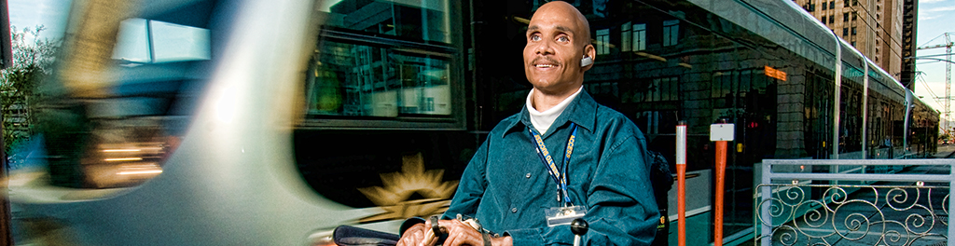

Transportation

Continued funding for transportations is crucial. People rely on transportation to participate in their communities. People with disabilities still face barriers and discrimination, especially to air travel. Transportation must be safe accessible and affordable. All modes of transportation must be accessible.

Air Travel

It is dangerous for people with disabilities who use wheelchairs (and other mobility devices) to travel by air. Many are injured and equipment is frequently damaged. NCIL supports the Air Carrier Access Amendments Act of 2021 (ACAAA) (S. 642 / H.R. 1696). The ACAAA would strengthen the original protections of the Air Carrier Access Act of 1986 and make air travel more equitable. It would require better accessibility of aircraft, airports, websites, and kiosks. It also includes a process for people with disabilities to file discriminations complaints.

Private Transportation

Strong rules and laws are needed to increase the number and availability of accessible vehicles in the private transportation industry. This includes, but is not limited to:

- Transportation networking companies (TNCs) like Uber and Lyft
- Taxis
- Car rentals
- Shuttle services
- Limousines
- Boats
- Bike rental services

TNCs (also called “Ride Hailing Services”) may help solve some of our community’s transportation needs. They are also creating new barriers. Both TNCs and taxis continue to fight against complying with the Americans with Disabilities Act. Accessible transportation at TNCs is woefully lacking. People with disabilities must be involved in all discussions and decisions about TNCs and other modes of transportation.

Amtrak & High-Speed Rail

Amtrak and other rail systems must continue to improve station, vehicle, and service accessibility. However, NCIL and other advocates are very concerned that Amtrak is taking a step backwards, with plans for some rail cars to have a narrower isle. This would limit accessibility for people using wheelchairs. Recent settlements with the Department of Justice and Amtrak have spurred them into a more concerted effort, but it will still take years before all facilities are accessible.

Websites and Reservations Systems and Mobile Apps

Many websites for making reservations for transportation services are not accessible and do not meet current accessibility standards. This is especially true for people who are blind or have low vision. Many are not equitable for people with disabilities, requiring them to make a call to get information, make a reservation, or get a discount. There are other forms of discrimination as well. This is also true of the mobile apps now used by many transportation businesses.

Self-Driving Cars

Self-driving cars, also known as autonomous vehicles, are not being designed for accessibility. Accessibility must be included from the beginning. Otherwise, people with disabilities will be left behind. Legislation is needed to ensure self-driving cars are being built to be inclusive.

Non-Emergency Medical Transportation (NEMT)

For many people with disabilities this is an essential life sustaining service. Advocates need to work with CMS to make the service more equitable for people in rural areas. Crossing county lines is frequently a barrier excluding people from necessary health care.

Healthcare

Expanding Coverage

The Biden Administration and Congress have talked about expanding healthcare coverage and services. NCIL supports helping more people get healthcare coverage. We also support expanding access to community-based long term services and supports (LTSS). Any efforts to expand healthcare, including universal coverage or a public option, must include the needs of the disability community, including expanding access to LTSS. We also want to make sure healthcare coverage lets disabled people get the equipment and supplies they need to live independently.

Prohibiting Healthcare Discrimination

There is a lot of discrimination against people with disabilities in healthcare, like substandard care and less access to needed services. This has serious consequences. The COVID-19 pandemic highlighted this for us. States and hospitals created new rules that discriminated against disabled people. They developed plans for “medical rationing” that determined who does and does not get treatment and care. Some disabled people were denied treatment altogether.

Black, indigenous, and other people of color (BIPOC) have died at alarming rates during the pandemic. LGBTQIA+ people and many other marginalized groups have also faced discrimination. Discrimination in healthcare has always had deadly consequences. During the pandemic, it has meant drastically higher infection and death rates.

NCIL supports strong enforcement of nondiscrimination laws. We also support new laws to address discriminatory practices. Some of our biggest areas of concern include:

- Medical equipment in clinics, offices, and facilities that is not accessible;
- Failure to communicate or provide information in accessible formats;
- Pressure to refuse life-sustaining treatment;
- Discriminatory “futile care” policies allowing healthcare providers to decide not to give life-saving treatment to someone even if they want it;
- Discrimination in organ transplants; and
- Quality Adjusted Life Years (QALYs). Insurance companies use QALYs to decide how much – or whether – to pay for certain treatments and services. Different disabilities and health conditions are given different number values. These are used to calculate the “value” of the treatment or service.

Chronic Pain and Opioids

Efforts to reduce opioid addiction must consider the needs of people with chronic pain. Some people with chronic pain need opioid medications. Because of some of the new laws, people with pain face more barriers to pain management. Many of these new laws focus on limiting opioid prescriptions. This has made it difficult for some people to get needed medication. Some people have been forced to reduce or stop their medication very quickly. Other people have been denied medical care completely.

Congress must understand the impact of recent laws. They must focus on comprehensive care for both pain and substance use. People with pain need access to the full range of the options that are available. Congress must work with people with pain and people with substance use disorders.

Opposing Assisted Suicide

Assisted suicide laws pose major dangers to people with disabilities. Every national disability organization with a position on assisted suicide opposes it (https://bit.ly/3NbId5c). Many national medical organizations also oppose it. This includes the American Medical Association and the American College of Physicians. Many states have repeatedly refused to pass assisted suicide laws as well.

The reasons we oppose it include:

- When assisted suicide is legal, it is the cheapest treatment available. This is attractive in our profit-driven healthcare system. This is dangerous.
- Terminal diagnoses are often wrong, and it is nearly impossible to know how long someone has left to live. Assisted suicide laws lead people to lose good years of their lives.
- If one doctor says “no,” people can “doctor-shop” (go from doctor to doctor) until they find one who will say “yes.”
- The “safeguards” do not protect people. There is no independent witness when the lethal drugs are taken. There is no real enforcement, and no one is charged with investigating. Therefore, there is no protection against abuse or coercion.
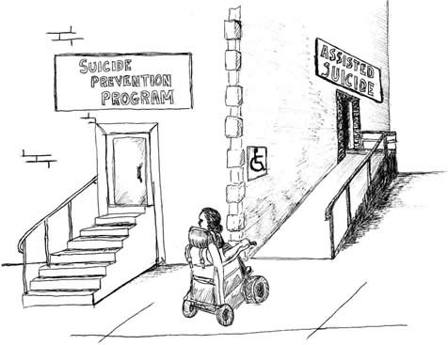
- Many other pressures exist that can cause people with compromised health to hasten their death.
- Evidence shows that assisted suicide laws lead to “suicide contagion,” driving up the general suicide rate.
- We already have the right to good end-of-life pain relief. This includes palliative sedation, if needed. Palliative sedation uses medication to decrease awareness to relieve suffering.

In 2019, the National Council on Disability released a report on Assisted Suicide (https://bit.ly/3zaebuu). The report examined the effect of the country’s assisted suicide laws on people with disabilities. The report found that the laws’ safeguards are ineffective. It also found that there is no oversight of abuses or mistakes. Many of those abuses have been documented by the Disability Rights Education and Defense Fund (https://bit.ly/3PQ5tYx).

Employment / Social Security

It has been more than 30 years since the Americans with Disabilities Act passed. However, people with disabilities have not made much progress with employment. People with disabilities are still employed at lower rates than nondisabled people. 19.3% of people with disabilities are employed. 66.3% of nondisabled people are employed. This is a huge difference. People with disabilities are also two times as likely to work part time as nondisabled people.

COVID Recovery

As we continue to recover from the COVID-19 pandemic, it should be recognized that people with disabilities continue to be negatively affected. Workers with disabilities have lost their jobs more than nondisabled workers. The inequality during COVID-19 continues to be even worse for young people with disabilities. It is also worse for disabled people of color. People with disabilities have lost almost 1 million jobs. Having a job can be a path out of poverty.

We need to continue to think about these issues as the country continues its recovery from the pandemic.

People with disabilities should be considered fairly for jobs. They should be considered based on their ability to do the responsibilities of the job.

The COVID-19 pandemic has shown us that working remotely can be effective. This benefits some workers with disabilities. It can help us make the best use of our skills and reduce barriers to employment.

Removing Barriers to Employment for Older Workers

- Get Rid of the Medicaid Buy-In (MBI) Age Limit
Some of the services and supports disabled people need are only available through Medicaid. Some people with disabilities are not eligible for Medicaid because they earn too much money. MBI helps more people with disabilities access needed services and supports. But right now, people in some states are only eligible until they turn 65. Our proposal would get rid of this age limit imposed by the Medicaid Buy-In (MBI) under the Ticket to Work legislation.

- Get Rid of “Disabled Adult Child” (DAC) Employment Restrictions
Some people with disabilities are in a group Social Security calls Disabled Adult Children (DAC). These people were disabled before age 22 and meet other requirements. They receive Social Security Disability Insurance (SSDI) benefits. DACs are the only group that receives SSDI and is not allowed to work above substantial gainful activity (SGA) after retirement age. (Substantial gainful activity is work that brings in a specific amount of money. For example, the SGA for non-blind people this year is $1310. People who earn more than $1310 are working above SGA.) Our second proposal would change this and allow DACs to work above SGA after retirement age. This would make the rules the same for all Social Security beneficiaries.

Action: In 2018, both proposals were introduced in one bill. It had support from both Republicans and Democrats. In 2019, a bill was introduced with just proposal #1. This was reintroduced this year. It is called the Supporting and Empowering the Nation to Improve Outcomes that Reaffirm Careers, Activities, and Recreation for the Elderly (SENIOR CARE) Act (S. 1476). NCIL supports this bill. We also hope proposal #2 will be introduced again. This bill needs more co-sponsors and support from other disability organizations to pass!

ABLE Age Adjustment Act

Many benefits people with disabilities rely on limit how much money people can have or save. ABLE Accounts are special accounts that allow people with disabilities to save their money for disability-related expenses. This can include things like housing, transportation, healthcare, and more. Money put in an ABLE Account does not affect eligibility for benefits, like Medicaid or SNAP (food stamps).

Right now, only people who were disabled before turning 26 are eligible for an ABLE Account. The ABLE Age Adjustment Act (S. 331 / H.R. 1219) would change that. If this bill passes, people who were disabled before turning 46 would be eligible for ABLE Accounts. This change would help millions of people and stabilize the program by increasing the number of people using these accounts. This bill needs more co-sponsors in order to pass!

Competitive Integrated Employment

NCIL opposes paying people with disability subminimum wages. NCIL also opposes the segregation of disabled employees in sheltered workshops or elsewhere. Sheltered workshops are 95% of the 14(c) certificate holders. These certificates allow employers to pay disabled people less than minimum wage for their work.

NCIL supports efforts to advance competitive integrated employment. Competitive refers to jobs where disabled and nondisabled people work for the same wages, benefits, and opportunities. Integrated refers to jobs in the community where disabled and nondisabled people work together doing the same or similar jobs.

NCIL supports the Transformation to Competitive Integrated Employment (TIME) Act (H.R. 2373). This bill would phase out the use of 14(c) certificates. It would provide grants to states and employers to support competitive integrated employment.

All these initiatives will help people with disabilities work their way out of poverty while benefitting the country’s economy as a whole. They will help the country’s productivity.

SSI Restoration Act

Supplemental Security Income (SSI) provides financial assistance to older adults and people with disabilities with little to no income or assets. Much of the program has not been updated since it began in 1972. Because of that, many people who rely on SSI live in poverty and struggle to meet their basic needs.

Emergency Preparedness

People with disabilities need to be involved in all parts of a disaster – preparedness, response, and recovery. Many offices of the government have refused to work with organizations led by people with disabilities. NCIL strongly recommends that lawmakers and the Independent Living community take action. We need disability civil rights laws to be monitored and enforced.

The Administration must enforce the laws to meet the needs of people with disabilities during disasters. Congress must provide funding to disability organizations to meet those needs.

There are two important bills that Members of Congress should support, sponsor, and pass into law. You can read more about both bills at reaadi.com.

REAADI for Disasters Act

S. 2658 / H.R. 4938 establishes programs and requirements to assist individuals with disabilities and older adults (age 50 or older) with disaster preparedness.

✔ NCIL supports this bill.

Among other provisions, the bill:

- requires the establishment of an advisory committee that includes disabled individuals and older adults to oversee the use of funds made available by this bill;
- allows states to contract with Centers for Independent Living to provide services and support to disabled individuals in preparing for hazards;
- requires the Department of Health and Human Services to award grants to carry out projects of national significance that, among other things, create opportunities for disabled individuals and older adults to directly contribute to disaster preparedness, recovery, and mitigation;
- modifies and expands the membership of the National Advisory Committee on Individuals with Disabilities and Disasters to ensure that it represents the diversity of the disabled and older adult communities; and
- establishes the Disability and Disaster Preparedness Advisory Commission to review settlement agreements involving potential violations of the Rehabilitation Act of 1973 and the Americans with Disabilities Act of 1990.

The Government Accountability Office must study the compliance of federal agencies with such enactments in expending funds to support disabled individuals and older adults in responding to, recovering from, and mitigating disasters.

Disaster Relief Medicaid Act

H.R. 4937 and S. 2646 establish a series of programs and requirements relating to Medicaid coverage of individuals affected by a federally-declared major disaster.

✔ NCIL supports this bill.

In particular, the bill provides for specific disaster relief coverage under Medicaid for individuals who meet specified income eligibility standards and, during the seven-day period preceding the disaster, were either residents of the impacted area or were employed in the impacted area (and subsequently lost employment). Coverage is effective for two years after the date of the disaster declaration.

State Medicaid programs must provide disaster relief coverage that is at least as comprehensive as the state's Medicaid coverage and the Medicaid coverage of the individual's home state, as applicable. The bill applies a 100% Federal Medical Assistance Percentage (i.e., federal matching rate) to such coverage and related administrative expenses.

Voting Rights

Voting Accessibility

Disabled people face major barriers to voting. Our goal is for all people with disabilities to vote in all elections. All people with disabilities must be able to vote privately and independently. All voters must have access to both in-person and remote voting. Both must have accessible options. This is even more urgent during the COVID-19 pandemic.

We have a strategy to reach this goal:

- We will help with education and get-out-the-vote campaigns. We will help with voter registration. We will develop plans and provide resources. We will train leaders. We will work with other organizations. We will do this in primaries and elections at all levels of government.
- We will encourage and educate people with disabilities to run for public office and hold appointed positions.
- We will work with the disability community to advocate for Federal funding. This funding should expand voting options. This includes accessible remote voting options for everyone. Both accessibility and security of voting must be improved.
- We will advocate to ensure any new voting technology is accessible and easy to use.

We also must keep the access that we already have. We will work to make sure voter websites are accessible and easy-to-use. This includes election offices, campaigns, and organizations that are educating voters. Each must also provide materials in alternative formats.

Fighting Voter Suppression

NCIL is committed to fighting laws that make it harder for people to vote.

We will fight against laws that:

- limit early voting and curbside voting;
- require strict voter identification to vote; and
- make it harder for people of color to vote.

This year, NCIL’s Voting Rights Subcommittee is focusing efforts on states that have passed voter suppression laws or have pending legislation. We will provide resources and platforms where updated and accurate information can be obtained

Executive Order 14019: “Promoting Access to Voting”

People across the country face many barriers to voting. Executive Order 14019 (https://bit.ly/3aeRkDy) promotes access to voting and addresses the barriers people of color and those with disabilities have faced for years. The order expands access to voter registration and election information.

Mental Health

Mental health disabilities are common. Half of Americans will get a mental health diagnosis at some time in their life. But people with mental health disabilities are left out of policy discussions about mental health. This exclusion has resulted in discrimination and other harm.

Mental Health and Violence

Many recent proposals to curb gun violence have falsely linked mental health and violence. People with disabilities are far more likely to be victims than perpetrators of violence.

NCIL opposes:

- the false linking of mental health disabilities and gun violence;
- all efforts to deny people’s rights based on diagnosis or disability; and
- the use of discriminatory and harmful violence prevention methods, including the use of databases based on diagnosis or treatment and the use of “threat assessments.”

These practices harm disabled people and people of color, and they do not prevent violence. For these reasons, NCIL strongly opposes the Behavioral Intervention Guidelines Act of 2021 (S. 1383 / H.R. 2877).

Forced “Treatment”

NCIL supports disabled people’s right to control their services and supports. NCIL opposes forced or coerced “treatment.” This includes involuntary institutionalization and forced drugging. It also includes Involuntary Outpatient Commitment “IOC” (also known as Assisted Outpatient Treatment “AOT”).

Institutionalization

People with disabilities are often forced to live in congregate settings. Unfortunately, there continue to be many efforts to increase beds in congregate settings.

These settings put people at more risk of death, injury, and further disability. This was true before COVID-19. COVID-19 has shown the world how urgent it is to get people out of these settings. We must invest in community services and supports. This includes:

- Housing
- Peer support services
- Voluntary community mental health services
- Voluntary community services for substance use disorders

The media has focused a lot on COVID-19 deaths in nursing homes. Psychiatric facilities and other congregate settings are just as deadly for people with COVID-19.

Institutionalization should be avoided whenever possible. Persons with mental illness are more likely to have a host of other conditions that put them of greater risk than their non-labeled counterparts. COVID complicates the danger for people with mental illness. We support additional funding that would go to community-based services.

NCIL supports COVID relief funding for mental health and substance abuse and believes that those funds should also be available for peer-to-peer and independent living services. We do not support forced interventions. We oppose any diversion of these funds to prisons.

The following bills are very important because 988 (a national suicide prevention hotline) will soon be operational and additional resources will be needed to discourage police intervention.

✔ NCIL supports:

- Coronavirus Mental Health and Addiction Assistance Act of 2021 (H.R. 593)
- Stopping the Mental Health Pandemic Act (H.R. 588)
- Improving Mental Health Access from the Emergency Department Act of 2021 (H.R. 1205)
- Mental Health Justice Act of 2021 (H.R. 1368)

Education

Individuals with Disabilities Education Act (IDEA)

The Individuals with Disabilities Education Act (IDEA) is a civil rights law. It says students with disabilities have the right to a free and appropriate public education. NCIL believes IDEA must be fully implemented. We believe it must be strongly enforced. Students should have an education that includes:

- The development of self-advocacy skills;
- Information about their rights;
- Opportunities to connect with adults with disabilities;
- Full access to all parts of their education. This includes academics, extracurricular activities, physical education, and social activities;
- The right assessments, technology, and supports to participate with their peers;
- An equal opportunity to be challenged;
- Schools that are accountable for the success of all students; and
- Due process rights when their rights are denied. Due process is a formal way to resolve disagreements with the school.

During COVID-19 students must continue to have an educational program that supports them. It must appropriately challenge them. They must continue to have access to assessments. They must have access to supports and technology they need. They must also have access to due process if their right to an education is not provided.

Restraint and Seclusion of Students

Restraint and seclusion cause harm. They are traumatic. But many schools continue to restrain and seclude students. Both restraint and seclusion are disproportionately used on students with disabilities and students of color. The use of restraint and seclusion should be banned.

The Keeping All Students Safe Act

✔ NCIL strongly supports this bill.

S. 1858 and H.R. 3474 would ban almost all seclusion and restraint. Schools would only be allowed to use physical restraint when someone is in immediate and unpreventable danger of physical harm. In those cases, restraints that make it hard to breathe or threaten the person’s life (like prone or supine restraint) cannot be used. Action is still needed to pass this bill and fully ban these practices.

College Accessibility for Students with Disabilities

Students with disabilities often have a hard time finding information they need from colleges. It is hard to find information about requirements for accommodations. It is hard to find information about disability programs. Many colleges are not prepared to accommodate students in typical times. The COVID-19 pandemic has made this worse. Federal legislation is needed.

Legislation should require colleges to accept an IEP or 504 plan as proof of disability. It should also affirm 504 accommodation requirements. NCIL supports the Respond, Innovate, Succeed, and Empower Act (also known as the RISE Act). The RISE Act would accomplish many of these things. It has not been reintroduced yet.

Technology

People with disabilities need more opportunities to access assistive technology (AT) devices and services. This includes devices that are generic and mainstream. This also includes personalized devices. All these devices can increase independence. They can increase self-determination. They can increase inclusion. And they can increase full participation.

There are many important things to consider when developing new technology:

- Universal design
- Inclusion
- Consumer control
- Consumer choice
- Peer support

These are also important when technologies become available in the marketplace. People with disabilities are best served when they have access to information, “hands-on” trial experiences, and supports. These can all help ensure the technology works for them. NCIL is encouraged by new devices that have incorporated Universal Design.

NCIL also supports the creations coming from the “Makers Community.” These can be devices made from 3-D printers. They can also be devices made from cardboard and other easily-found materials.

Assistive Technology Act

Congress has committed to expanding consumer choice and control in state Assistive Technology (AT) programs and Alternative Financing Programs (AFPs). AFPs help people with disabilities pay for the assistive technology they need.

NCIL supports this. Congress has also directed the AFPs to incorporate credit-building activities. This can include things like financial education and providing information about other possible funding sources.

NCIL is monitoring the reauthorization of the Assistive Technology Act. NCIL supports changes that:

- Authorize Alternative Financing Programs (AFPs) to ensure that viable AFPs exist in every state and territory. AFPs shall provide no or low-cost financing for the purchase of assistive technology via a low-interest loan fund; an interest buy-down program; a revolving loan fund; or a loan guarantee or insurance program.
- Incorporate consumer control and consumer direction throughout state AT program activities. This includes the Advisory Committee and the development and management of AFPs. These changes will mean people with disabilities have more power and control.

Violence and Abuse

The COVID-19 pandemic has put a spotlight on violence in our society. It has shown us violence of racism borne of white supremacy. It has highlighted the violence of oppression and the violence of institutionalization.

Black, Brown, Indigenous and other people of color (BIPOC) have died at much higher rates. There are many reasons for this. This includes short- and long-term lack of access to quality healthcare and poor treatment from the medical and prison industrial complexes.

People with disabilities in congregate settings are also victims of sexual assault and caregiver violence. Getting out of these places is important. These settings account for at least 40% of COVID-19 deaths in the U.S.

Federal and state funding must be available to get people out of institutions. This process is often called transition. This funding must also help people stay out of institutions. This is called diversion. This will help end the violence and death because of institutionalization. Funding must also increase access to healthcare for all BIPOC.

People who have been victims of violence should be able to receive the services they want and need. This includes victims of sexual assault, domestic assault, and caregiver violence. They should be able to receive culturally-specific services. In order for that to happen, the Senate needs to reauthorize VAWA, the Violence Against Women Act (https://bit.ly/3NbXmDB). VAWA passed the House in March 2021 and was recently referred to the Senate Committee on the Judiciary in May 2022.

People with disabilities experience serious violent crime (sexual assault, robbery and aggravated assault) at three times the rate of people without disabilities*. During a crisis like a pandemic, personal violence increases. Hotlines and online chat support services are still in service. You can contact one of them to speak with someone who is trained to help.

- Deaf Abused Women’s Network (DAWN) for legal, medical, system advocacy, and survivor support services. Video Phone: 202.559.5366 or deafdawn.org
- National Domestic Violence Hotline: 800-799-7233 or 800-787-3224 (TTY) or www.thehotline.org
- National Sexual Assault Hotline: 800.656.HOPE (4673) or chat online at online.rainn.org

* U.S. Department of Justice, Bureau of Justice Statistics 2017

Veterans

NCIL supports efforts to provide all Veterans and their families with services and benefits in the most effective and efficient manner possible.

Veterans Health Administration (VHA)

NCIL supports:

- Reform by the Veterans Administration (VA) and Congress for the VHA. This reform must ensure appointments are processed in a timeline manner.
- Veteran Spouses: Offering Veteran spouses the ability to receive services if they are being cared for by a Veteran. These include Veteran Caregiver Services and Veteran-Directed Home and Community Based Services (HCBS).
- Veteran Healthcare: The VHA needs enough funding for Veterans’ healthcare. Congress must provide this funding. This includes expanding community-based options like Veteran-Directed HCBS.

Veterans Benefit Administration (VBA)

NCIL supports:

- Reform by the VA and Congress for the VBA claims process. This reform must ensure consistency, timely processing, and adjudication of claims.
- Proper support: Veterans with post-traumatic stress disorder (PTSD), traumatic brain injury (TBI), and mental health disabilities due to service need to be able to access support. The Department of Defense (DOD), the VA, and Congress need to ensure this. This includes destigmatizing mental illness. It also includes making processes easier so finding and getting help is not so difficult.
- Employment: Employment opportunities help Veterans transition from military to civilian life. Congress must provide funding. This must support education, employment, and training programs.
- Benefits: Congress must not reduce benefits for Veterans and their families.
- Pre-9/11 Veterans: Benefits have been created for post-9/11 military members. These benefits must be available to pre-9/11 Veterans, too.

Veteran Homelessness Prevention

The President and Congress must support efforts to prevent Veteran homelessness. This includes making HUD-VASH (Veterans Affairs Supportive Housing) vouchers more available to Veterans in rural areas. These vouchers provide housing and support services to Veterans.

Veterans and Centers for Independent Living

Veterans need to be able to access services in the communities where they live. Congress, DOD, and the VA need to engage and collaborate with community-based organizations, like Centers for Independent Living (CILs). This collaboration will ensure Veterans and their families can access the services and supports they need.

Civilian Health and Medical Program of the Department of Veterans Affairs (CHAMPVA)

CHAMPVA is a comprehensive health insurance program. The VA shares the cost of covered healthcare services for people who are eligible. NCIL supports the CHAMPVA Children’s Care Protection Act of 2021 (S. 727 / H.R. 1801). This bill would allow children of eligible Veterans to continue coverage up to age 26. The Affordable Care Act left a gap for children of eligible Veterans from ages 23-26.

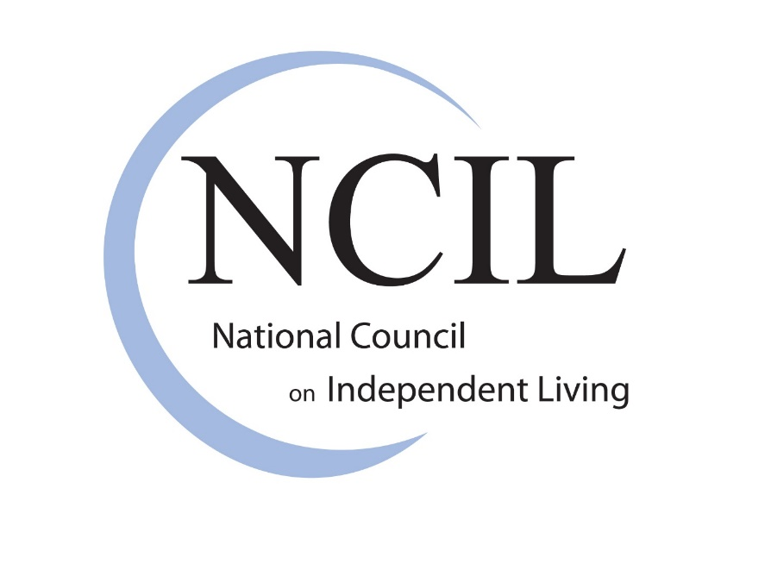
PO Box 31260
Washington, DC 20030

web: www.ncil.org

email: ncil@ncil.org

voice: 202.207.0334

toll free: 1.844.778.7961

