National Council on Independent Living

2022 Annual Council Meeting Agenda

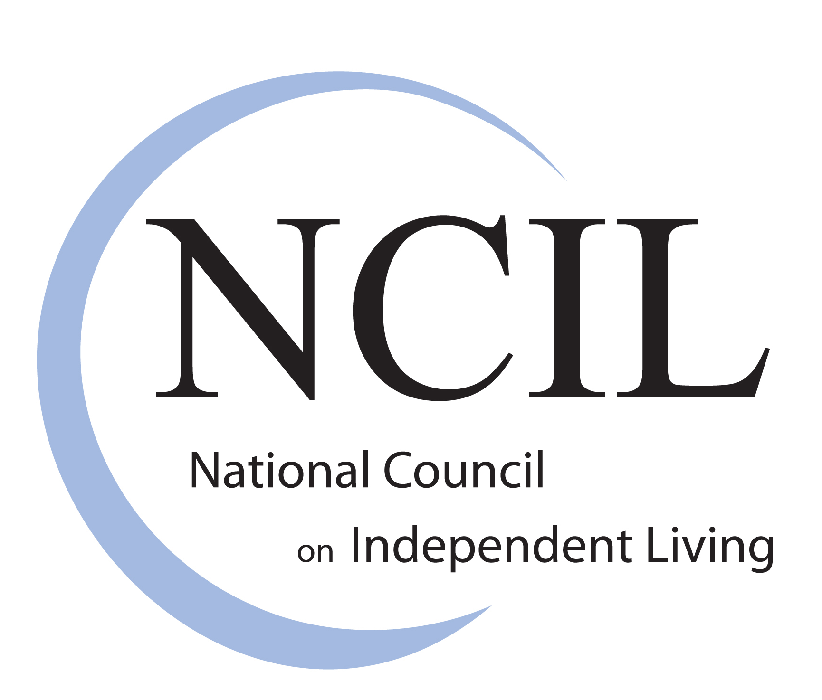

Tuesday, July 26, 2022; 2:15-3:00 p.m. Eastern

Independence Ballroom; Grand Hyatt Washington

Please note the times outlined below are estimated and may occur earlier or later than stated in the agenda.

2:15 p.m. Call to Order & Welcome Kent Crenshaw

2:20 p.m. Review of Nomination & Election Procedures Kim Conner

2:25 p.m. Announcement of Elected Executive Committee Positions
Kim Conner
Vice President
Secretary
Diversity Chair

Announcement of Member At-Large Positions Kim Conner
3 Elected Positions

Announcement of Elected Regional Representative
Positions
Kim Conner
Regions 2, 3, 4, 6, 8, & 10

2:30 p.m. Reports

A. President Kent Crenshaw
B. Interim Executive Director Darrell Jones
C. Vice President Lou Ann Kibbee
D. Secretary Kim Conner
E. Treasurer Jeremy Morris

2:45 p.m. Acknowledgement of NCIL’s Committees and Subcommittees Lou Ann Kibbee

2:48 p.m. Resolutions (No resolutions were submitted for consideration) Lou Ann Kibbee

2:50 p.m. Old Business New Business
Announcements
Kent Crenshaw

3:00 p.m. Adjournment

