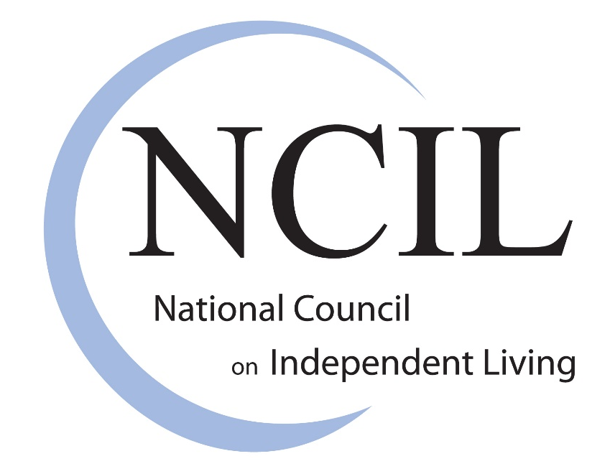

National Council on Independent Living

Advocacy and Legislative Agenda

NCIL’s mission is to advance the disability-led Independent Living Movement to expand the capacity of Independent Living Programs to enhance the human and civil rights of all people with disabilities.

Priority 1: Fund Centers for Independent Living 3
Priority 2: End the Institutional Bias 7
Pass the HCBS Access Act and Better Care Better Jobs Act 7
Priority 3: Support People with Disabilities in Disasters 8
Pass the Real Emergency Access for Aging and Disability Inclusion (REAADI) for Disasters Act 8
Support ACL / HHS’s Proposal in the President’s Budget for Human Services in Disasters 9
Establish a Disaster Human Services Emergency Fund 9
Establish a Capacity Building Grant Program and Technical Assistance Center 9
NCIL Legislative Positions 10
Long Term Services & Supports 10
Housing 10
Chronic Pain & Opioids 11
Employment & Social Security 12
Transportation 13
Healthcare 14
Civil Rights 14
Voting Rights 15
Education & Youth 15

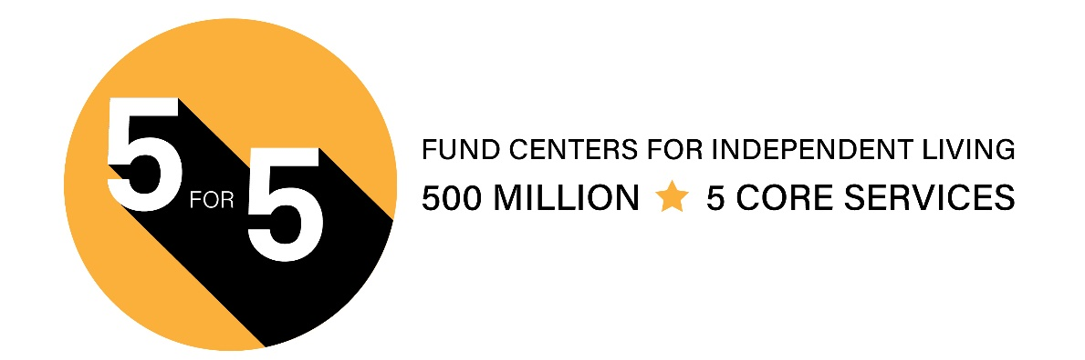
Priority 1: Fund Centers for Independent Living

Invest in Community Living & Independence for People with Disabilities

Centers for Independent Living (CILs) (Title VII, Rehabilitation Act, as amended) have been underfunded for decades, leading to individuals with disabilities lacking access to critical services and support!
Many areas in the U.S., especially in rural communities do not have access to a CIL. CILs need more funding in order to expand their service areas to address the unmet needs.

1,216,970 Services Provided

In 2020, CILs transitioned 3,915 individuals from institutional settings to the community. Based on information from the Kaiser Family Foundation, the average nursing home cost is $105,852 each year, compared to home and community-based supports, which average $31,100 per year. That equates to a savings of $292,654,080 annually, or a 231% return on investment.

712,223 Successful Outcomes

CILs provide a unique one-stop resource to people with disabilities. Most of our staff, board, and management are individuals with disabilities. This creates responsive, dynamic, and knowledgeable places for people to turn to.

In 2020, 66% of all staff of CILs were people with disabilities, employing 4,575 individuals with disabilities with 1,197 in management of their CIL.

Individuals with Disabilities Need Better Access to Comprehensive Independent Living Services

Funding CILs enables individuals with disabilities to live in their homes with their families where they can work, attend school, worship, and participate in other community activities. CILs are hubs of disability information, resources, services, and advocacy. CILs are vital to the whole community. It also creates tremendous savings for taxpayers.

What is Independent Living?

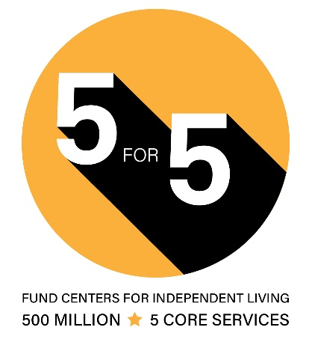
A movement, a philosophy, specific programs that provide tools, resources, and support for integrating people with disabilities fully into their communities to promote equal opportunities, self-determination, and respect. All people can: live with dignity, make their own choices, and participate fully in society.

Why Community Living?

- People prefer to live in their own homes.
- It is a legal right.
- It costs less.
- Everyone benefits when everyone can contribute.

Centers for Independent Living (CILs)

CILs are hubs of disability information, resources, services, and advocacy. CILs have a unique ability to creatively address barriers within their individual communities, allowing the CIL network to respond quickly and effectively in times of crisis and emergency. Investing in CILs benefits the entire community and yields a strong return for taxpayers. Federally funded CILs provide five core services:

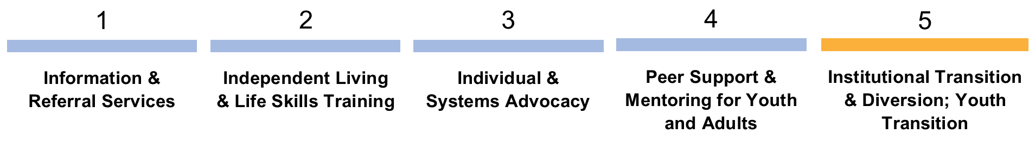

Statewide Independent Living Councils (SILCs)

Each state and U.S. territory is required to maintain a SILC. SILCs develop a three year strategic plan that creates a unified vision for the state on how to address barriers to independent living and other issues impacting people with disabilities.

America is home to: 403 CILs · 330 Branch Offices · 56 SILCs

Department of Health and Human Services, Administration for Community Living (ACL)

The Office of Independent Living Programs (OILP) within ACL is tasked with overseeing Independent Living agencies on a national level.

Founding Document: Title VII, Rehabilitation Act of 1973, as amended

There are two types of CIL funding:

1. Subchapter B – Independent Living Services 2. Subchapter C – Centers for Independent Living

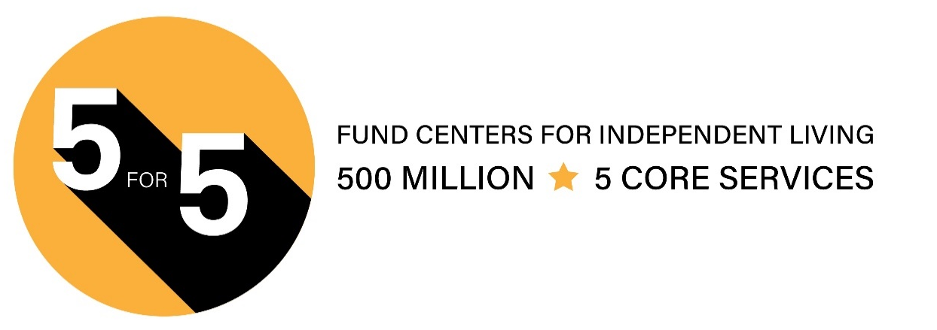
INDEPENDENT LIVING IN ACTION

Centers for Independent Living provide holistic services that meet people with disabilities where they are and assist them during their journeys to achieve self-defined goals. These are their stories.
SHAYA

Shaya was living in a nursing facility for three years after a car accident resulted in a traumatic brain injury as well as a persistent mobility disability affecting her ability to walk. After rehabilitation, it was not considered safe for her to be discharged since her apartment was not accessible. Shaya needed an accessible apartment, some in-home care, and some assistive tools to help her live independently. The CIL provided assistance securing these supports.

It has now been more than six months since Shaya’s transition to the community and she is still living in her own home, her family providing support and happy that she can go out with friends whom she had not seen in years. CIL staff keep in touch with Shaya to make sure that she is still doing well and to offer assistance if needed to maintain her independence.

KENNY

Kenny, is a young man who returned to his own home a year ago after an amputation had trapped him in a nursing facility.

“I didn’t feel like I belonged there,” Kenny said about his time in the nursing facility. “I wanted to get out of there, but I didn’t know how I was going to live with my amputated leg. The CIL’s Peer Advocate told me about their struggles and what they did to deal with those challenges. It was helpful to tell them my story and brainstorm ideas of what I could do to feel more comfortable.”

Kenny reached out to the CIL at the beginning of 2023 and asked about becoming a Peer Advocate himself. The CIL encouraged him and believes that he will be an incredible help to others.
GG

GG was having difficulty advocating for himself effectively with his Managed Care Organization (MCO) and his service coordinator. He had been without appropriate transportation because of his need for a gurney and his service coordinator was not returning calls. The CIL Advocate used her resources with the MCO and held a 3-way call to demonstrate an example of using effective communication for GG to self-advocate. He now independently advocates for appropriate transportation at the MCO advisory meetings and other state MCO meetings.
SAM

Sam, who is autistic and a member of the CIL’s grassroots advocacy group, Wheels in Motion (WIM), achieved her goal of obtaining a part time job. She had learned and practiced self-advocacy and group advocacy skills as part of WIM. She was recruited by the national advocacy group Self Advocates United as One to be a trained, paid self-advocate.
NICOLE

Nicole had just finished her bachelor’s degree and begun working when her local Vocational Rehabilitation office closed suddenly. After being transferred to another office, Nicole was faced with a new case worker determined to undermine her goal of pursuing a master’s degree. She turned to her CIL for help advocating for the services she needed to continue her education.

Nicole completed her masters in six months with honors and credits the accommodations that resulted from successful advocacy.

Vocational Rehabilitation continued denying Nicole assistance to create a business plan. Over the course of that year, Nicole wrote and published four books and did a TEDx talk (http://bit.ly/3YkubUG), among other noteworthy accomplishments. Nicole then joined her state’s Statewide Independent Living Council, where she was perfectly positioned to ask tough questions of the Vocational Rehabilitation agency.

Her CIL staff advocate, Cathy, was there through it all. “She encourages me and keeps reminding what I have done and how hard I have worked; that it will happen. Cathy is a big factor in the success in my life. If all people with disabilities had access to CIL services, it would heal a lot of disability issues and give individuals the support they need.”
DESTINEY

Destiney is a 23-year-old woman with multiple disabilities. She had been fighting with her half-sister to maintain custody of her 3-year old son. The half-sister was threatening that DHS would take her son away from her if she did not let her half-sister have him. Destiney felt it was because her family did not think she could care for her son because she was disabled.

The CIL advocated for Destiney through her court proceedings regarding her rights as a parent and ability to care for her son.

Destiney successfully maintained custody of her son, who lives with her in their new home. She makes her own choices and lives independently with services in place. She now has opportunities and the freedom to socialize within her community as much as she likes!
5for5campaign.com Questions: contact Jessica Podesva at jessica@ncil.org

Priority 2: End the Institutional Bias

Pass the HCBS Access Act and Better Care Better Jobs Act
NCIL is committed to advocating to end the institutional bias and improve access to consumer-controlled home and community-based services for people with disabilities and older adults. One of the core services of Centers for Independent Living is to help transition people from institutional settings but many consumers struggle to obtain all the HCBS services they need.

People with disabilities who are eligible for Medicaid long term services and supports or LTSS and require assistance with their activities of daily living (bathing, dressing, eating, etc.) currently have immediate access to institutional settings such as nursing homes but if they want to remain in their homes with the help of Medicaid Home and Community-Based Services (HCBS), they are often put on waiting lists and can wait years or even decades for services and supports to live independently in their community.

Currently the HCBS Access Act (H.R. 1493 and S 762) and Better Care Better Jobs Act (H.R. 547 and S 100) are two critical pieces of legislation that will help end this institutional bias and make substantial improvements to the home and community-based services work force.

For more information on the HCBS Access Act:

- Full Text Senate: https://bit.ly/3CBRxvL
- Full Text House: https://bit.ly/3qPJk4B
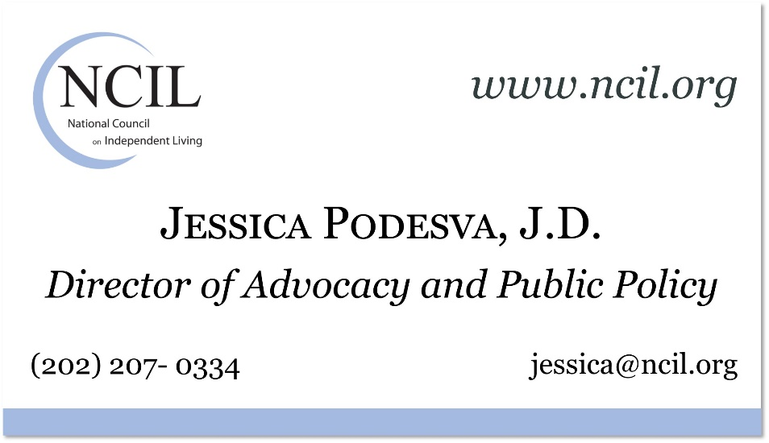
- One Pager: https://bit.ly/3CRGn6l

For more information on the Better Care Better Jobs Act:

- Full Text Senate: https://bit.ly/3Pj0gdM
- Full Text House: https://bit.ly/3CzfLGN
- One Pager: https://bit.ly/43JcsZP

Priority 3: Support People with Disabilities in Disasters

Pass the Real Emergency Access for Aging and Disability Inclusion (REAADI) for Disasters Act
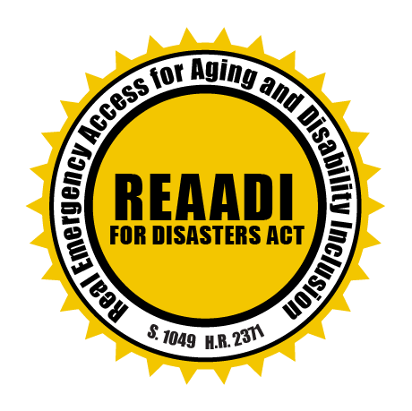
People with disabilities and older adults are two to four times more likely to die or be injured during a disaster than nondisabled people.

Current disaster infrastructure fails 61 million adults with disabilities and more than 55.8 million adults age 65 or older adults who live in the United States.

Disproportionate deaths and injuries are a result of barriers to emergency management services including disaster planning, critical evacuation information, accessible shelters and transportation, and recovery assistance.

REAADI for Disasters Act is a bipartisan bill that fills the gaps in disaster preparedness.

It takes meaningful legislative actions to ensure access to disaster resources and services for disabled people and older adults.

✔ Bipartisan: REAADI was introduced in the Senate as S.1049 by Senator Casey (D-PA) and in the House of Representatives as H.R. 2371 by Congresswoman Dingell (D-MI-6) and Congressman Fitzpatrick (R-PA-1).

✔ Whole Community Resilience: REAADI for Disasters Act provides opportunities for people with disabilities, older adults, and disability-led organizations to provide guidance, technical assistance, and training for disaster preparedness, recovery, and response at local, regional, and national levels.

✔ Effective Use of Federal Disaster Dollars: REAADI for Disasters Act includes mechanisms to review and ensure all federal funds spent in disasters comply with accessibility and civil rights laws.

Cosponsor REAADI today!

Contact Michael Gamel-McCormick at Michael_Gamel-McCormick@aging.senate.gov or Meg Makarewicz at Makarewicz@mail.house.gov.

Support ACL / HHS’s Proposal in the President’s Budget for Human Services in Disasters

Disasters are increasing in frequency and intensity. Storms, tornadoes, flooding, and extreme heat are causing many places across the country to live in a constant state of disaster, and people with disabilities are being left behind.

We need to take a broader view as we think about preparedness and response in the 21st century.

Establish a Disaster Human Services Emergency Fund

Aging and Disability Networks are in every state and they serve a role in disaster planning and response. ACL’s networks can partner to fill and meet the needs of disabled and aging communities who are often the most at risk in disasters.

SUPPORT will help with things such as:

- providing Community Living support;
- helping prevent unwanted placement in nursing homes and other institutions;
- helping people who have been displaced return back home as quickly as possible;
- connecting people to community disaster services, transportation, nutrition services, personal care, or durable medical equipment; and
- all the things the Disability Community knows that people need to be able to make it through disasters and then recover.

Establish a Capacity Building Grant Program and Technical Assistance Center

This would allow ACL to provide disaster capacity building grants across all disability types and across the lifespan, and establish a Center to:

work with the networks to create advanced planning policies, and partner with public health agencies with emergency response to help build their capacity and build long lasting partnerships.

Learn more at https://tinyurl.com/bdfmz95c

NCIL Legislative Positions

Long Term Services & Supports

Latonya Reeves Freedom Act: H.R. 2708 / S. 1193

✔ Position: Support

This bill would prohibit discrimination against individuals with disabilities who need long-term services and supports.

Housing

Visitable Inclusive Tax Credits for Accessible Living (VITAL) Act: S. 1377

✔ Position: Support

This bill increases the low-income housing tax credit to serve the housing needs of older people and people with disabilities. Specifically, the bill increases state allocations of the credit and credit amounts for projects for assisting households with disabled individuals.

The bill requires each state housing finance agency to establish and operate a Resource Center for the Low-Income Housing Tax Credit Program to support new program applicants and recipients. It also establishes a National Low-Income Housing Tax Credit Advisory Council to provide best practice recommendations to state housing finance agencies and other entities relating to affordable housing trends.

Affordable Housing Credit Improvement Act: H.R. 3238 / S. 1557

✔ Position: Support

This bill would reform the tax credit to provide additional incentives to developers to build homes affordable to the extremely low-income households who are most impacted by the housing crisis, as well as underserved rural and Native American communities.

Housing Fairness Act (118th Congress: H.R. 68)

✔ Position: Support

This bill is also known as the Veterans, Women, Families with Children, Race, and Persons with Disabilities Housing Fairness Act of 2023.

This bill expands efforts to detect and address housing discrimination.

Specifically, the Department of Housing and Urban Development (HUD) must conduct a nationwide testing program to (1) detect and document differences in the treatment of prospective renters, homebuyers, or mortgage borrowers; (2) measure patterns of adverse treatment because of the race, color, religion, sex, familial status, disability status, or national origin of a renter, homebuyer, or borrower; and (3) measure the prevalence of such discriminatory practices across housing and mortgage lending markets.

The bill also reauthorizes through FY2027 the Fair Housing Initiatives Program, which supports organizations that provide direct assistance to individuals who have been victims of housing discrimination.

Additionally, HUD must implement a grant program to assist public and private nonprofit organizations in (1) conducting comprehensive studies on the causes or effects of housing discrimination and segregation, and (2) implementing pilot projects that test solutions to help prevent or alleviate housing discrimination and segregation.

Chronic Pain & Opioids

Non-Opioids Prevent Addiction in the Nation (NOPAIN) Act: Included in the Consolidated Appropriations Act of 2023

🈩 Position: Support, with concerns

We applaud efforts to expand coverage of non-opioid options, so long as they do not create unnecessary barriers where opioid prescribing is appropriate. The Consolidated Appropriations Act of 2023 requires HHS to study this law’s effect on prescribing. In future legislation, we would like to see Congress require reporting on patient outcomes such as pain severity and recovery time.

Block, Report, and Suspend Suspicious Shipments Act (118th Congress: H.R. 501)

🈩 Position: Amendment needed

This bill would flag suspicious pharmacy orders; however, it does not clearly define what constitutes a “suspicious order.” If a suspicious order is blocked in error, patients could suffer immediate harm from lack of access to necessary medication.

Protecting Americans from Dangerous Opioids Act (118th Congress: S. 606)

✘ Position: Oppose

This bill would require the FDA to remove existing medications from the market. Some of our members have led stable and successful lives taking one specific medication for many years; we are seriously concerned for these individuals’ well-being if the FDA were to ban their treatment plan solely because federal law requires fewer medication formulations in the analgesic category.

Employment & Social Security

Transformation to Competitive Integrated Employment Act: H.R. 1263 / S. 533

✔ Position: Support

This bill addresses employment standards for people with disabilities.

The bill directs the Department of Labor to award grants to states and certain eligible entities to assist them in transforming their business and program models to support people with disabilities by:

- providing competitive integrated employment,
- assisting such individuals in finding and retaining work in such employment,
- providing integrated employment and integrated community participation and wraparound services for such individuals, and
- ensuring that such services comply with federal regulations for individuals receiving home and community-based services.
- The bill also prohibits the issuance of new special certificates that allow payment of subminimum wages to people with disabilities and phases out existing certificates over a five-year period.

The bill directs Labor's Office of Disability Employment to award grants to provide technical assistance and other strategic support to employers transitioning from special certificates to competitive integrated employment for people with disabilities.
Labor must contract with a nonprofit entity to conduct an evaluation of the impact of these transitions.

Social Security Fairness Act (118th Congress: H.R. 82 / S. 159)

✔ Position: Support

This bill repeals provisions that reduce Social Security benefits for individuals who receive other benefits, such as a pension from a state or local government.

The bill eliminates the government pension offset, which in various instances reduces Social Security benefits for spouses, widows, and widowers who also receive government pensions of their own.

The bill also eliminates the windfall elimination provision, which in some instances reduces Social Security benefits for individuals who also receive a pension or disability benefit from an employer that did not withhold Social Security taxes.

These changes are effective for benefits payable after December 2023. Assigned to Senate Finance Committee.

Transportation

Air Carrier Access Amendments Act: H.R.1267 / S. 545

✔ Position: Support

This bill expands protections for airline passengers with disabilities and requires air carriers to meet certain minimum accessibility standards.

The Department of Transportation (DOT) must prescribe regulations setting minimum accessibility standards for new and existing aircraft, airport facilities, websites, and kiosks. The accessibility standards must address topics including:

- boarding and deplaning equipment, including ensuring individuals can board and deplane an aircraft from their personal assistive devices (e.g., wheelchairs);
- seating accommodations;
- lavatories;
- visually accessible announcements; and
- proper stowage of assistive devices in the cargo hold to prevent damage.
- Existing aircraft have five years from the effective date of the regulations to comply with the standards. DOT must assess civil penalties against an air carrier for violations of these provisions and refer patterns of discrimination to the Department of Justice (DOJ).
- DOT must also ensure that passengers with disabilities may (1) file a complaint with the agency in response to disability-related discrimination, and (2) receive assistance through a toll-free hotline or other electronic method.

The bill also authorizes DOJ and aggrieved passengers to bring civil actions for discrimination against an air carrier.

WHEELChairs on Airplanes Act: H.R. 1772

✔ Position: Support

This bill would amend title 49, United States Code, to prevent discrimination against airline passengers with disabilities who use lithium-ion-powered wheelchairs and mobility aids that are safe for air travel, and for other purposes.

Prioritizing Accountability and Accessibility for Aviation Consumers Act: H.R. 1445 / S. 400

✔ Position: Support

This bill requires the Department of Transportation (DOT) to annually report on aviation consumer complaints related to passengers with a disability.

Each report must include (1) the number and nature of complaints filed with DOT related to passengers with a disability during the previous five years, (2) an overview of DOT's complaint review process and how quickly complaints are addressed, and (3) the number of complaints DOT referred to other departments and agencies for enforcement action.

Healthcare

No Patient Left Alone Act: H.R. 219

✔ Position: Support

This bill requires hospitals, as a condition of Medicare participation, to have certain written policies and procedures that provide for patient visitation rights and to inform patients of such rights, including any applicable restrictions.

Protecting Health Care for All Patients Act: H.R. 485

✔ Position: Support

This bill prohibits all federal health care programs, including the Federal Employees Health Benefits Program, and federally funded state health care programs (e.g., Medicaid) from using prices that are based on quality-adjusted life years (i.e., measures that discount the value of a life based on disability) to determine relevant thresholds for coverage, reimbursements, or incentive programs.

Civil Rights

ACCESS Act: H.R. 241

✘ Position: Strongly oppose

This bill would amend the Americans with Disabilities Act of 1990 to promote compliance through education, to clarify the requirements for demand letters, to provide for a notice and cure period before the commencement of a private civil action, and for other purposes. NCIL strongly opposes this legislation because as it imposes un-necessary burdens on people with disabilities

Guardianship Bill of Rights Act (118th Congress: S. 1148)

✔ Position: Support

A bill to establish rights for people being considered for and in protective arrangements, including guardianships and conservatorships, or other arrangements, to provide decision supports.

Voting Rights

Same Day Registration Act (118th Congress: H.R. 239)

✔ Position: Support

NCIL supports this legislation as it provides same day voter registration for all people and removes Barriers faced by person with disabilities in registering to vote.

To amend the Help America Vote Act of 2002 to require States to provide for same day registration. This bill requires states with a voter registration requirement to make same-day voter registration available at the polling place on any day voting is permitted.

Education & Youth

Keeping All Students Safe Act: H.R. 3470

✔ Position: Support

This bill would prohibit and prevent seclusion, mechanical restraint, chemical restraint, and dangerous restraints that restrict breathing, and to prevent and reduce the use of physical restraint in schools.

International Children with Disabilities Protection Act: S. 847

✔ Position: Support

This bill would establish the International Children with Disabilities Protection Program within the Department of State. The purpose of this program is to assist organizations of persons with disabilities in communicating about and advocating for policies that ensure the family inclusion and transition to independent living of children with disabilities.

Submit your Hill Report Form at surveymonkey.com/r/hillvisit

