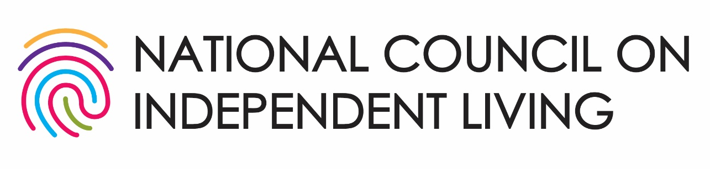

Legislative Priorities

118th Congress ·2024

NCIL’s mission is to advance the disability-led Independent Living Movement to expand the capacity of Independent Living Programs to enhance the human and civil rights of all people with disabilities.

Priority 1: Fund Centers for Independent Living 3
Priority 2: End the Institutional Bias 6
Pass the HCBS Access Act, HCBS Relief Act, and Better Care Better Jobs Act! 6
Priority 3: End Subminimum Wage 6
Pass the Transformation to Competitive Integrated Employment Act! 6
Priority 4: Freedom to Earn & Marry 7
Pass the SSI Savings Penalty Elimination Act! 7
NCIL Legislative Positions 8
»» Long Term Services and Supports 8
»» Healthcare 8
»» Disability and Disaster 9
»» Housing 9
»» Chronic Pain & Opioids 11
»» Employment and Social Security 13
»» Civil Rights 14
»» International Matters 15
118th Congress Legislative Victories! 15
FAA Reauthorization 15


If you have any questions about the issues discussed in this document, please reach out to NCIL’s Director of Advocacy and Public Policy, Jessica Podesva at jessica@ncil.org or 202-207-0334.

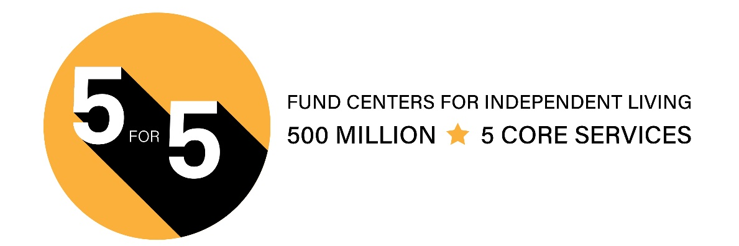
Priority 1: Fund Centers for Independent Living

Invest in Community Living & Independence for People with Disabilities

Centers for Independent Living (CILs) (Title VII, Rehabilitation Act, as amended) have been underfunded for decades, leading to individuals with disabilities lacking access to critical services and support!

Many areas in the U.S., especially in rural communities do not have access to a CIL. CILs need more funding in order to expand their service areas to address the unmet needs.

1,216,970 Services Provided

In 2020, CILs transitioned 3,915 individuals from institutional settings to the community. Based on information from the Kaiser Family Foundation, the average nursing home cost is $105,852 each year, compared to home and community-based supports, which average $31,100 per year. That equates to a savings of $292,654,080 annually, or a 231% return on investment.

712,223 Successful Outcomes

CILs provide a unique one-stop resource to people with disabilities. Most of our staff, board, and management are individuals with disabilities. This creates responsive, dynamic, and knowledgeable places for people to turn to.

In 2020, 66% of all staff of CILs were people with disabilities, employing 4,575 individuals with disabilities with 1,197 in management of their CIL.

Individuals with Disabilities Need Better Access to Comprehensive Independent Living Services

Funding CILs enables individuals with disabilities to live in their homes with their families where they can work, attend school, worship, and participate in other community activities. CILs are hubs of disability information, resources, services, and advocacy. CILs are vital to the whole community. It also creates tremendous savings for taxpayers.

What is Independent Living?

A movement, a philosophy, specific programs that provide tools, resources, and support for integrating people with disabilities fully into their communities to promote equal opportunities, self-determination, and respect. All people can: live with dignity, make their own choices, and participate fully in society.

Why Community Living?

- People prefer to live in their own homes.
- It is a legal right.
- It costs less.
- Everyone benefits when everyone can contribute.

Centers for Independent Living (CILs)

CILs are hubs of disability information, resources, services, and advocacy. CILs have a unique ability to creatively address barriers within their individual communities, allowing the CIL network to respond quickly and effectively in times of crisis and emergency. Investing in CILs benefits the entire community and yields a strong return for taxpayers. Federally funded CILs provide five core services:

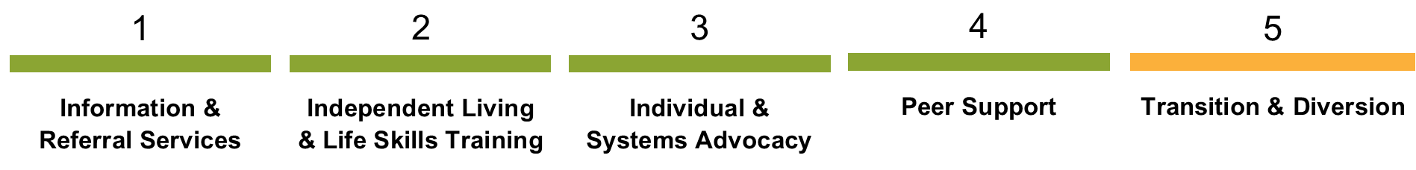

Statewide Independent Living Councils (SILCs)

Each state and U.S. territory is required to maintain a SILC. SILCs develop a three-year strategic plan that creates a unified vision for the state on how to address barriers to independent living and other issues impacting people with disabilities.

America is home to: 403 CILs · 330 Branch Offices · 56 SILCs

Department of Health and Human Services, Administration for Community Living (ACL)

The Office of Independent Living Programs (OILP) within ACL is tasked with overseeing Independent Living agencies on a national level.

Founding Document: Title VII, Rehabilitation Act of 1973, as amended

There are two types of CIL funding:

1. Subchapter B – Independent Living Services 2. Subchapter C – Centers for Independent Living

FIFTH CORE SERVICE: TRANSITION & DIVERSION IN ACTION!

Centers for Independent Living provide transition services that meet people with disabilities where they are and assist them during their journeys to achieve self-defined goals. These are their stories.


MIKE

Mike is a 53-year-old man with Spina Bifida. He is the youngest of 9 children, and unlike his siblings who pursued college and other avenues of independence, Mike was told he could neither work nor attend college due to his disability.

Living with his mother after his father's passing, Mike felt isolated and undervalued. Mike was introduced to his local Center for Independent Living (CIL) for help finding housing of his own. Within one month, Mike moved into his own accessible apartment in Buckhannon, West Virginia.

This move transformed his life. For the first time, he developed meaningful friendships with his neighbors, enjoying activities like movie nights and card games. With assistance, Mike now handles his own finances.


KENNY

Kenny is a young man who returned to his own home after an amputation had trapped him in a nursing facility. “I didn’t feel like I belonged there,” Kenny said about his time in the nursing facility. “I wanted to get out of there, but I didn’t know how I was going to live with my amputated leg. The CIL’s Peer Advocate told me about their struggles and what they did to deal with those challenges. It was helpful to tell them my story and brainstorm ideas of what I could do to feel more comfortable.”

Kenny reached out to the CIL at the beginning of 2023 and asked about becoming a Peer Advocate himself. The CIL encouraged him and believes that he will be an incredible help to others.


SHAYA

Shaya was living in a nursing facility for 3 years after a car accident resulted in a brain injury and mobility disability. After rehabilitation, she was told she could not be discharged since her apartment was not accessible. Her local CIL helped her secure an accessible apartment, in-home care, and assistive tools to help her live independently.

It has now been more than one year since Shaya’s transition to the community and she is still living in her own home. Her family is providing support and happy that she can go out with friends who she had not seen in years. Staff from her Center for Independent Living keep in touch with Shaya to make sure that she is still doing well and to offer assistance if needed to maintain her independence.

Priority 2: End the Institutional Bias


Pass the HCBS Access Act, HCBS Relief Act, and Better Care Better Jobs Act!
NCIL is committed to advocating to end the institutional bias and improve access to consumer-controlled home and community-based services for people with disabilities and older adults.

One of the core services of Centers for Independent Living is to help transition people from institutional settings, but many consumers struggle to obtain all the Home and Community-Based Services (HCBS) they need.

People with disabilities who are eligible for Medicaid long-term services and supports (LTSS) and require assistance with their activities of daily living (bathing, dressing, eating, etc.) currently have immediate access to institutional settings such as nursing homes. But if they want to remain in their homes with the help of Medicaid Home and Community-Based Services, they are often put on waiting lists and can wait years or even decades for services and supports to live independently in their community.

Currently, the HCBS Access Act (H.R. 1493 and S. 762), the HCBS Relief Act (H.R. 6296 and S. 3118) the and Better Care Better Jobs Act (H.R. 547 and S. 100) are three critical pieces of legislation that will help end this institutional bias and make substantial improvements to the home and community-based services work force.

- Read more about the HCBS Access Act: https://bit.ly/3CRGn6l
- Read more about the HCBS Relief Act: https://bit.ly/3zbIao1
- Read more about the Better Care Better Jobs Act: https://bit.ly/43JcsZP

Priority 3: End Subminimum Wage

Pass the Transformation to Competitive Integrated Employment Act!
Currently, under section 14(c) of the Fair Labor Standards Act of 1938, it is legal for employers to pay disabled people subminimum wages based on their disability status.

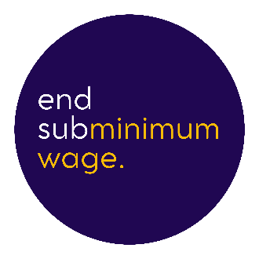
NCIL believes that disabled people deserve fair pay for their work and the practice of paying people with disabilities subminimum wage needs to end with no exceptions.

The Independent Living movement has long opposed the use of 14(c) certificates and has advocated for the advancement of competitive integrated employment opportunities.

The Transformation to Competitive Integrated Employment Act or TCIEA (H.R. 1263 and S. 533) would phase out existing 14(c) certificates over a five-year period, prohibit new certificates from being issued and provide grant funding to support businesses transitioning their business model to one of competitive and integrated employment.

TCIEA also provides a framework states can use to support people whose employers do not choose to transition their business model to competitive integrated employment.

- Read more about the Transformation to Competitive Integrated Employment Act: https://bit.ly/4eAnpm8

Priority 4: Freedom to Earn & Marry


Pass the SSI Savings Penalty Elimination Act!
The Supplemental Security Income (SSI) program provides a monthly financial benefit to qualified people with disabilities. Currently, to qualify and remain eligible for the SSI program, disabled people cannot have resources more than $2,000 for an individual and $3,000 for a married couple.

These asset limits pose a significant barrier to independence for many people with disabilities, preventing them from engaging in work or getting married, since the allowable combined asset limit is less than the allowable amount that they would be able to hold if they were unmarried.

These asset limits have not changed since 1984 and have not been adjusted to account for inflation or any other economic conditions. With the significant increases in inflation and cost of living, it is crucial that these asset limits are raised and annually adjusted to reflect inflation and economic conditions.

The SSI Savings Penalty Elimination Act (H.R. 5408 and S. 2767) would increase the asset limits to $10,000 for individuals and $20,000 for married couples as well as set both limits to annually adjust for inflation.

This is an especially crucial piece to addressing the country’s housing crisis.

NCIL Legislative Positions

»» Long Term Services and Supports

Latonya Reeves Freedom Act: H.R. 2708 / S. 1193

✔ Position: Support

This bill would prohibit discrimination against individuals with disabilities who need long-term services and supports.

The Long-Term Care Workforce Support Act: S. 4120

✔ Position: Support

This bill will increase the number of direct care professionals, including in rural communities and provide pathways to enter and be supported in the workforce for women, people of color, and disabled people. It will also improve the compensation of direct care workers and improve the quality of long-term care.

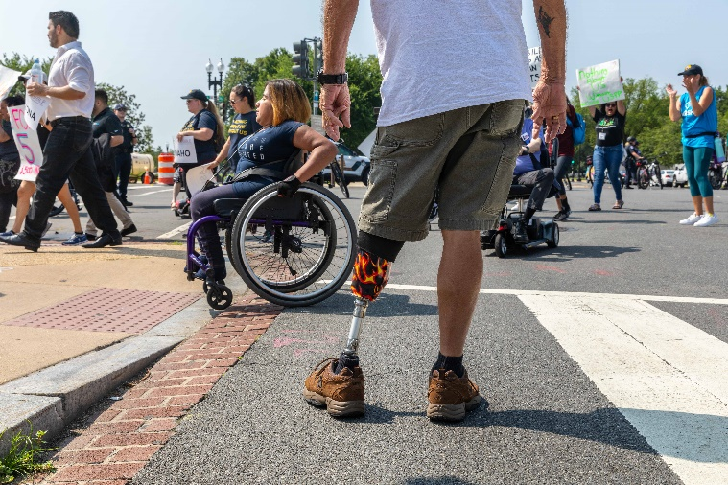
»» Healthcare

No Patient Left Alone Act: H.R. 219

✔ Position: Support

This bill requires hospitals, as a condition of Medicare participation, to have certain written policies and procedures that provide for patient visitation rights and to inform patients of such rights, including any applicable restrictions.

Protecting Health Care for All Patients Act: H.R. 485

✔ Position: Support

This bill prohibits all federal healthcare programs, including the Federal Employees Health Benefits Program and federally-funded state healthcare programs (such as Medicaid) from using prices that are based on quality-adjusted life years (measures that discount the value of a life based on disability) to determine relevant thresholds for coverage, reimbursements, or incentive programs.

Status Update: The House passed this bill and the Senate referred it to the Committee on Finance in February 2024.

House Concurrent Resolution 109: Expressing the sense of the Congress that assisted suicide (sometimes referred to using other terms) puts everyone, including those most vulnerable, at risk of deadly harm

✔ Position: Support

This resolution states that the federal government should not adopt or endorse policies or practices that support, encourage, or facilitate suicide or assisted suicide.

National Concussion and Traumatic Brain Injury Clearinghouse: H.R. 3083

🈩 Position: Support with concerns

This bill establishes and requires the Secretary of Health and Human Services to create and maintain a clearinghouse of concussion and traumatic brain injury best practices, medical knowledge, appropriate certification, and research to be known as the National Concussion and Traumatic Brain Injury Clearinghouse. NCIL supports this bill in substance. However, we are concerned that there are not additional appropriations included to support the work outlined in the bill.

»» Disability and Disaster

Real Emergency Access for Aging and Disability Inclusion (REAADI) for Disasters Act: H.R. 2371 / S. 1049

✔ Position: Support

REAADI provides opportunities for people with disabilities, older adults, and disability-led organizations to provide guidance, technical assistance, and training for disaster preparedness, recovery, and response at local, regional, and national levels. REAADI also includes mechanisms to review and ensure all federal funds spent in disasters comply with accessibility and civil rights laws.

»» Housing

Visitable Inclusive Tax Credits for Accessible Living (VITAL) Act: H.R. 3963 / S. 1377

✔ Position: Support

This bill increases the low-income housing tax credit to serve the housing needs of older people and people with disabilities. Specifically, the bill increases state allocations and credit amounts for projects for assisting households with disabled individuals.

The bill requires each state housing finance agency to establish and operate a Resource Center for the Low-Income Housing Tax Credit Program to support new program applicants and recipients. It also establishes a National Low-Income Housing Tax Credit Advisory Council to provide best practice recommendations to state housing finance agencies and other entities relating to affordable housing trends.

Affordable Housing Credit Improvement Act: H.R. 3238 / S. 1557

✔ Position: Support

This bill would reform the tax credit to provide additional incentives to developers to build homes affordable to the extremely low-income households who are most impacted by the housing crisis, as well as underserved rural and Native American communities.

Housing Fairness Act: H.R. 68

✔ Position: Support

This bill expands efforts to detect and address housing discrimination. It requires that the Department of Housing and Urban Development (HUD) conduct a nationwide testing program to (1) detect and document differences in the treatment of prospective renters, homebuyers, or mortgage borrowers; (2) measure patterns of adverse treatment because of the race, color, religion, sex, familial status, disability status, or national origin of a renter, homebuyer, or borrower; and (3) measure the prevalence of such discriminatory practices across housing and mortgage lending markets. The bill also reauthorizes the Fair Housing Incentives Program through FY2027 and requires HUD to implement a grant program to assist public and private nonprofit organizations.

The Universal Design Tax Incentive Act: H.R. 8547

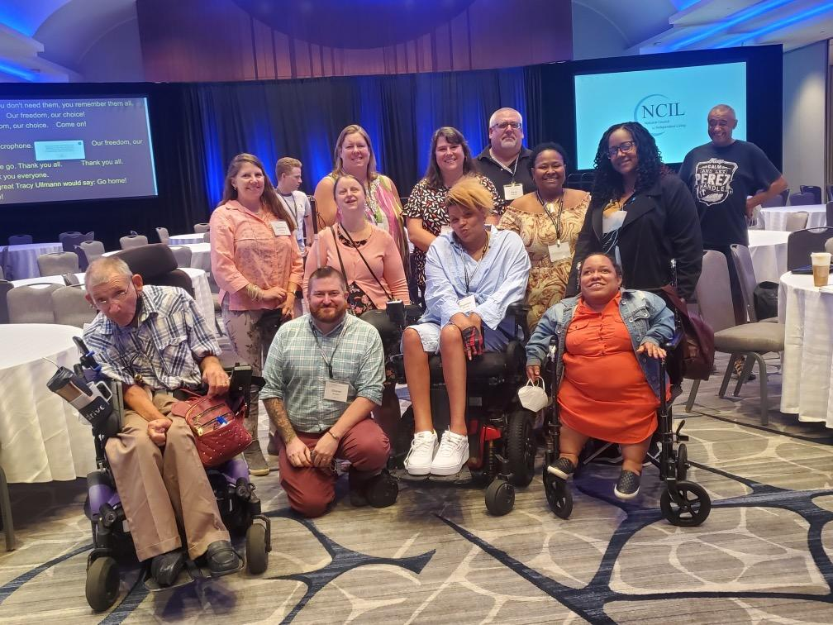
✔ Position: Support

This bill establishes a tax credit for certain costs during the construction or renovation of residential and commercial buildings that are certified by the Department of Housing and Urban Development (HUD) as satisfying Universal Design Standards. It also creates a federal working group of stakeholders including Centers for Independent Living to establish universal design standards.

Dignity in Housing Act of 2023: H.R. 2842

✔ Position: Support

This bill amends the United States Housing Act of 1937 to require the Secretary of Housing and Urban Development (HUD) to make inspections of each public housing project consisting of 100 dwelling units or more every two years at minimum to determine whether the project is, and units in the project are, maintained in accordance with the requirements of this Act. It also directs the Secretary to make the results available to the public and authorizes the Secretary to require HUD to inspect certain public housing developments and ensure compliance with quality and safety standards.

»» Chronic Pain & Opioids

Patients and Communities Reauthorization Act: H.R. 4531 / S. 3393

🈩 Position: Support in part, oppose in part

This reauthorization bill contains several pieces of legislation, which are represented as sections of H.R. 4531 in the House and S. 3393 in the Senate.

✘ Oppose: Section 116 of the Senate bill, also known as the FREED of Opioids Act (S. 2737)

✘ Oppose: Section 115 of the Senate bill, also known as A bill to require the Secretary of Health and Human Services to prepare a report that outlines a plan for completing a review of approved opioid analgesic drugs that considers the public health effects of such opioid drug (S. 3557)
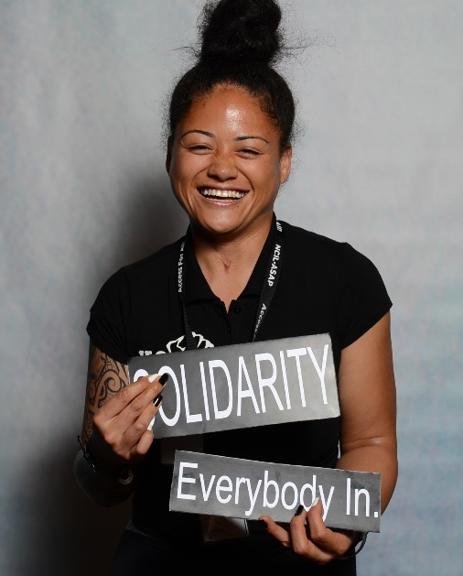
These sections would require the FDA to reconsider approval for existing medications on the market. Some of our members have led stable and successful lives taking one specific medication for many years. After numerous studies showing serious harm from destabilizing long-term opioid therapy, we are gravely concerned that passage of this bill would result in harm to people who rely on these medications.

In April 2023, an FDA panel met to advise on a research methodology known as enriched enrollment randomized withdrawal (EERW) in drug trials. Since opioid medications have risks and benefits for different subgroups, we believe it is unwarranted to outmode a research methodology that has shown benefit, when studies have found it does not appear inferior to other methodologies.

✔ Support: Section 399V-8 of the Senate bill, also known as Advancing Research for Chronic Pain Act (H.R. 7164)

This section amends title XVIII (Medicare) of the Social Security Act (SSA) to require the Secretary of Health and Human Services (HHS), acting through the Director of the Centers for Disease Control and Prevention (CDC) and the National Institutes of Health (NIH), and the heads of other agencies as appropriate, to: 1) identify gaps in the available research data and collect de-identified population research data using medical claims and survey data to fill gaps in available data, such as information concerning chronic pain, utilization of medical and social services by patients with chronic pain conditions, the direct healthcare costs of pain treatment, both traditional and alternative, and the indirect costs (such as missed work, public and private disability, and reduction in productivity); and 2) develop, in collaboration with individuals and organizations with appropriate chronic pain expertise, standard definitions and approaches for population research on chronic pain to efficiently promote greater comparability of data. It also directs the Secretary to develop standard definitions, approaches, and risk factors that may be associated with such conditions, including genetic and environmental risk factors and other information, as appropriate.

✘ Oppose: Section 120 of the house bill, also known as the Remote Opioid Monitoring Act (H.R. 4093)

We are concerned that this section contains no mention of individualized risk assessment or consent, despite potential to significantly infringe on liberty and privacy. Those of us in pain treatment already undergo monthly urine drug screens, psychological screening, pill counts, prior authorizations, behavior contracts, and pharmacy lock-ins. Adding even more surveillance to the 8-10 million Americans with long-term opioid prescriptions would risk increasing the stigma we already face, and is unlikely to improve an overdose crisis overwhelmingly driven by the illicit and counterfeit drug market.

Budgeting for Opioid Addiction Treatment (LifeBOAT) Act (S. 2559) and Safe Disposal of Opioids Act (H.R. 5615)

✘ Position: Oppose

Given the complexities of insurance coverage and prior authorization, we believe funding addiction treatment with a per-milligram tax on opioid medication would disproportionately burden vulnerable patients with pain. Administrative hurdles and pharmacy delays may leave patients vulnerable to the illicit counterfeit drug market, worsening the crisis this bill seeks to address.

Protecting Americans from Dangerous Opioids Act: S. 606

✘ Position: Oppose

This bill would require the FDA to remove existing medications from the market. Some of our members have led stable and successful lives taking one specific medication for many years. We are seriously concerned for these individuals’ well-being if the FDA were to ban their treatment plan solely because federal law requires fewer medication formulations in the analgesic category.

Block, Report, and Suspend Suspicious Shipments Act: H.R. 501

🈩 Position: Amendment needed

This bill would flag suspicious pharmacy orders. However, it does not clearly define what constitutes a “suspicious order.” If a suspicious order is blocked in error, patients could suffer immediate harm from lack of access to necessary medication.

Improving Medicaid Programs’ Response to Overdose Victims and Enhancing (IMPROVE) Addiction Care Act: H.R. 4950 / S. 2481

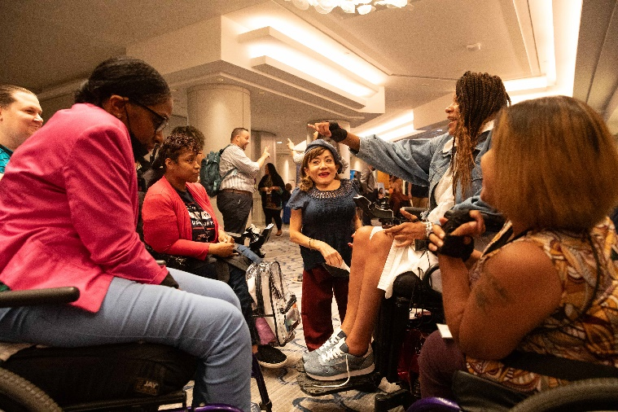
✘ Position: Oppose

The IMPROVE Addiction Care Act resembles the California Medical Board’s Death Certificate Project, which was redesigned and scaled back after reports of unintended harm to patients. Before rolling out a similar policy nationally, Congress should track outcomes from the revised project in California.

Alternatives to PAIN Act: H.R. 7142

✘ Position: Support

This bill would expand coverage of non-opioid treatment options. NCIL supports the expansion of efforts to expand coverage of non-opioid treatment options, so long as they do not create unnecessary barriers where opioid prescribing is appropriate. NCIL applauds the inclusion of language in this bill that states “Some individuals require opioids to manage their condition including for chronic pain and palliative care.”

»» Employment and Social Security

SSA Claims Processing Improvement Act: H.R. 8546

✔ Position: Support

This bill requires the Social Security Administration (SSA) to update an ongoing national training program for field office staff and processors who review claims by those receiving Disability Insurance and Supplemental Security and establish a formal process to annually analyze training needs based on identified processing error trends. Additionally, this legislation requires SSA to improve customer service standards and ensure that all services at the SSA, including appeals of covered benefit denials, are in a format that is appropriate for the specific needs of individuals with disabilities, such as audio versions of notifications, and large print and braille options. Finally, the bill amends the Social Security Act to provide for certain technology modernizations and ensure that all decisions to terminate Disability Insurance are reviewed by an additional claims’ processor.

Social Security Fairness Act: H.R. 82 / S. 159

✔ Position: Support

This bill repeals provisions that reduce Social Security benefits for individuals who receive other benefits, such as a pension from a state or local government.
The bill eliminates the government pension offset, which in various instances reduces Social Security benefits for spouses, widows, and widowers who also receive government pensions of their own.

The bill also eliminates the windfall elimination provision, which in some instances reduces Social Security benefits for individuals who also receive a pension or disability benefit from an employer that did not withhold Social Security taxes.

These changes are effective for benefits payable after December 2023. It has been assigned to Senate Finance Committee.

»» Civil Rights

Access Act: H.R. 241

✘ Position: Oppose

NCIL opposes this legislation as it imposes unnecessary burdens on disabled people.

Same Day Registration Act: H.R. 239


✔ Position: Support

This bill allows for same day voter registration for all people and removes barriers faced by people with disabilities when registering to vote.

Guardianship Bill of Rights Act: S. 1148

✔ Position: Support

NCIL opposes guardianship. This bill establishes rights for people who are at risk of guardianship and for people who are in guardianships, conservatorships, or other arrangements. It also establishes a national council focused on preventing guardianship and elevating less restrictive arrangements.

Keeping All Students Safe Act: H.R. 3470 / S. 1750

✔ Position: Support

This bill would prohibit and prevent seclusion, mechanical restraint, chemical restraint, and dangerous restraints that restrict breathing. It would prevent and reduce the use of physical restraint in schools.

»» International Matters

International Children with Disabilities Protection Act: H.R. 5847 / S. 847

✔ Position: Support

The International Children with Disabilities Act creates a small new grants program within the Department of State to support and empower disability activists to press for reform in their societies – and to ensure that no family is forced to give up a child to an orphanage on the basis of disability. The legislation also creates a $2,000,000 global training program to expose policymakers, professionals, and activists to effective ways to protect families and avoid new institutionalization.

118th Congress Legislative Victories!

FAA Reauthorization
NCIL applauds the passage of the Federal Aviation Administration Reauthorization Act. This bill will improve flying safety, expand the aviation workforce and strengthen consumer protections for travelers with disabilities. This bill:

- Creates a new Airport Accessibility Grant Program.
- Requires domestic and foreign air carriers to:
  - publish information related to power wheelchairs, including the dimensions of aircraft cargo holds;
  - issue refunds if a passenger cannot fly due to the wheelchair no longer fitting in the cargo hold; and
  - evaluate frequency and types of mishandling of mobility aids and take actions to make in-flight wheelchair seating available.
- Requires the Department of Transportation (DOT) to publish an annual report on how quickly, effectively, and efficiently consumer complaints related to traveling with a disability are received, addressed, and resolved by DOT.
- Requires regulations regarding seating accommodations for disabled passengers and the establishment of an optional Known Service Animal Pilot Program.
- Creates requirements for web accessibility.
- Requires airlines to provide information online regarding the rights and responsibilities of both airlines and passengers about the availability of on-board wheelchairs.

PO Box 31260
Washington, DC 20030

web: www.ncil.org
email: ncil@ncil.org
voice: 202.207.0334

