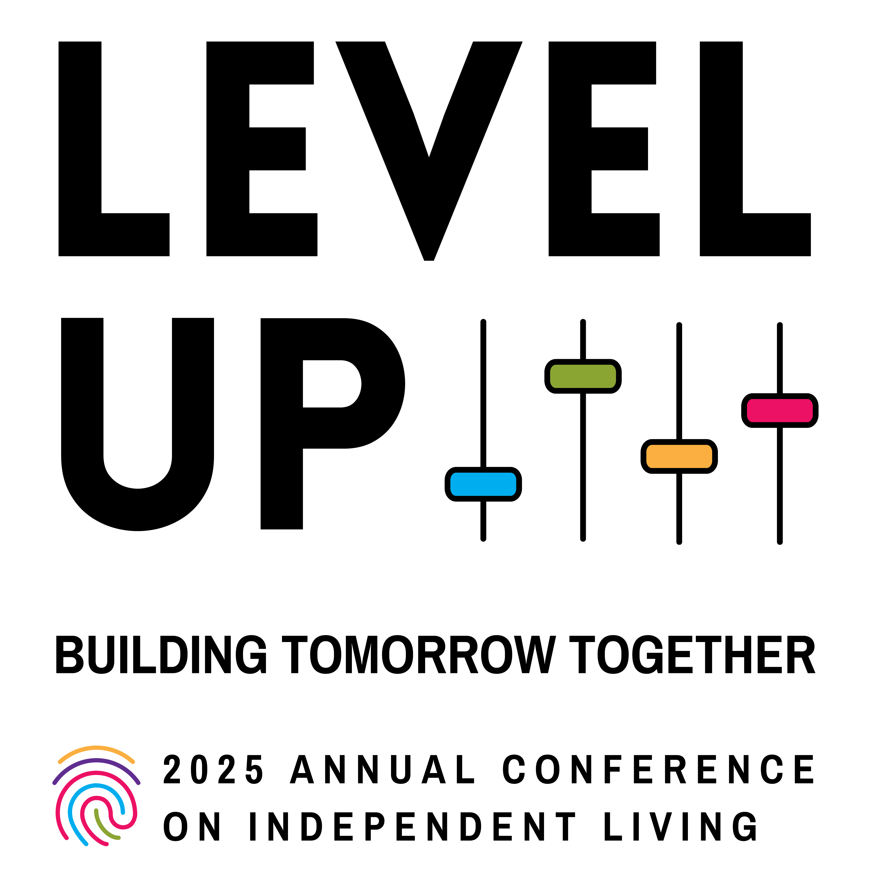

Presented by the National Council on Independent Living

Table of Contents

Table of Contents 2
Hill Report Form 3
A Message from the Executive Director 3
Agenda At a Glance 5
Full Schedule of Events 8
About Workshop Sessions 19
Speakers 48
Annual Council Meeting Agenda 52
Map of Independence Level (5B) 54
Restrooms 55
Health & Safety Protocols 55
Onsite Registration 55
NCIL Regions by State 56
Do-It-Yourself Sign Kits 58
What to Bring 59
Access, Accommodations, & Resources 59
Advocate’s Guide to the Hill 62
Sponsors 71

Hill Report Form

After your Hill Visits, submit your Hill Report Form at ncil.org/report

A Message from the Executive Director

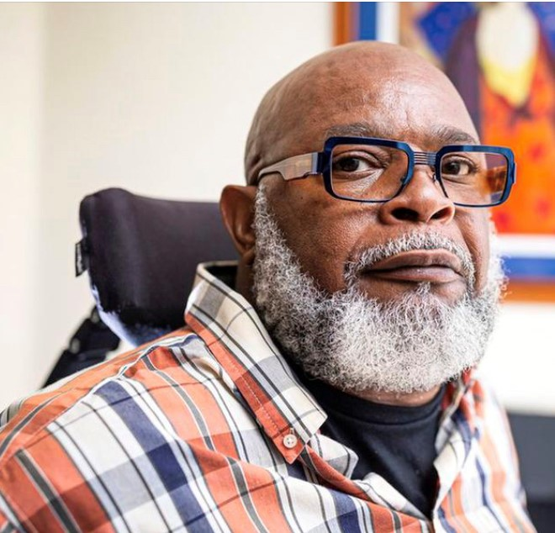
NCIL’s 2025 conference theme, Level Up: Building Tomorrow Together, perfectly aligns with the spirit of the quote, “You are not obligated to complete the work, but neither are you free to abandon it.” This year’s theme emphasizes that creating a more inclusive, accessible, and equitable world requires collective action and a commitment to continuous progress.

“You are not obligated to complete the work” acknowledges that no single person can do everything. This aligns with Level Up — the idea that while we each have limits, we can always grow, improve, and contribute. Progress is not about perfection but about striving for better together.

NCIL encourages every advocate, ally, and leader to bring their unique skills and energy to the movement, knowing that the collective effort will amplify individual contributions.

“Neither are you free to abandon it” reminds us of our personal responsibility, our obligation to take action. Even though we cannot do it all, our participation is crucial. This aligns with Building Tomorrow Together — which highlights the shared responsibility within the Independent Living movement.

It emphasizes that while systemic change may feel overwhelming, every action — large or small — moves us closer to a better future. Each contribution, whether through advocacy, education, or support, helps lay the foundation for tomorrow.

Together NCIL’s theme and this quote are our Call to Action. It is a powerful reminder that advancing disability rights, justice, and Independent Living requires both individual dedication and collective effort.

Together, we can level up our skills, partnerships, and impact, knowing that while the work may never be fully complete, our contributions today are vital steps toward building the better tomorrow we envision.

I would also like to extend our sincerest thanks to our conference sponsors: Centene; Airbnb; Waymo; CIL Suite; and Microsoft.

Theo Braddy

Executive Director Use our hashtag!

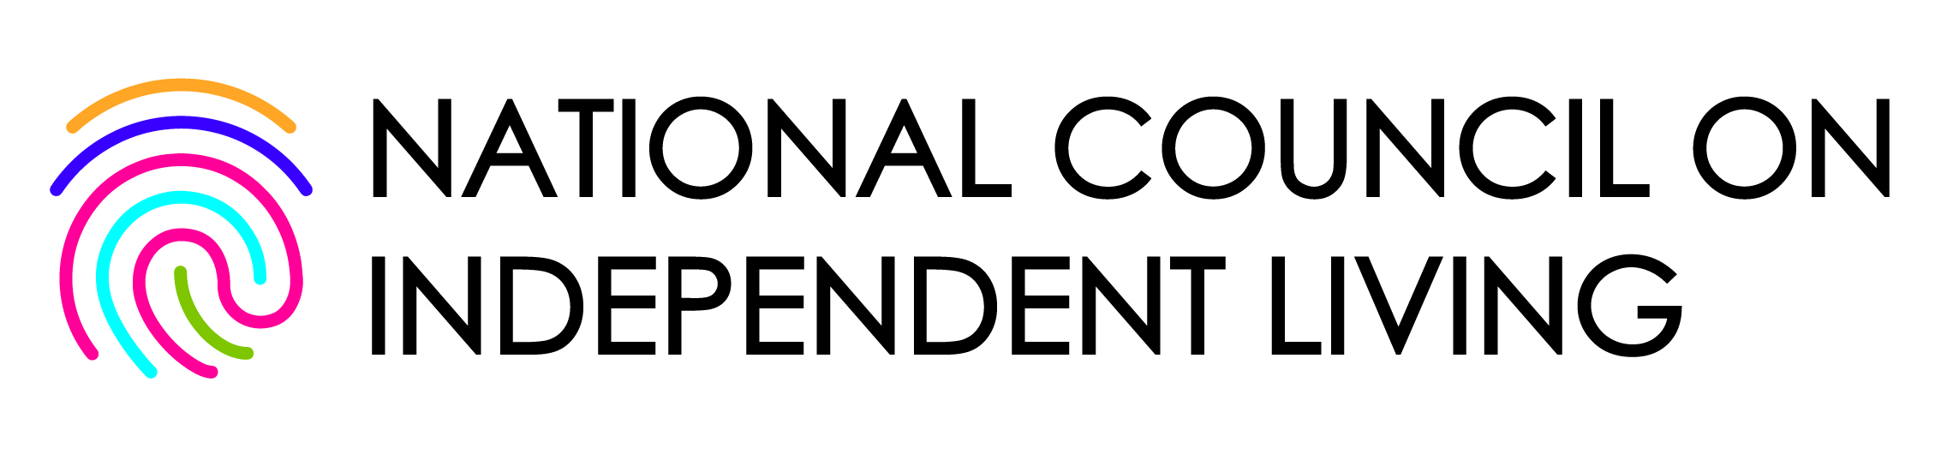
#NCIL2025

Agenda At a Glance

Monday, July 21, 2025

- 8:00 a.m. – 12:30 p.m.: Registration + Exhibits Open (Independence Foyer)
- 9:00 – 10:00 a.m.: Opening Plenary (Independence A)
- 10:15 – 11:30 a.m.: Advocacy Updates (Independence A)
- 11:30 a.m. – 12:30 p.m.: Day on the Hill Prep + Regional Caucuses (Independence A)
- 12:30 – 2:00 p.m. Lunch (on your own)
- 2:15 – 2:45 p.m.: March Assembly (11th + G Streets NW)
- 3:00 – 4:00 p.m.: March to the Capitol
- 4:00 – 5:00 p.m.: Rally at the Capitol (U.S. Capitol)

Tuesday, July 22, 2025

- 8:00 a.m. – 5:00 p.m.: Registration + Exhibits Open (Independence Foyer)
- 9:00 – 10:00 a.m.: AI for Access: Expanding Possibilities (Independence Ballroom)
- 10:00 – 11:30 a.m.: Exhibit Fair + Coffee Break Sponsored by Airbnb! (Independence Foyer)
- 11:45 a.m. – 1:00 p.m.: Awards Luncheon (Independence Ballroom)
- 1:45 – 2:30 p.m.: Annual Council Meeting (Independence Ballroom)
- 2:30 – 3:45 p.m.: Concurrent Workshops 1 (Various locations)
- 4:00 – 5:15 p.m.: Concurrent Workshops 2 (Various locations)
- 8:00 – 9:00 p.m.: ADA35: Social Hour (Independence Ballroom)
- 9:00 – 11:00 p.m.: ADA35: Celebration of Community (Independence Ballroom)

Wednesday, July 23, 2025

- 8:00 a.m. – 12:00 p.m.: Registration + Exhibits Open (Independence Foyer)
- 9:00 – 10:15 a.m.: Concurrent Workshops 3 (Various locations)
- 10:30 – 11:45 a.m.: Concurrent Workshops 4 (Various locations)
- 12:00 p.m.: Lunch (on your own)
- 12:30 p.m.: Hill Visits (U.S. Capitol)
- 3:30 – 5:30 p.m.: Professional Headshots (Location: Independence Level)

Thursday, July 24, 2025

- 8:00 a.m. – 12:00 p.m.: Registration Open (Independence Foyer)
- 9:00 – 10:15 a.m.: Concurrent Workshops 5 (Various locations)
- 10:30 – 11:45 a.m.: Concurrent Workshops 6 (Various locations)
- 11:45 a.m. – 1:00 p.m.: Lunch (on your own)
- 1:00 – 2:00 p.m.: Welcome to the IL Party! (Independence A)
- 2:00 – 3:00 p.m.: Closing Plenary + Legislative Debriefing (Independence A)

Full Schedule of Events

SUNDAY, July 20, 2025

Registration Open

3:00 – 6:00 p.m. / Independence Foyer

Board Meeting

1:00 – 5:00 p.m. / Lafayette + Farragut

Board meetings are open to the public but not part of the formal conference agenda.

MONDAY, July 21, 2025

Registration + Exhibits Open

8:00 a.m. – 12:30 p.m. / Independence Foyer

Sensory Retreat / Quiet Space

8:00 a.m. – 12:30 p.m. / Washington Boardroom

Dialogue Zone

8:00 a.m. – 11:00 a.m. / McPherson + Franklin

Opening Plenary

9:00 – 10:00 a.m. / Independence A

The 2025 Opening Plenary will be given by Keri Gray, a dynamic entrepreneur, facilitator, cancer survivor, and a passionate advocate for racial and disability justice. Don’t miss this exciting conference opener! Read more about Keri Gray on Page 48.

Advocacy Updates

10:15 – 11:30 a.m. / Independence A

Hear directly from members of NCIL’s Advocacy and Public Policy Committee about the latest progress in NCIL’s advocacy work. This panel will provide a focused discussion on key priorities for upcoming Hill visits and explore effective strategies for grassroots advocacy in today’s fast-changing policy environment.

Day on the Hill Prep + Regional Caucuses

11:30 a.m. – 12:30 p.m. / Independence A

This is an opportunity for attendees to meet with their Regional Representatives and strategize for their Capitol Hill Visits. Each state decides who will attend which meeting to ensure that every legislator is visited. A list of Regions by state is available at ncil.org/regions.

Lunch (on your own)

12:30 – 2:00 p.m.

The March & Rally can be physically and emotionally taxing. We encourage you to take advantage of this lunch break to eat something.

March Assembly

2:15 – 2:45 p.m. / 11th + G Streets NW

Participants should assemble between 2:15 p.m. – 2:45 p.m. at G and 11th Streets, NW. The March will begin promptly at 3:00 p.m.

March to the Capitol

3:00 – 4:00 p.m. / Washington DC

NCIL conference attendees, members, and allies march from the Grand Hyatt to Capitol Hill. Complimentary Do-It-Yourself Sign Kits will be available on the conference floor the morning of Monday, July 21. Read more about Do-It-/Yourself Sign kits and potential message ideas on Page 58.

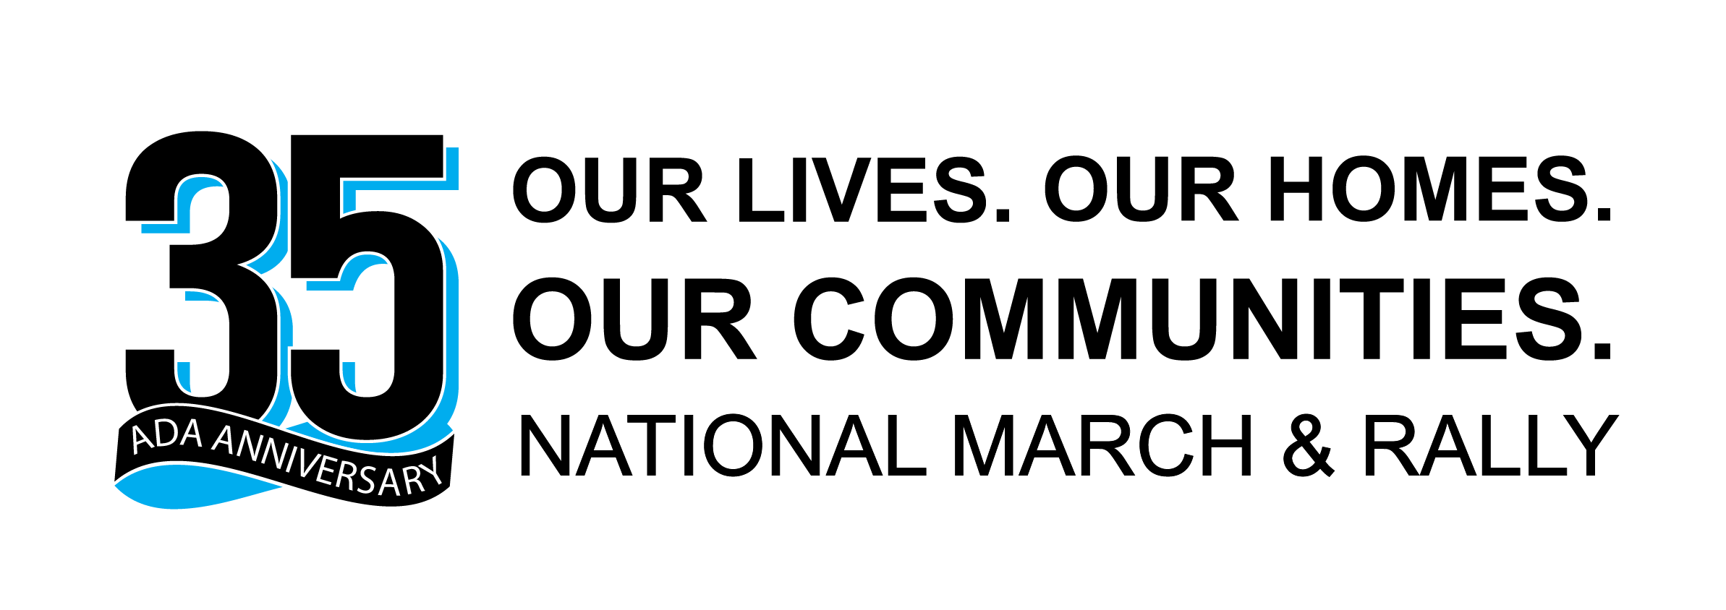

Rally at the Capitol

4:00 – 5:00 p.m. / U.S. Capitol

Marchers will converge at the U.S. Capitol for an empowering rally featuring a number of speakers, including leaders in the Independent Living Movement and elected officials working on the issues we care about most.

TUESDAY, July 22, 2025

Registration + Exhibits Open

8:00 a.m. – 5:00 p.m. / Independence Foyer

Sensory Retreat / Quiet Space

8:00 a.m. – 5:00 p.m. / Washington Boardroom
8:00 p.m. – 11:00 p.m. / McPherson + Franklin

Dialogue Zone

None

AI for Access: Expanding Possibilities Through Innovation

9:00 – 10:00 a.m. / Independence Ballroom

Join us for a dynamic and timely panel led by Dr. Victor Pineda, a global leader in disability rights and inclusive innovation. This engaging conversation will explore the evolving landscape of artificial intelligence (AI) and its profound implications for the disability community. Featuring thought leaders from the U.S. Access Board, adaptive technology users, and corporate innovators, the panel will examine how AI is transforming assistive technology, enhancing workplace accessibility, and reshaping the future of independent living. Together, we’ll unpack the opportunities and challenges of integrating AI into our daily lives and advocacy efforts — empowering communities to shape the future of inclusion. Read more about Victor Pineda on Page 50.

Exhibit Fair + Coffee Break

10:00 – 11:30 a.m. / Independence Foyer


Spend some time browsing the products and services offered by our exhibitors, many of which are your fellow NCIL members. The NCIL Conference would not be possible without the generous support of our exhibitors and sponsors. Exhibits will be open all day Monday and Tuesday. Coffee Break sponsored by Airbnb!

Awards Luncheon

11:45 a.m. – 1:00 p.m. / Independence Ballroom

Join us to celebrate and honor this year’s national award winners! Awards will be presented over lunch after a keynote address by Kely Cat-Wells. Admission to this event is included in full conference registration. Read more about Keely Cat-Wells on Page 51.

Annual Council Meeting

1:45 – 2:30 p.m. / Independence Ballroom

Attend the Annual Council Meeting to hear the results of the elections for Governing Board members. This year, elections were held prior to the conference for: President; Treasurer; 3 Member At-Large positions; and Representatives of Regions 1, 3, 5, 6, 7, and 9.

Concurrent Workshops 1

2:30 – 3:45 p.m. / Various locations

See Concurrent Workshops 1, Page 20.

Concurrent Workshops 2

4:00 – 5:15 p.m. / Various locations

See Concurrent Workshops 2, Page 24.

ADA35: Social Hour

8:00 – 9:00 p.m. / Independence Ballroom

Join NCIL Staff, Board Members, and fellow attendees for this hour of networking, food, and drinks. Light snacks and non-alcoholic beverages will be available, accompanied by a cash bar.

ADA35: Celebration of Community
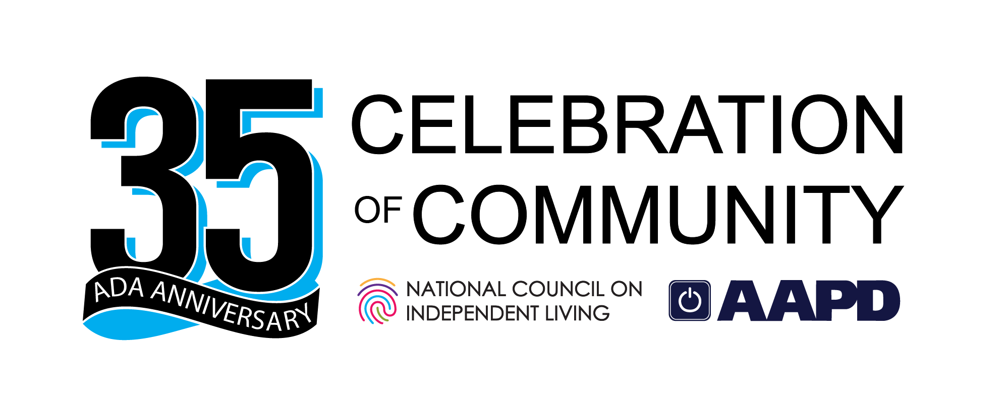
9:00 – 11:00 p.m. / Independence Ballroom

This year, NCIL will host a ticketed event as we celebrate the power of community on the 35th Anniversary of the Americans with Disabilities Act. A ticket to this event is included with full conference registration.

WEDNESDAY, July 23, 2025

Registration + Exhibits Open

8:00 a.m. – 12:00 p.m. / Independence Foyer

Sensory Retreat / Quiet Space

8:00 a.m. – 12:00 p.m. / McPherson

Dialogue Zone

8:00 a.m. – 12:00 p.m. / Franklin

Concurrent Workshops 3

9:00 – 10:15 a.m. / Various locations

See Concurrent Workshops 3, Page 27.

Concurrent Workshops 4

10:30 – 11:45 a.m. / Various locations

See Concurrent Workshops 4, Page 33.

Lunch (on your own)

12:00 p.m.

Grab a bite to eat before heading to meet with your elected officials.

Hill Visits

12:30 p.m. / U.S. Capitol

NCIL members are strongly encouraged to go and meet with their elected officials (or set up virtual meetings where necessary) to discuss pressing issues impacting people with disabilities and Independent Living nationwide. Read more about Hill Visits on Page 63.

Professional Headshots

3:30 – 5:30 p.m. / Location: Independence Level

For two hours, you will have the opportunity to have your headshot taken with NCIL’s professional photographer, Andrew Robertson. Sessions are expected to take approximately 5 minutes per person. Registration is not required, but please do your best to arrive at or before 5:00 to accommodate any wait time. The event will end promptly at 5:30. Donations are appreciated and will be split 50/50 between NCIL and the photographer. Photos will be available for download shortly after the conference concludes. Please note that by participating in this event, you agree to allow NCIL to use the photos taken on NCIL’s website and other marketing materials.

THURSDAY, July 24, 2025

Registration Open

8:00 a.m. – 12:00 p.m. / Independence Foyer

Sensory Retreat / Quiet Space

8:00 a.m. – 5:00 p.m. / McPherson

Dialogue Zone

8:00 a.m. – 6:45 p.m. / Franklin

Concurrent Workshops 5

9:00 – 10:15 a.m. / Various locations

See Concurrent Workshops 5, Page 39.

Concurrent Workshops 6

10:30 – 11:45 a.m. / Various locations

See Concurrent Workshops 6, Page 43.

Lunch (on your own)

11:45 a.m. – 1:00 p.m.

Welcome to the IL Party!

1:00 – 2:00 p.m. / Independence A

Join us for an interactive experience designed to strengthen our Centers for Independent Living through equal access and full participation — not by identity, but by right and capability. Using our four “party zones” — Invite, Venue, Dance Floor, and DJ Booth — this session empowers you to see who is invited, spot barriers, recognize what enables full participation, and ensure everyone helps shape how we party together. By reflecting, sharing experiences, and making personal pledges, we’ll collaborate to make our CIL truly welcoming — for all.

Closing Plenary + Legislative Debriefing

2:00 – 3:00 p.m. / Independence A

Wrap up a fantastic week of learning, advocating, and networking at NCIL’s Closing Plenary and Legislative Debriefing! This year, our Closing Plenary keynote speaker will be Ly Xīnzhèn M. Zhǎngsūn Brown, an internationally recognized advocate, community organizer, community builder, and scholar-activist. Read more about Ly Xīnzhèn M. Zhǎngsūn on Page 49.

Board Meeting

3:00 – 5:30 p.m. / Lafayette + Farragut

Board meetings are open to the public but not part of the formal conference agenda.

About Workshop Sessions

Workshop Classifications

Workshops are classified by target audience: frontline staff & consumers, advocates & project directors, or executive directors & board members. Workshops are also classified as newcomer, experienced, or appropriate for all knowledge levels.

Workshop Tracks

- Emerging Leaders Track: Workshops given by and for emerging leaders in Independent Living. How we can learn from emerging leaders and help develop Independent Living leadership.
- Innovations and Technology Track: Workshops that explore innovative new ideas, strategies, technologies and inventions that work to advance Independent Living philosophy and practice.
- Transformation through Collaboration Track: Workshops looking into diversifying partnerships, growing relationships, and opening funding opportunities.
- Level Up Your Advocacy Track: Workshops addressing advocacy topics and strategies. How we can advance and grow the Independent Living movement through consumer-driven advocacy.
- How To: Make It Happen Track: Workshops that describe challenges and the tactics and solutions presenters used to overcome them. Best practices for newcomers and those wishing to level up their organization’s provision of core services while maintaining Independent Living values.

Concurrent Workshops 1: Tuesday, July 22; 2:30 - 3:45 p.m.
1

1.1 Developing an IL-Led Funding Formulary

Independence Ballroom
Innovations and Technology Track
Target audience: Appropriate for all audiences. Knowledge level: experienced.

This workshop will focus on the work done in the state of Wisconsin to develop an equitable funding formulary for IL services. This effort was led by the Coalition of Independent Living Centers, and engaged Independent Living Center (ILC), Designated State Unit (DSU) and Statewide Independent Living Council (SILC) members in the development of a comprehensive formula. Presenters will share their new formula and discuss how and why they determined their criteria.

Presenter

Jason Glozier is the Executive Director for the Wisconsin Coalition of Independent Living Centers. Jason has been involved in disability rights and justice work for the better part of his 40 years and brings a wealth of knowledge from grassroots organizing to policy and program development.

Jason Beloungy has been the Executive Director of Access to Independence, the CIL in Madison, Wisconsin, since 2019, after having served as Assistant Director since 2010. Before his tenure with Access to Independence, Jason was a Policy Analyst for NCIL in Washington, D.C. Jason got his start in the Independent Living movement in 2004 as an IL Specialist. Additionally, Jason served 5 years as Chair of the Board of Directors for the WI Coalition of Independent Living Centers (WCILC) and has served on the Wisconsin's SILC. Jason is currently on the Board of Directors for NCIL, where he co-chairs the Advocacy and Public Policy Committee, and chairs their CIL Capacity Committee.

1.2 BASE Film Extravaganza: Community Partnership through Film and Connection to the Arts

Lafayette / Farragut
Innovations and Technology Track
Target audience: Frontline staff & consumers. Appropriate for all knowledge levels.

The presentation seeks to teach IL Center staff about tools to increase innovative programming, unique community collaborations; thus, spotlighting our BASE Film Extravaganza program. The objectives of the BASE Film Extravaganza include: 1) Teach consumers with wide-ranging disabilities how films are created through writing scripts, directing, acting, running professional grade camera, sound, lighting, audio equipment, and editing. Participants have developed skills in lighting, special effects, prop design, and staging through this project. 2) Provide consumers with disabilities opportunities to build filmmaking skills that lead to internships and employment with local film production companies.

Presenters

Gavin Workman graduated from college with a bachelor’s in psychology and a minor in fine arts in the spring of 2012. Since, he has worked as a vocational rehabilitation employment specialist, client services supervisor for Bridges of Montana, and has been with Summit Independent Center since 2021. Gavin assists with running programing at Summit’s all ages all abilities social engagement center BASE, teaching IL skills classes at local high schools, disability etiquette trainings for local schools and businesses, founded and runs a weekly all abilities art group, and assists with teaching film production skills for the BASE Film Extravaganza program. He has co-facilitated 6 presentations at Montana statewide conferences and co-facilitated a conference session at the 2023 APRIL conference.

John Howard has been a driving force in inclusive filmmaking and disability advocacy since 2015. As the BASE Coordinator for Montana Summit ILC, he developed and manages the BASE Extravaganza Film Program, where people with disabilities create, write, direct, and act in original short films. He also oversees all-abilities programs, including improv, stage combat, and game nights. With a Bachelor’s in Media Arts (2009), John has worked on over 40 short films in various roles, including directing, editing, and practical effects. He has collaborated with the Montana Film Festival, Treasure State Studios, and The Rural Institute to expand accessible filmmaking opportunities. John has managed programs funded by the Christopher & Dana Reeve Foundation, ensuring greater accessibility in film and the arts. Additionally, he has presented on inclusive filmmaking at national conferences, worked with Camp Horror Film Festival to feature all-abilities shorts, and spent years managing live events, film screenings, and comedy showcases.

1.3 Accessible Marketing 101: Reaching Everyone, Every Time

Franklin / McPherson
How To: Make It Happen Track
Appropriate for all audiences and knowledge levels.

This workshop provides a high-level overview of how Centers for Independent Living can apply accessibility best practices across all areas of marketing. From websites and social media to email campaigns, events, and print materials, attendees will learn practical strategies to ensure their messaging is inclusive and effective. Gain valuable insights to help your organization engage with and reach all audiences, including people with disabilities, every time.

Presenter

Susan Larsen is an accessible marketing specialist and founder of Susan Larsen Marketing, dedicated to helping organizations create inclusive communications. With over a decade of experience in marketing and a Certified Professional in Accessibility Core Competencies (CPACC) credential, Susan partners with CILs, SILCs, and other mission-driven organizations to ensure their websites, social media, and outreach materials meet accessibility standards. She is a member of the International Association of Accessibility Professionals, NCIL, APRIL, and a proud member of the Leadership Baltimore County cohort for 2025. Susan is passionate about promoting accessibility and inclusion, equipping organizations to engage diverse audiences effectively while building trust and impact.

Concurrent Workshops 2: Tuesday, July 22; 4:00 - 5:15 p.m.

2

2.1 Collaboration Across the Aging and Disability Networks to Meet the Need of Americans Aging with Long-term Disabilities: Examples of Success and Opportunities for Improvement

Independence Ballroom
Transformation through Collaboration Track
Appropriate for all audiences and knowledge levels.

Approximately 14% of Americans between 35 and 59 live with a disability. The Administration for Community Living (ACL) sought to better understand the nature and extent of the partnerships between the aging and disability networks in their support of this population to remain living safely in their homes and communities as they age. ACL, with RTI International, conducted six in-person site visits, interviewing representatives from the CILs, aging network, and broader partners to shed light on elements of collaboration, examples of successful partnership, and considerations for improvement. Study results indicate that while some elements of coordination are well established, there are also areas for improvement.

Presenters

Meredith Raymond: As a Deputy Program Analyst for the Administration for Community Living, Meredith Raymond has subject matter expertise in health, aging, and disability policy. Meredith’s roots are in the independent living movement and prior to ACL, she directed and managed a case management agency and nursing home transition program in Silver Spring, Maryland. She holds a bachelor’s degree in political science from the University of Florida and a master’s degree in social work from Washington University in St. Louis.

Jennifer Howard: As gerontologist with RTI International, Dr. Jennifer Howard’s research focuses on the intersection of disability and aging. She currently serves as Project Director of the Administration for Community Living’s (ACL’s) Rapid Cycle Research and Evaluation contract, under which she has led multiple disability-focused projects on behalf of ACL. In her previous role as Research Associate for IMPAQ International, her projects focused on long-term services and supports, including the development and refinement of a national set of indicators to measure states’ progress in rebalancing their LTSS systems for people with disabilities and older adults. Dr. Howard’s previous experience in disability program and policy-related research also includes overseeing a national disability organization’s research agenda. She holds a PhD in Gerontology from the University of Maryland, Baltimore County.

2.2 Importance of Individualized Reentry Plans for Individuals with Disabilities

Lafayette / Farragut
Innovations and Technology Track
Appropriate for all audiences and knowledge levels.

Participants will learn about one Center for Independent Living, what an IRP (individualized reentry plan) is, and why it is necessary for successful reentry for individuals with disabilities. Presenters will discuss the statistics of individuals with disabilities who are in the justice system.

Presenters

Sharif Brown is the youngest of 19 children and was born and raised in Queens, NYC. Sharif started working with the disabled population in 1996. Sharif relocated to North Carolina in 2016 and started a pre- and post-release reentry program with Alliance of Disability Advocates.

Wayne Bell is former military and a 20+ year postal worker. Wayne has been doing in-reach into prisons through his ministry for over 10 years.

2.3 Leveling Up the Next Generation: Building Disabled Teens Through Mentorship and Leadership Development

Franklin / McPherson
Emerging Leaders Track
Appropriate for all audiences and knowledge levels.

This workshop will focus on equipping mentors, educators, and community leaders with the tools to help disabled youth "level up" their leadership development. Through mentoring strategies and actionable tips, we’ll explore how to support teens in growing their self-advocacy, leadership skills, and resilience.

Presenters

Leah Smith is the Associate Director of the National Center for Disability, Equity, and Intersectionality. For the past decade, she has also co-facilitated Her Power! This 4-day event is for teen girls with disabilities and explores issues around disability and media representation, self- acceptance, and leadership skills.

Concurrent Workshops 3: Wednesday, July 23; 9:00 – 10:15 a.m.
3

3.1 Leveraging Additional Funding and Support: Leveling Up Sustainability

Independence Ballroom
Transformation through Collaboration Track
Appropriate for all audiences and knowledge levels.

Many CILs are seeking to expand services and bring in additional funding to support their work. In this interactive session, presenters will share effective strategies for identifying funding sources, partners, and opportunities to build or expand employment, youth transition and other related services. Presenters will highlight strategic partnerships, provide resources on how funders can braid and sequence funding to support employment, and facilitate a dialogue with participants on needed resources and support.

Presenters

Rebecca Salon is a Senior Advisor on the LEAD Center/WIOA Policy Development Center at National Disability Institute. She was Project Director of the LEAD Center for over six years, starting in 2013. Rebecca also works at the District of Columbia’s Department on Disability Services (DDS) on projects related to Employment First, was Project Director for DC’s No Wrong Door and Partnerships in Employment Systems Change grants, and works on many other program initiatives through DDS’s developmental disabilities and vocational rehabilitation administrations. Rebecca previously was Executive Director of the Lt. Joseph P. Kennedy Institute, where she worked for 20 years in positions that spanned all of its programs and projects. Since 1988, Rebecca has been an advisor to Project ACTION!, DC’s state-wide self-advocacy coalition run by adults with developmental disabilities.

Nancy Boutot has nearly 30 years’ experience in local, state, and national employment programs, focusing on community integration, employment policy, career pathways, and asset development. She brings subject matter expertise in Discovery and Customized Employment, financial empowerment, disability benefits management, work supports, and cross-systems collaboration. She is an experienced presenter and subject matter expert on employment and financial empowerment for individuals with disabilities.

3.2 #TeachDisabilityHistory

Lafayette / Farragut
Emerging Leaders Track
Appropriate for all audiences and knowledge levels.

The #TeachDisabilityHistory campaign aims to promote the importance of teaching disability history. The campaign is led by a dedicated committee of disabled young adults from across Massachusetts. They are passionate about expanding knowledge around the importance of teaching disability history. During the workshop, attendees will learn about the campaign and committee, as well as play an interactive game to test their knowledge of disability history. The campaign is supported by Easterseals Massachusetts, a nonprofit that provides equal opportunities for people with disabilities to live, learn, work, and play.

Presenters

Desi Forte is the Youth Program Manager at Easterseals Massachusetts. She has been in this role since 2013, helping to grow the programs centered around empowering youth with disabilities through leadership as well as mentoring. Alongside a group of young adults working with Easterseals MA, Desi helped start the #TeachDisabilityHistory Campaign. Desi is also an active member of the disability community and serves as vice chair of the Massachusetts Statewide Independent Living Council. Through both her work and advocacy, she is passionate about furthering disability rights.

Cody Rooney lives in Emerson, Massachusetts, currently studying political science at UMass Amherst. He is a Change-Make-A-New-Deal for Youth and has been part of the #TeachDisabilityHistory campaign committee with Easterseals MA since 2020. Cody is passionate about disability rights and youth issues traveling around the country to meet with policymakers, present at conferences. He is excited to present at this year's NCIL conference.

Olivia Thompson is a communications graduate and has been a part of the #TeachDisabilityHistory campaign committee with Easterseals MA for 2 years. She serves on multiple boards in her community including being on the Easterseals Massachusetts board of directors as a youth representative. Teaching disability history through education and awareness is important to her.

3.3 The Living Legacy of Diane Coleman and the Disability Rights Lawsuit That Says Assisted Suicide Laws Violate the ADA

Independence BCDE
Level Up Your Advocacy Track
Appropriate for all audiences and knowledge levels.

Assisted suicide laws set up a two-tiered system where some suicidal people receive suicide prevention while others receive suicide assistance, and the difference is their health and disability. This endangers older, ill and disabled people, especially from underserved and marginalized groups. Learn about the groundbreaking lawsuit challenging assisted suicide as unlawful discrimination under the ADA, Section 504 and the U.S. Constitution. All people with disabilities deserve equal healthcare and suicide prevention, not healthcare disparities and suicide assistance.

Presenters

Ian McIntosh is Interim Executive Director of Not Dead Yet beginning this past January 2025 in the wake of the sudden passing of the organization's founder, President and CEO, Diane Coleman. Before taking the helm at Not Dead Yet, Ian was the Director of Disability Outreach at the Patients Rights Action Fund (PRAF), a leading national organization that fights against assisted suicide legislation across the country by marshalling diverse coalitions in individual states to oppose assisted suicide bills. As a Canadian living in America with extended family in the UK, Ian has long personal experiences with the international intersection of disability and healthcare and has advocated for and written on various topics, having been published in the International Journal of Disability, Community & Rehabilitation. He lives in the Historic District of Manassas, Virginia with his wife and two children.

Steve Lieberman is the Senior Director of Advocacy & Policy for United Spinal Association. In this role, he oversees United Spinal’s Advocacy Program, including its Grassroots Advocacy Network, which comprises more than 2,500 registered advocates across all 50 states. He also develops United Spinal’s advocacy-related programming. Additionally, he serves a co-chair of the Consortium for Citizens with Disabilities (CCD) Rights Task Force. Prior to joining United Spinal, he spent ten years as a staffer in the United States Senate. As one of the few openly-disabled Congressional staffers during his service on Capitol Hill, he developed an understanding of the most effective methods for influencing members of Congress as well as the dire need for improvement in Congressional understanding of the disability experience. Steve holds a B.A. in Political Science from George Washington University. He lives in Bethesda, Maryland with his wife and two children.

3.4 Mentorship, Leadership & Legacy

Independence FGHI
Emerging Leaders Track
Appropriate for all audiences and knowledge levels.

In this interactive session, we’ll explore how mentorship and intergenerational leadership strengthen our movement and ensure lasting change. Many young advocates feel intimidated when approaching seasoned leaders or asking for leadership opportunities—but building these relationships is a powerful step toward creating impact and ensuring the legacy of disability rights continues.
Participants will reflect on their own leadership goals and learn how to:

- Approach potential mentors and ask meaningful questions with confidence and curiosity.
- Identify mentorship and leadership opportunities
- Move from fear to empowerment when speaking with people in positions of power
- Understand the dynamics of inter-generational leadership and what it means to “pass the torch.”

We’ll also hear from experienced advocates who are excited to connect with emerging leaders and share insight on how to carry forward the values, history, and future vision of the Independent Living movement. Whether you're looking to take on your first board seat or simply build confidence in connecting with mentors, this workshop will give you practical tools and inspiration to take the next step.

Concurrent Workshops 4: Wednesday, July 23; 10:30 – 11:45 a.m.
4

4.1 Prioritizing, Strengthening, and Leveraging Partnerships to Maximize Opportunities and Outcomes

Independence Ballroom
Transformation through Collaboration Track
Target audience: Appropriate for all audiences. Knowledge level: experienced.

Arizona is home to one of the smallest, most rural CILs, which is on tribal land, and one of the largest, most urban CILs in the country, mirroring the contrasting landscape of the state. These complex dynamics require thoughtful planning, frequent reevaluation, and continuous reflection to ensure stability, sustainability, and progress. Join representatives of the Arizona Independent Living Network as they share the strategies, challenges, and impacts of their intentional and ongoing efforts to build capacity, strengthen relationships, and leverage partnerships while advancing social justice and enhancing and expanding disability resources, services, and opportunities across the state.

Presenters

Mellie Adu (she / they) has worked in the disability community for 35 years, including at CILs in three states, currently serves as Chief Executive of Strategy and Innovation for Arizona Statewide Independent Living Council (AZSILC) and has also served as a SILC member. Mellie was reluctant to make the shift from CIL to SILC work a dozen years ago but soon recognized the critical role SILCs have in strategic systems change and wholeheartedly embraced the challenge of eliminating barriers and forging pathways for AZSILC to be a true catalyst for change, growth, and enduring impact. As a longtime facilitator of strategic action planning for individuals and organizations, Mellie is well regarded for pioneering projects, programming, and practices that generate solutions, create opportunities, and sustain progress.

Vicki Cuscino: After a five-year stint as a journalist, Vicki Cuscino switched paths to social justice, focusing on health equity, ending violence against women, and disability rights – with over two decades devoted to Independent Living. She has worked at three CILs in two states, currently serving as Executive Director at Direct Advocacy & Resource Center. With experience on two SILCs, Vicki chairs AZSILC’s SPIL Development Committee that employs a universal access approach to engage our communities to develop a plan grounded in disability rights and justice and aimed at galvanizing substantive change, growth, and impact. She is known for being an ardent advocate for justice, resourceful and unconventional in developing solutions, and committed to cultivating cross-sector partnerships for change.

Eileen Tohonnie is the Executive Director of Assist to Independence, a Center for Independent Living located in Navajo Nation. Eileen, who is also an appointed member of the Arizona SILC, worked with state and tribal vocational rehabilitation programs for many years prior to making the decision to lead the CIL that serves the Navajo, Hopi, and San Juan Southern Paiute tribal nations. The catalyst for this change was the recognition that her experience, education, and training were needed in the areas of self-advocacy and systems advocacy for tribal members with disabilities.

4.2 Endgame: Unlocking the Retention Code

Lafayette / Farragut
Emerging Leaders Track
Appropriate for all audiences and knowledge levels.

Do you want to save your CIL money? Increase efficiency and productivity? Improve culture and morale? Maintain partnerships and progress? Come chat with Programs Directors from Disability Empowerment Center who worked together to create unique staff retention strategies to decrease turnover and boost organization performance while lowering costs and roadblocks to growth. You will leave this workshop with tools to begin conversations and establish tools to support your teams' unique needs.

Presenters

Cassidy Thorne: “I once asked my supervisor “Do I have a disability?” In true IL fashion, I was told to reflect. It wasn’t until then that I considered I have a disability that impacts how I interact with a world that isn’t built for me. When my obstacles were magnified, I was not only encouraged to get to where I needed to be but given the opportunity to grow beyond them. I learned the tools I needed to be able to do my best work and be my best self. As leaders, our goal should be to have staff say that working at a CIL was pivotal to them reaching their goals. I want to pass on the opportunity to grow within an organization while appreciating those whose time with us is steppingstone to their career goals knowing IL with go with them”.

Leanna Namovic: “Despite becoming disabled as a toddler, I didn’t learn about Disability Culture until college, where I was introduced to the independent living model. I went on to get my Doctorate in Occupational Therapy, straddling the line between being seen as a practitioner and a patient. The program worked closely with our local CIL, where I co-founded a self-management group for people with SCI/D. It feels so good to be able to say, ‘Hey, welcome to the club. You’re not alone, come share disabled wisdom’. In my work at a CIL, I wear both my OT and disability hat every day to think of creative solutions for staff and participants. I feel most at home getting to teach (and learn) tips to help our bodyminds survive (and thrive) in this ableist world”.

4.3 Indigenous Perspectives of Disability

Independence BCDE
How To: Make It Happen Track
Appropriate for all audiences and knowledge levels.

The South Dakota Center for Disabilities successfully created and expanded the Oyáte Circle initiative across the state and nation. Led by Jim Warne, Oglala Lakota Tribal Member, information on this model of “Indigenized” approaches to disability related efforts across health, education, mental health, and other sectors can be applied across the various disability networks, including Independent Living. In the Lakota language, Oyáte is translated to "the people". The Oyáte Circle is focused on indigenous communities in South Dakota.
Presenter

Jim Warne: Educator-Advocate-Filmmaker Jim Warne, Oglala Lakota, Community Engagement Director, USD Center for Disabilities, Oyáte Circle, Sanford School of Medicine, and Administrative Affiliate, Arizona College of Medicine. Jim owns Warrior Society Development, LLC. Jim has over 30 years’ experience in the disability advocacy and education arena. He consults with various government agencies, universities, and Tribal Nations and is a motivational speaker. Jim is an Emmy nominated producer through his WSD Productions Film Division and now his Gen7 Film Productions. Jim is an Emmy Judge and Member of the Academy. Website: warrior-society.com and gen7films.com.

4.4 Breaking Barriers: The First Case of Using Japan’s Public Personal Assistance Service Abroad for the Long Term

Independence FGHI
Transformation through Collaboration Track
Target audience: Advocates & project directors. Knowledge level: experienced.

This workshop introduces a groundbreaking policy change in Japan that, for the first time, allows disabled individuals to use publicly funded personal assistance services during long-term stays abroad. Kyota Yagi, a member of Japan’s CIL and a trainee in the U.S. for 10 months, will explain the negotiation process and strategies that led to this groundbreaking decision. Additionally, the session will discuss the current state of Japan’s disability movement, which has been enhanced by public personal assistance systems, and explore the potential for expanding international collaboration in the Independent Living Movement.

Presenter

Kyota Yagi: “When I was 15, I got a spinal cord injury during judo practice. After the injury, I spent one year in the hospital and then lived with my family for three years, depending on their support. At 20, I began living independently with 24-hour personal assistance. Since then, I have been active at CIL Iroha, where I currently serve as the Vice Representative. In 2023, I was selected as a trainee for the Duskin Leadership Training program for people with disabilities. From February to December 2025, I will be training in the United States. I will be the first person with a disability to use Japan’s public assistance services overseas for a long-term stay”.

Concurrent Workshops 5: Thursday, July 24; 9:00 – 10:15 a.m.
5

5.1 TBA: Hot Topic Workshop

Independence Ballroom

5.2 Newcomers with Disabilities in the United States: Towards a More Inclusive Independent Living Movement

Lafayette / Farragut
Emerging Leaders Track
Appropriate for all audiences and knowledge levels.

Critically affected by Trump Administration’s hostile approach to DEI and to immigration, refugees and immigrants with disabilities are experiencing the highest negative impact often overlooked by both disability movement and immigrants movement. In this workshop, participants will learn about unique barriers faced by newcomers with disabilities, and how ILCs can extend services to newcomers with disabilities, including by establishing mutually beneficial allyship with refugees and the immigration sector.

Presenters

Elham Youssefian is the Director of Disability Inclusion and Accessibility in the International Refugee Assistance Project (IRAP). Her mission is to advocate for equal protection and human rights for refugees and displaced persons with disabilities. Prior to that, Elham was with the International Disability Alliance (IDA) as the senior adviser on humanitarian, disaster risk reduction, and climate action. Elham is a blind lawyer born and raised in Iran, immigrated to the United States in 2015. She has led extensive research and advocacy on human rights of persons with disabilities including with Human Rights Watch and Center for Human Rights in Iran, and holds a Master of Human Rights Law from the London School of Economics. In 2023, Elham was recognized as one of BBC 100 Influential Women because of her advocacy on inclusion of persons with disabilities in climate action.

Isabel Hodge is the Executive Director of the US International Council on Disabilities (USICD). Isabel’s training and advocacy work involves striving for the US’ ratification of and assisting countries with implementation of the United Nations Convention on the Rights of Persons with Disabilities (CRPD) and advocating for improved support for refugees and asylees with disabilities. She currently serves as the co-chair of the Consortium for Constituents with Disabilities International Task Force, Secretary of Disabled Peoples’ International (DPI) Board of Directors, the Vice President of DPI North America and the Caribbean, and on the Board of Directors for Wheelchairs for Kids International. Isabel is a person with a disability, and a US Marine Corps veteran.

J.C. Salyer is Associate Professor of Practice in Anthropology and the Director of the Human Rights Program at Barnard College. He is also the staff attorney for the Arab-American Family Support Center, a community-based organization in Brooklyn, where he runs the organization's immigration clinic. His book, Court of Injustice: Law Without Recognition in U.S. Immigration (Stanford University Press) combines anthropological and legal analysis to understand how the US immigration law operates and how immigrants and their attorneys navigate this often-hostile system. J.C. will co-present recent research findings supported by his 2025 Human Rights and Anthropology students on the rights violations experienced by people with disabilities seeking safety in the US.

5.3 Independent Living Technology Program: Decreasing Digital Inequity in our Communities

Independence BCDE
Innovations and Technology Track
Appropriate for all audiences and knowledge levels.

This workshop will teach CIL staff about Access Living’s thriving technology program. During the session, the facilitators will discuss the digital inequity consumer’s face, the importance of offering a technology program to consumers, and suggested programmatic structure and lessons. We will also touch on possible funding opportunities within your communities.

Presenters

Katie Blank joined Access Living in 2009 as the Homeless Prevention and Rapid Rehousing Coordinator. Since then, she has worked as the MFP-CRP Transition Coordinator moving consumers out of nursing facilities, the Peer Supports Supervisor facilitating a mentoring group and supervising an independent living training program for consumers moving out of nursing facilities, and the Youth Team Manager. Today, Katie is the Senior Manager of the Independent Living Department overseeing the following programs: Youth programing (Fast Track, YIELD, and Illinois Pathways to Partnership), Survivors of Gun Violence program, Technology program, and Colbert Engagement and Supports program. Katie holds a master’s degree in social work from the University of Illinois at Chicago and a Master of Arts in Teaching in Early Childhood Education from National Louis University.

Rachel Rush: As Access Living’s Independent Living Technology Coordinator, Rachel teaches digital literacy classes and provides one-to-one technology support to people with disabilities. Prior to joining Access Living, she worked with migrants and refugees in the Chicago area teaching ESL. Originally from the UK, Rachel also previously lived in Hong Kong for 10 years where she worked on research related to labor rights and environmental justice issues. Rachel holds a PhD in Public Policy.

5.4 Stronger Together: Bringing More Voices to the Table in IL Leadership

Independence FGHI
How To: Make It Happen Track
Appropriate for all audiences and knowledge levels.

For Centers for Independent Living (CILs) and Statewide Independent Living Councils (SILCs), staying grounded in the community means having leaders and staff who reflect the people they serve. This session will offer practical ways to bring in more voices and lived experiences, particularly from individuals with disabilities who have often been left out of leadership roles. Through discussion, examples, and planning tools, participants will explore how to recruit and support board members and staff from a wider range of backgrounds. We'll discuss what gets in the way, what has worked for others, and the steps organizations can take to reflect the community better and strengthen peer support along the way.

Presented by: IL Training & Technical Assistance Center

Concurrent Workshops 6: Thursday, July 24; 10:30 – 11:45 a.m.
6

6.1 CILs as Emergency Preparedness and Disaster Resiliency Hubs

Independence Ballroom
How To: Make It Happen Track
Appropriate for all audiences and knowledge levels.

Join the Disability Disaster Access and Resources (DDAR) team at California Foundation for Independent Living Centers (CFILC) as we convene a workshop on using the Independent Living Core Service model to create and support Emergency Preparedness and Disaster Resiliency Hubs for people with disabilities. We will examine our model in California and share lessons learned from recent wildfires. This roundtable workshop will include representatives from DDAR, Access Central Coast (a CIL serving Ventura, Santa Barbara, and San Luis Obispo counties in California), Pacific Gas & Electric, and California Office of Emergency Services (CalOES).

Presenters

Serra Rae is the Disability Disaster Access and Resources Program Manager for California Foundation for Independent Living Centers.

Vance Taylor serves as the Chief of the Office of Access and Functional Needs at the California Office of Emergency Services (Cal OES).

Jennifer Griffin is the Executive Director of Access Central Coast, the Independent Living Center serving California's Ventura, Santa Barbara, and San Luis Obispo Counties.

6.2 Litigation as a Catalyst: How Legal Action Drives Change in the Disability Community

Lafayette / Farragut
How To: Make It Happen Track
Target audience: Executive directors & board members. Knowledge level: experienced.

Litigation is a powerful tool for advancing disability rights, from enforcing the ADA to recent victories in accessibility. Kelley Simoneaux, a disabled lawyer, will explore how legal action drives systemic change and highlights injustices. She will discuss how Centers for Independent Living (CILs) can leverage litigation to enhance advocacy, assess when legal action is appropriate, and support consumers. Real-world examples will show how litigation drives policy changes, improves accessibility, and empowers the disability community.

Presenters

Kelley Simoneaux is a nationally recognized attorney and disability rights advocate, dedicated to securing justice for individuals with spinal cord injuries and catastrophic harms. Paralyzed at 16 in a car wreck, her personal experience fuels her relentless advocacy in and out of the courtroom. As the founder of The Spinal Cord Injury Law Firm, PLLC, Kelley is the first woman with a spinal cord injury to establish a law firm focused on catastrophic injury cases. She also founded Wheel2Ride to improve rideshare options for people with mobility disabilities and serves on multiple boards, advising government agencies on disability rights. Kelley is passionate about advancing adaptive sports and has been instrumental in efforts to make Adaptive Boxing a Paralympic event.

Josh Basile is a quadriplegic attorney, disability rights advocate, and founder of Determined2Heal and SPINALpedia. After sustaining a spinal cord injury at 18, Josh transformed his personal challenges into a mission to empower others with disabilities. Through Determined2Heal, he offers resources and mentorship for those adjusting to life after injury, while SPINALpedia serves as an innovative video mentoring platform for the spinal cord injury community. As a practicing lawyer, Josh specializes in advocating for greater accessibility and inclusion in all areas of life. His legal and advocacy work has led to significant policy changes, improving the lives of people with disabilities nationwide.

6.3 Developing Your Power Analysis for Subminimum Wage Phaseout

Independence BCDE
Level Up Your Advocacy Track
Target audience: Advocates & project directors. Appropriate for all knowledge levels.

With how intertwined subminimum wage phase-out has become with disability employment services, phasing out 14(c) requires the collective partnership of numerous stakeholders (Self-advocates, Councils on Developmental Disabilities, Rehabilitation Services agencies, parents' networks, and of course, Centers for Independent Living). Join an interactive discussion to identify how you can grow your 14(c) phaseout coalition to eliminate subminimum wage, while also bringing competitive, integrated employment (CIE) job opportunities for people with disabilities in your community.

Presenter

Nick Boyle is the Economic Justice Policy Analyst at Access Living, Chicago's Center for Independent Living. In his position, Nick works to identify barriers to building wealth amongst people with disabilities, focusing on workforce development, public benefits, and improving access to financial services. During Nick’s time at Access Living, he built a coalition of self-advocates, provider networks, parent advocates, and others to advocate for the successful passage of the Dignity in Pay Act. Nick is currently working on the implementation of the Dignity in Pay Act, expanding ABLE Account access in Illinois, and defending against cuts to critical public benefits such as Social Security and Medicaid.

6.4 Cracking the Compliance Code: Mastering IL Grantee Monitoring & Success

Independence FGHI
How To: Make It Happen Track
Target Audience: Appropriate for all audiences. Knowledge level: experienced.

A practical guide to navigating oversight, avoiding compliance pitfalls, and leveraging reviews for long-term impact. Independent Living (IL) grantees must navigate various monitoring processes to ensure compliance and program success. This training provides a clear breakdown of baseline, targeted, and comprehensive reviews, helping grantees understand their role, responsibilities, and strategies for preparing effectively. Participants will gain insights into compliance triggers, key performance metrics, and reporting requirements, ensuring they understand how to avoid common pitfalls and respond proactively to oversight. Additionally, grantees will receive guidance on engaging with review teams and using monitoring results to strengthen their operations.

Presented by: IL Training & Technical Assistance Center

Speakers

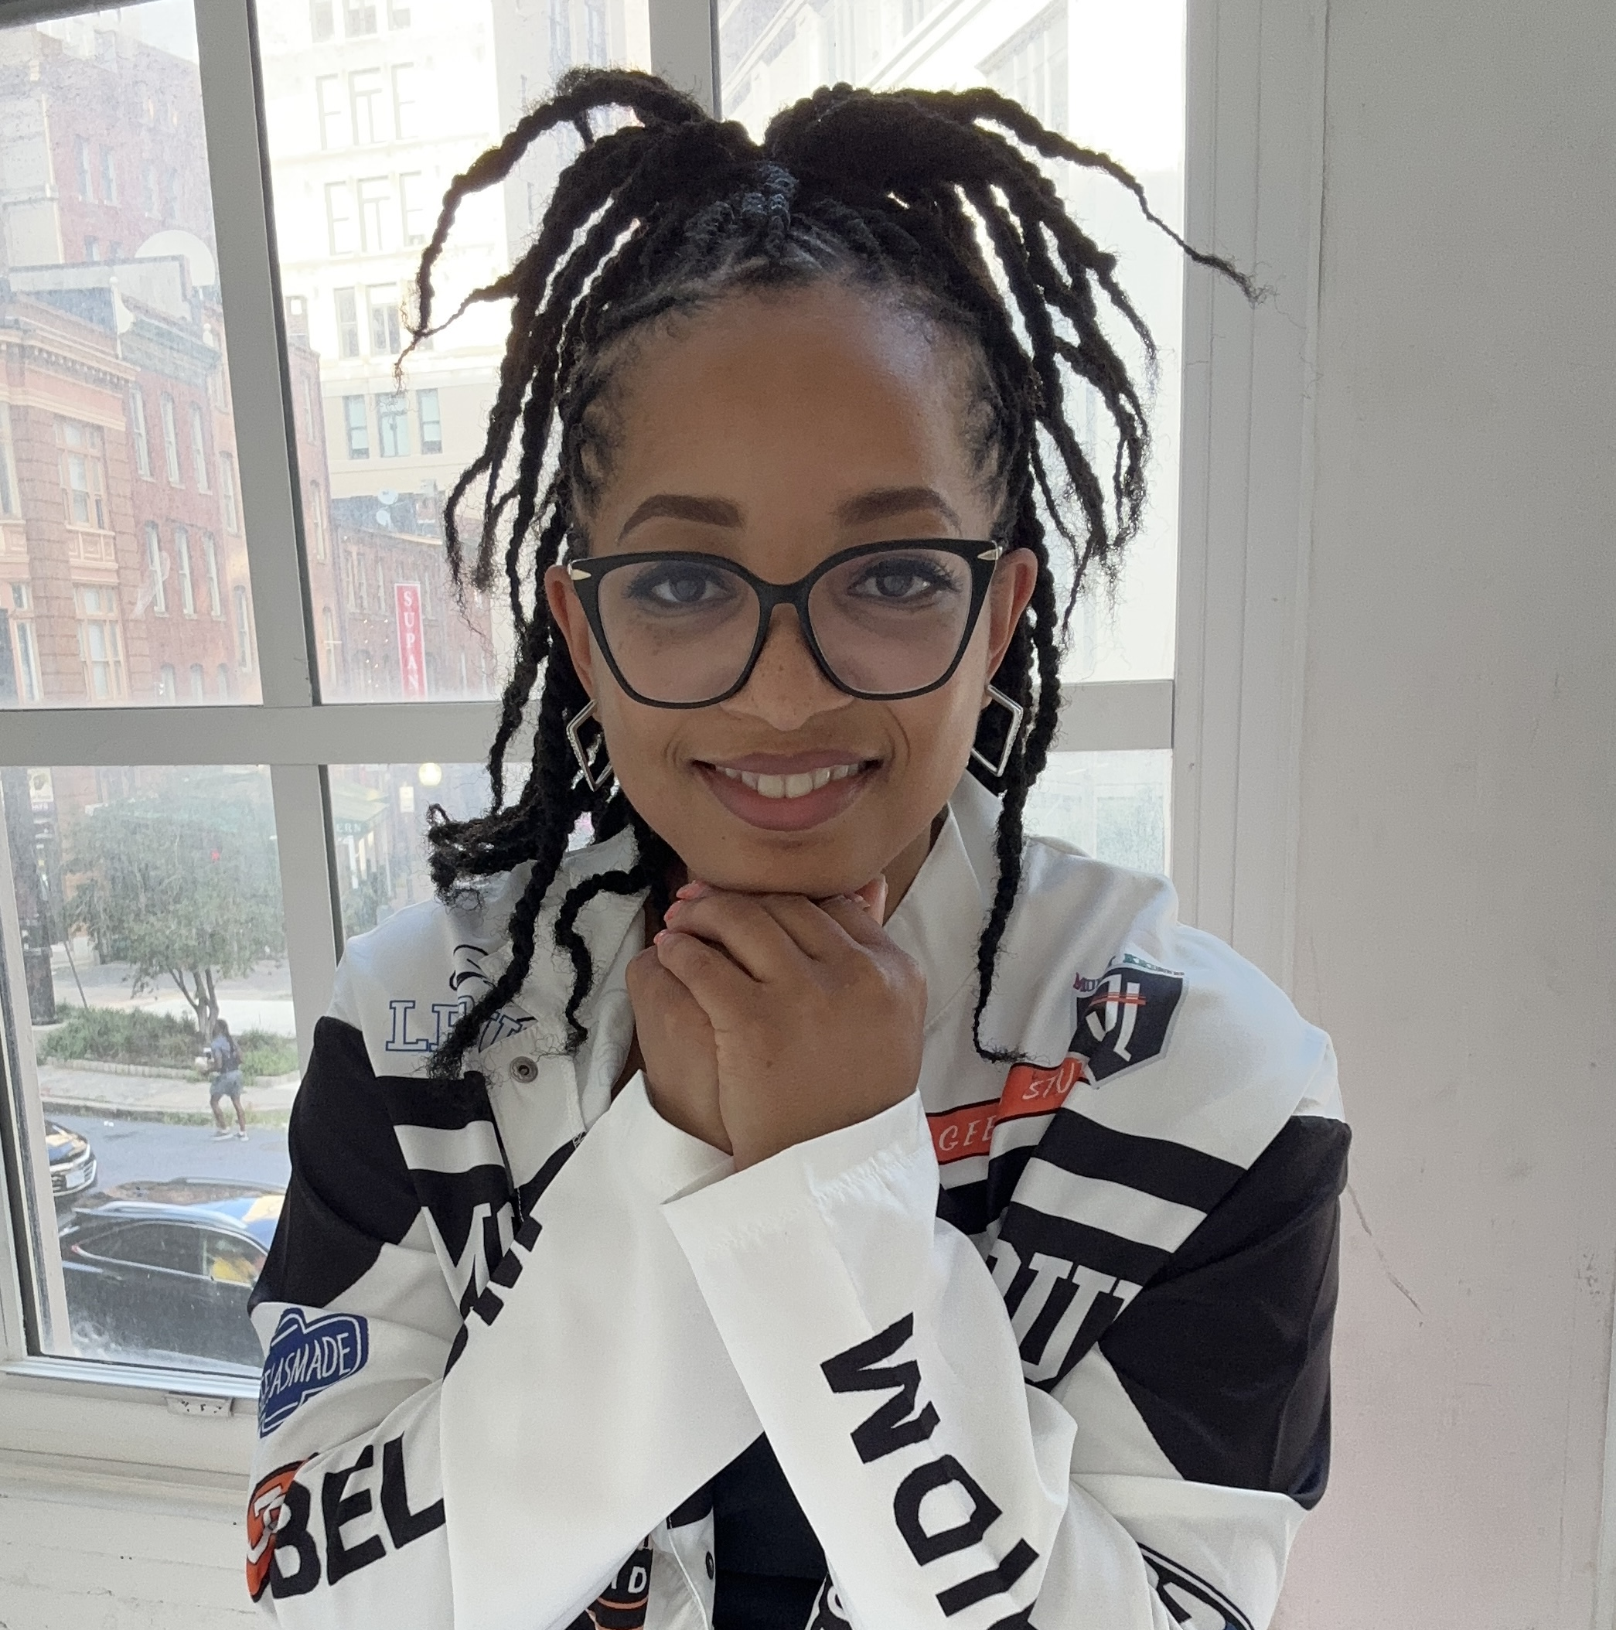
Keri Gray (Opening Plenary)

Keri Gray is a dynamic entrepreneur, facilitator, cancer survivor, and a passionate advocate for racial and disability justice. As the CEO of Ignite by Keri Gray, she is dedicated to fostering professional communities that are intentional and equitable, with a strong focus on racial and disability justice education.

She is the founder of the National Alliance of Melanin Disabled Advocates (the NAMED Advocates), an organization that is reshaping social justice movements’ approach to ableism and building cross-movement solidarity with disabled leaders of color.

Keri has spearheaded impactful projects like the ‘Beyond Diversity’ initiative, a seven-month program that equips leaders with tools to advance organizational culture and policies. Her consulting work includes collaborations with major entities like Goldenvoice and the Coachella Valley Music & Arts Festival, for whom she designed the ‘Accessible+ Job shadowing program,’ a career development program for disabled professionals of color working in the live events industry.

Her career highlights include recruiting approximately 4,000 professionals for over 100 organizations and Fortune 500 companies and designing programs that have helped over 1,000 professionals secure competitive employment and build influential networks. Keri’s work has garnered attention from major publications and media outlets such as Teen Vogue, the New York Times, People Magazine, Time Magazine, PBS NewsHour, Madamenoire, and the Diet Coke campaign #Unlabeled.

Ly Xīnzhèn M. Zhǎngsūn Brown (Closing Plenary)

Ly Xīnzhèn M. Zhǎngsūn Brown is an internationally recognized advocate, community organizer, community builder, and scholar-activist whose work addresses interpersonal, corporate, and state violence targeting disabled people at intersections of race, class, gender, sexuality, faith, language, and nation. They were the 2016 recipient of NCIL’s Diana Viets Award.

Ly Xīnzhèn is director of public policy at National Disability Institute, where their work advances financial freedom and economic justice for disabled people via law and policy. Formerly, Ly Xīnzhèn was policy counsel at the Center for Democracy and Technology and an associate at Georgetown Law’s Institute for Tech Law and Policy, where they led the only policy and advocacy project in the United States focused on disability rights, algorithmic harm, and technology justice for several years. Most recently, they co-authored a research and policy report on labor, disability rights, and emerging tech in the workplace for National Disability Institute and New Disabled South.

Ly Xīnzhèn is also Assistant Teaching Professor of Disability Studies at Georgetown University, founding Executive Director of The Autistic People of Color Fund, and is creating Disability Justice Wisdom Tarot. They serve as past president and current treasurer of the Disability Rights Bar Association, Disability Justice Committee representative to the National Lawyers Guild board, and a Commissioner on the Maryland Commission on LGBTQIA+ Affairs. Disability Justice and abolition are their political homes as an organizer; as a feminist critical legal studies scholar, they work in critical race and disability theory and in science and technology studies. They will be very pleased if you ask them about Ethiopian food.
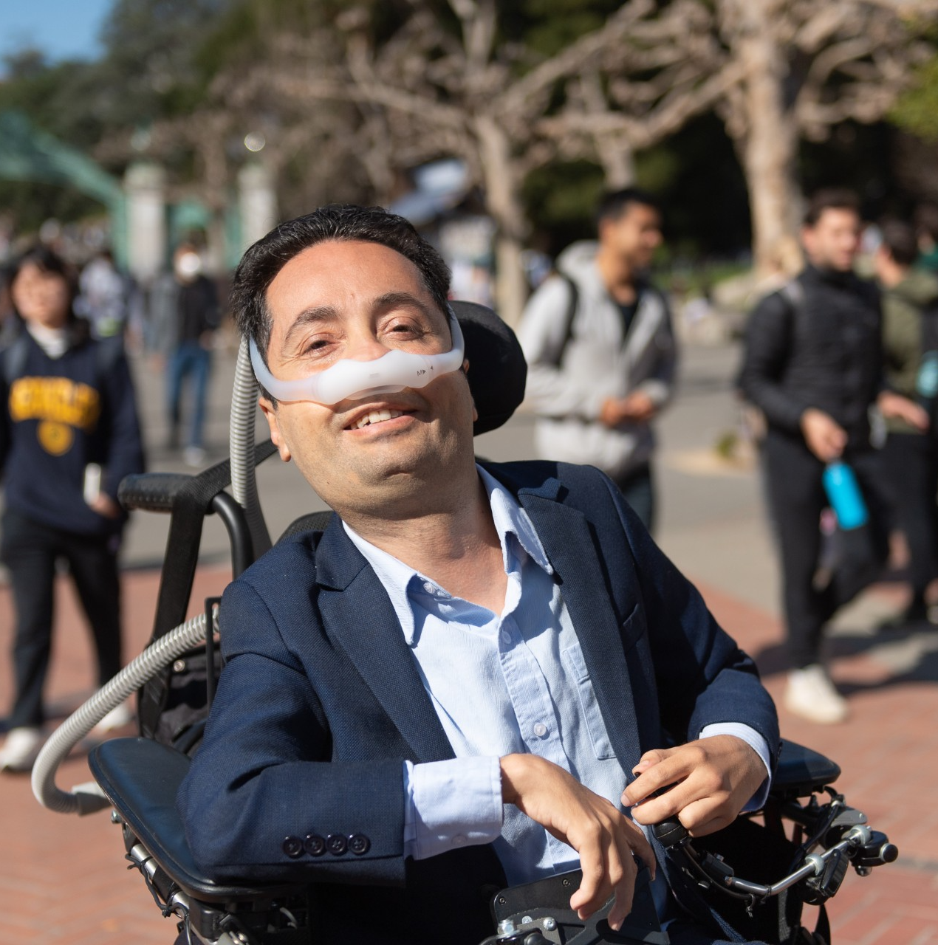

Victor Pineda (Artificial Intelligence Panel)

Dr. Victor Santiago Pineda is an international disability rights advocate, urban planner, and filmmaker. He currently serves as Executive Director of the Center for Independent Living in Berkeley and as a lecturer and Director of the Inclusive Cities Lab at UC Berkeley. As founder of World Enabled, Dr. Pineda has led global initiatives advancing disability-inclusive urban development and smart city innovation.

He is a member of the World Economic Forum’s Global Future Council on Cities and Urbanization and Co-Chair of the UN-Habitat Partner Constituency Group on Persons with Disabilities. With a Ph.D. in Urban Planning from UCLA, his work spans policy, research, and media to promote inclusive design and social impact worldwide.

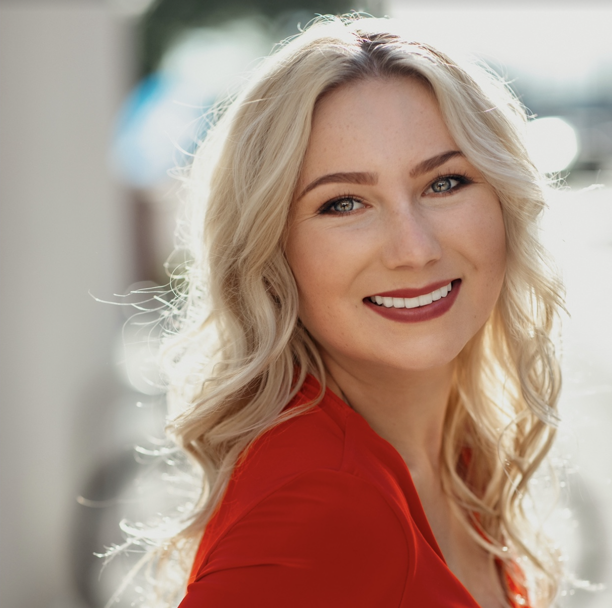
Keely Cat-Wells (Awards Luncheon)

Since becoming Disabled in her teens, Keely has worked to advance disability rights. She is the CEO of Making Space, a talent and learning platform that equips Disabled professionals with resources and opportunities to build meaningful careers. Under her leadership, Making Space partnered with NBCUniversal to place the first-ever Disabled hosts on NBC Sports’ Paralympics broadcast for Paris 2024. Other partners include Indeed, Netflix, and Visa. Keely also co-founded Making Space Media with Sophie Morgan, a division producing film and TV content centering Disabled voices, securing a first-look deal with Reese Witherspoon’s Hello Sunshine.

Notably, their recent documentary “Fight To Fly” exposed the inequalities that Disabled travelers face, triggering policy reform and establishing a Working Group to advise the UK Government.

Previously, Keely founded C Talent, a talent agency that increased disability representation in media and built a roster with a reach of over 50 million. Acquired in 2022, C Talent became the largest acquisition of a company specializing in Disabled talent.

Keely is a Forbes 30 Under 30 honoree, a Diana Award recipient, and has served on the advisory board of Lady Gaga’s Born This Way Foundation. She currently sits on the Los Angeles City Games Advisory Committee and holds the distinction of being the youngest-ever Presidential Leadership Scholar. Additionally, she is a Storyteller in Residence at the Clinton Global Initiative, a White House Mental Health Youth Forum Leader, and one of two Gloria Steinem fellows. Learn more at keelycatwells.com and making-space.com.

Annual Council Meeting Agenda

Tuesday, July 22, 2025; 1:45 – 2:30 p.m. Eastern

Independence Ballroom; Grand Hyatt Washington

Attend the Annual Council Meeting to hear the results of the elections for Governing Board members. This year, elections were held prior to the conference for: President; Treasurer; 3 Member At-Large positions; and Representatives of Regions 1, 3, 5, 6, 7, and 9.

Please note: the times outlined below are estimated and may occur earlier or later than stated in the agenda.

1:45 p.m. Call to Order & Welcome
Kent Crenshaw

1:50 p.m. Review of Nomination & Election Procedures
John Herring

1:55 p.m. Announcement of Elected Executive Committee Positions
John Herring

President
Treasurer

Announcement of Member At-Large Positions
John Herring

3 Elected Positions

Announcement of Elected Regional Representative Positions
John Herring

Regions 1, 3, 5, 6, 7, 9

2:00 p.m. Reports

A. Outgoing President Kent Crenshaw
B. Executive Director Theo Braddy
C. Vice President Jeff Hughes
D. Secretary John Herring
E. Outgoing Treasurer Jeremy Morris

2:15 p.m. Acknowledgement of NCIL’s Committees and Subcommittees
Jeff Hughes

2:20 p.m. Old Business
Kent Crenshaw

New Business
Announcements

2:30 p.m. Adjournment


Map of Independence Level (5B)

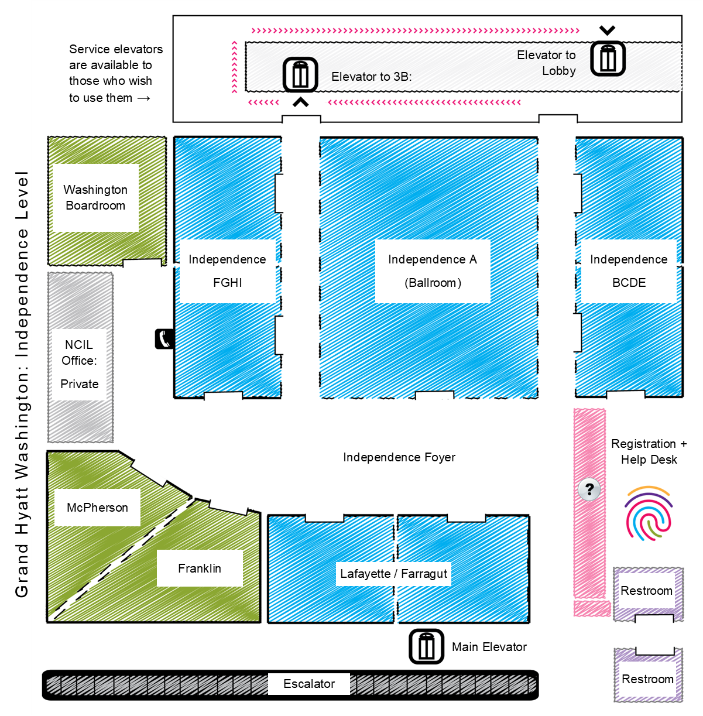

Restrooms

All restrooms on Independence Level (5B) will be gender inclusive for the duration of the conference. Additional restrooms are available on Declaration Level (1B) and Constitution Level (3B).

Health & Safety Protocols

By attending the 2025 Annual Conference on Independent Living, you agree to abide by and engage in certain health and safety protocols while attending the conference sessions. Please note, these may be adjusted depending on the current public health environment.

Masks are encouraged, but will be optional this year, pending any unforeseen events. Please plan to bring your own mask if you would like to wear one. Social distancing must be practiced at all Annual Conference activities.

If you have any questions regarding the new protocols, please reach out to jenny@ncil.org.

Onsite Registration

- NCIL Member: $350
- Non-Member: $450
- Youth (26 or younger): $150
- Daily Rate - NCIL Member: $130 / day
- Daily Rate - Non-member: $175 / day

Personal Assistant Registration Policy

Personal Assistants are not required to pay the registration fee but should fill out a form to receive a badge. Personal Assistants are welcome to attend all conference events, including scheduled meals and receptions.

Tickets

Your ticket to the Awards Luncheon and ADA35 Celebration of Community is your name badge. Tickets to the ADA35 Celebration of Community for any unregistered guests should be purchased in advance.

NCIL Regions by State

Region I (1): Connecticut, Maine, Massachusetts, New Hampshire, Rhode Island, Vermont. Region I Representative: Steve Higgins.
Region II (2): New Jersey, New York, Puerto Rico, Virgin Islands. Region II Representative: Aaron Baier.
Region III (3): Delaware, District of Columbia, Maryland, Pennsylvania, Virginia, West Virginia. Region III Representative: Vacant.
Region IV (4): Alabama, Florida, Georgia, Kentucky, Mississippi, North Carolina, South Carolina, Tennessee. Region IV Representative Edward Mitchell.
Region V (5): Illinois, Indiana, Michigan, Minnesota, Ohio, Wisconsin. Region V Representative: Jennifer Kucera.
Region VI (6): Arkansas, Louisiana, New Mexico, Oklahoma, Texas. Region VI Representative: Vacant.
Region VII (7): Iowa, Kansas, Missouri, Nebraska. Region VII Representative: Vacant.
Region VIII (8): Colorado, Montana, North Dakota, South Dakota, Utah, Wyoming. Region VIII Representative: Tami Hoar.
Region IX (9): Arizona, California, Hawaii, Nevada, American Samoa, Guam, Northern Mariana Islands, Trust Territory of the Pacific Islands. Region IX Representative: Lisa Hayes.
Region X (10): Alaska, Idaho, Oregon, Washington. Region X Representative: Kimberly Meck.

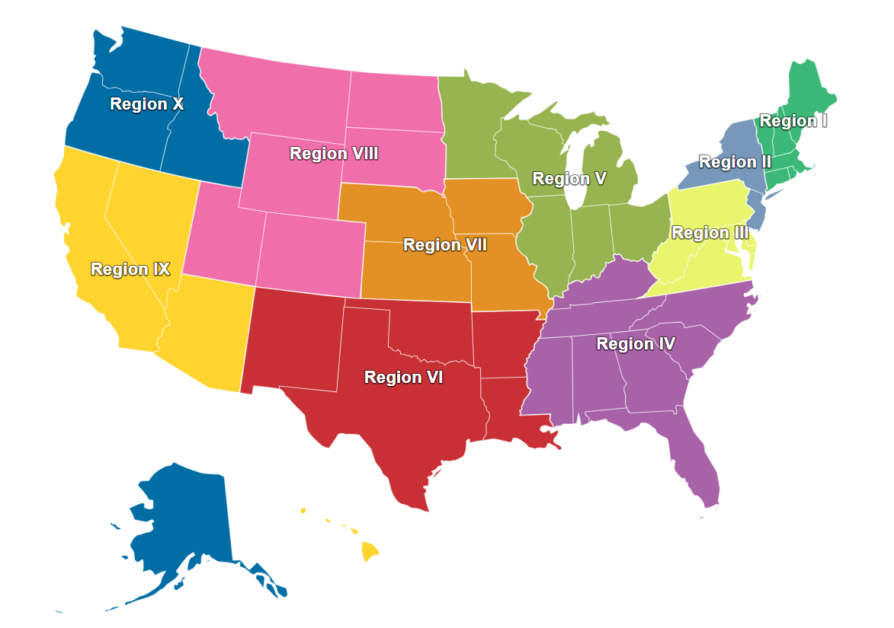

Do-It-Yourself Sign Kits

Complimentary Do-It-Yourself Sign Kits will be available on the conference floor the morning of Monday, July 21. Please take the kit back to your room and use it to create your signs for the Rally on Monday. Feel free to be creative. Some examples include:

- Institutionalization Is No Way to Live!
- Disability Is a Natural Part of the Human Condition
- I ❤ INDEPENDENT LIVING
- 35 Years Later — Still Fighting for Basic Rights
- Death By 1,000 Budget Cuts
- Nothing About Us Without Us
- End Institutions. Fund Freedom!
- Real Inclusion Requires Real Investment
- Fund Freedom, Not Facilities - Protect Medicaid HCBS
- LIVE, LOVE, LEAD ON
- Full Community Integration Now
- I Roll for Justice
- Support Independence. Fund Community Living!
- Respect Existence or Expect Resistance
- Institutions Are Not Solutions
- Our Lives. Our Homes. Our Communities.
- Freedom = Living in the Community!
- Justice Delayed is Justice Denied
- Money Follows the Person — Not the Institution!
- SHEESH.
- Community Care Saves Lives
- Our Homes Not Nursing Homes! #FreeOurPeople
- ADA + 504: I Am Equal Too
- Don’t Warehouse Me, Bro
- Civil Rights Are Not Special Needs
- Cure Ableism
- Institutions = Cages.
Community = Freedom.
- Justice Not Just Us
- There’s No Place Like Home
- Ableism Is Trash
- People Over Profits

What to Bring

Remember to bring along the following items to ensure your comfort and safety:

- attire appropriate for both very hot and chilly temperatures;
- repair equipment / tools for your devices; and
- any medications or assistive devices you may need during strenuous activity.

Access, Accommodations, & Resources

Environmental / Chemical Sensitivities

Fragrances and chemicals can be barriers to access. To help make this Conference accessible to participants for whom chemicals or fragrances are an access barrier, NCIL requests that you come fragrance free. Please refrain from wearing any scented products or washing with them. This includes clothing that has been laundered with fragranced detergent or fabric softening products. Additionally, please completely air out any dry-cleaned clothing before wearing it to the Conference.

Smoke can also be an access barrier. It is essential that we maintain a smoke-free environment. If you smoke, please use the designated smoking area located outside the Hyatt. Please refrain from smoking near any other doorways or paths of travel. The hotel entrance at 11th Street should be the least polluted with cigarette smoke and vehicle exhaust, although it unfortunately has steps.

Parking

The maximum vehicle height for the garage at the Grand Hyatt is 6’ 6”. Taller vehicles (up to 8’ 2”) may park in the City Center complex, directly across the street from the Grand Hyatt. City Center offers an overnight parking rate of $24 / night, which is less than the rates at the Grand Hyatt.

Sensory Retreat / Quiet Room

During all conference hours, a space is reserved as a quiet zone / sensory retreat. This room is provided for individuals who need a break from overstimulation and / or the large group environment of the conference. Please help us maintain this accommodation. Do not use this space to hold conversations or meetings. The dialogue zone is available for that purpose. Check the Full Schedule of Events for locations at a given time.

Auxiliary Aids & Services

CART captioning, sign language interpreters, assistive listening devices, personal assistants, accessible materials, and other services will be provided for all Conference activities. However, participants must arrange their own services for Hill Visits. Congress is responsible for providing interpreters for Hill Visits upon request. Email contact: interpreters@saa.senate.gov.

Local Service Providers: Personal Assistant Services

NCIL’s Personal Assistants will be available during conference hours only. NCIL’s personal assistants are only to be used for basic tasks. If you need more assistance than basic tasks, you will be required to bring your own personal assistant. Personal assistants may attend all conference activities free-of charge but should register to receive a name badge. Use the information below to arrange your own personal assistant service during non-conference hours.

Right at Home Washington DC

- Phone: 202-269-0008 / Contact form: https://www.rightathome.net/dc/contact

DC Health Home Care Agency Directory (PDF): https://bit.ly/3z3NBFw

Local Service Providers: Wheelchair and Scooter Rental and Repair

ZASK Medical Supply - Alexandria, VA

- Phone: 703-354-1266 / Email: info@zaskmedical.com

ScootAround (Rentals only. Delivery available.)

- Phone: 1-888-441-7575 / Website: scootaround.com

Express Mobility Services

- Phone: 703-346-8796 / Website: expressmobilityservices.com

Scooterplus / Lenox Medical Supply (Rentals only. Delivery available.)

- Phone: 1-866 474-4356 or 202-387-1960 / Website: lenoxmedicalsupply.com

Advocate’s Guide to the Hill

Each year, the highlight of the NCIL Annual Conference is the convergence of members from across the nation, who unite on Capitol Hill to share their stories with their Senators and Representatives.

Rally Site

The Rally will take place at the US Capitol in Area 12, next to the Reflecting Pool on Monday, July 21; 4:00 – 5:00 p.m.

Hill Visits

The afternoon of Wednesday, July 23 has been set aside for Hill Visits. NCIL members are strongly encouraged to meet with their elected officials (or set up virtual meetings where necessary) to discuss pressing issues. These meetings must be arranged in advance. Senators and Representatives set their own policies about whether they are meeting with constituents in-person or virtually. When scheduling meetings, ask about any COVID protocol or practices that are required so that you can be prepared. The public spaces within the Grand Hyatt can be utilized for in-person meetings with elected officials and their staff for those needing a meeting space outside of the Capitol.

Getting to the Capitol

Directions from the Grand Hyatt Hotel to Area 12, next to the Capitol Reflecting Pool:

- Depart 11th & G Streets NW.
- Travel 2 blocks East on G St. NW.
- Turn Right on 9th St. NW, travel 3 blocks South.
- Turn Left on Pennsylvania Ave. NW, travel 4 blocks SE.
- Proceed to Area 12 of the Capitol Grounds, immediately North of the Capitol Reflecting Pool.

The metro stations at Union Station and South Capitol are located just a few blocks away from the House and Senate office buildings. Union Station is to the North, closest to the Senate office buildings. Capitol South is located to the South, closest to the House office buildings.

Cabs are also readily available near the U.S. Capitol. A limited amount of wheelchair accessible Uber vans are also available in DC. For more information: uber.com/ride/uberwav.

About Your Visit to Capitol Hill

Security Notice: To meet with your elected official, you will have to pass through a security screening in all House and Senate office buildings. You are encouraged to bring photo ID with you on your Capitol Hill Visit.

You will be required to pass through a body scanner. If you are unable to be scanned or uncomfortable, please request a pat down or wand screening. All bags are subject to thorough search and security screening. If you have any of the following items with you on your visit to Capitol Hill, you may not be allowed to visit your representative. Prohibited items include:

- Mace and pepper spray
- Any sharp or pointed object
- Knives of any size, including pocketknives
- Cans and bottles
- Any bag larger than 14" wide x 13" high x 4" deep (per security discretion)
- Weapons of any kind
- Non-aerosol spray
- Aerosol containers
- Signs

This is an abbreviated list. If in doubt, leave it at the hotel!

Tunnels

Both the Senate and the House Office Buildings are connected by underground tunnels. Once you pass through security to either the Senate or the House Office Buildings, you can move about freely between buildings of that office without having to repeatedly go through security. The interconnecting tunnels can be found in the basements of both the Senate and House Office Buildings.

Map of Rally Site
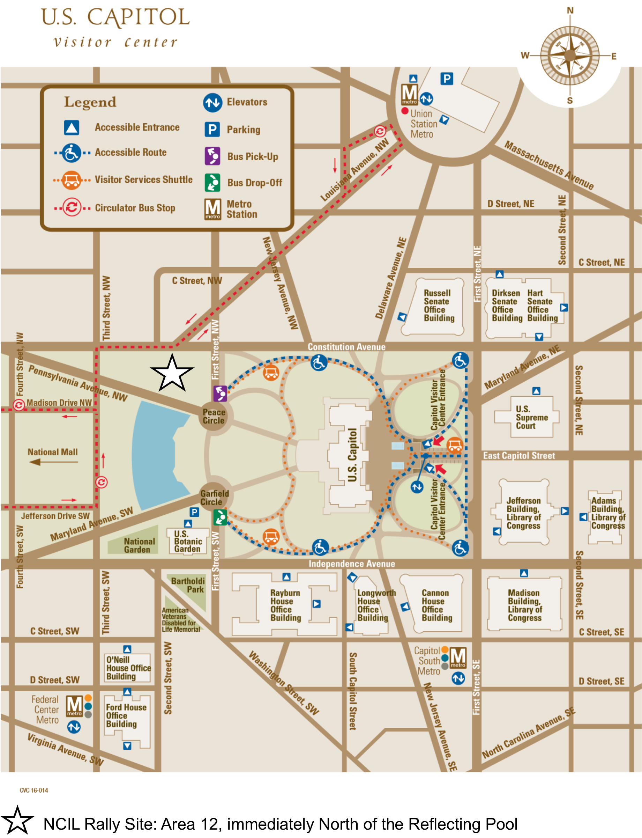

Accessible Entrances

- Capitol Building: Public tours enter through the Capitol Visitor Center; Official House business enters on the south side of the Capitol; Official Senate business enters on the north side of the Capitol.
- Capitol Visitor Center (CVC): Main entrance at First and East Capitol streets. The CVC also offers an on-demand shuttle and other services.
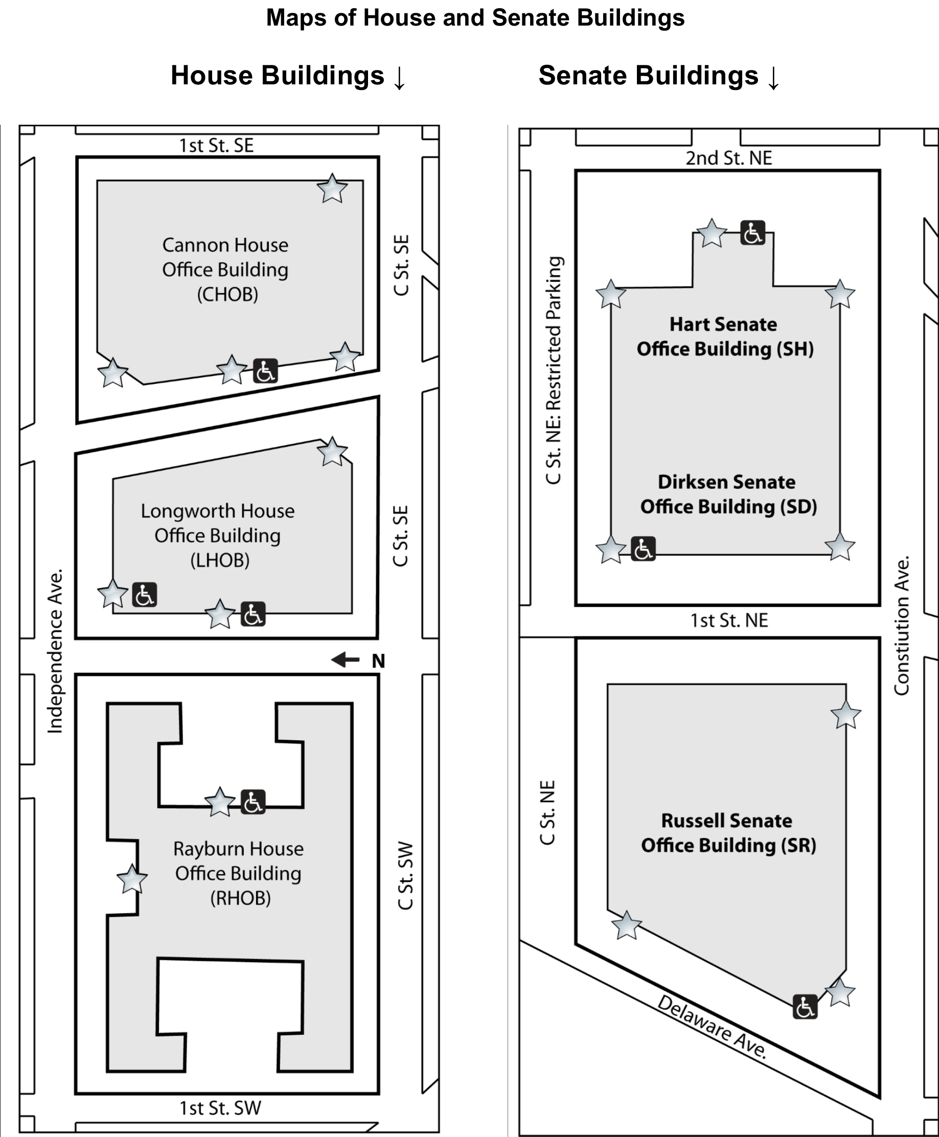
- Cannon House Office Building: Entrance on New Jersey Avenue, SE, south of the terrace at the intersection with Independence Avenue.
- Dirksen Senate Office Building: First and C Street entrance.
- Ford House Office Building: Entrance on 3rd Street, SW or 2nd Street, SW.
- Hart Senate Office Building: Second Street entrance or Constitution Avenue entrance.
- Longworth House Office Building: Main entrance, Independence and New Jersey Avenues. Or the South Capitol Street entrance.
- O'Neill House Office Building: C Street SW between 2nd and 3rd Streets.

Hill Cafeterias

Have some down time in between appointments once you are in the House or Senate Office Buildings? Both offer a number of places to have everything from a quick snack to a full meal. For more specific information on directions to tunnels, eateries, or to your Representative’s office, feel free to ask Hill staff or security.

Please note that only water is being provided at this year’s Rally.

Senate Office Buildings:

- Russell Basement: Coffee and Sandwich Shop
- Dirksen Basement: Full Cafeteria - Your best bet on the Hill!

House Office Buildings:

- Longworth Basement: Cafeteria
- Rayburn Basement: Coffee and Sandwich Shop

There is also a cafeteria located inside the U.S. Capitol Building.

Services on Hill Visits

CART (Communications Access in Real Time), sign language interpreters, assistive listening devices, personal assistants, accessible materials, and other services will be provided upon request for all NCIL conference activities. However, participants must arrange their own services for Hill Visits on Wednesday, July 24. Congress is responsible for providing interpreters for Hill Visits upon request. The following email contact is provided by the Capitol Visitor Center: interpreters@saa.senate.gov.

Directories of the 118th Congress: Second Session

Directory of the Senate: To contact your Senator, use the directory at: senate.gov/senators/contact. Senators are listed alphabetically with their phone numbers, email addresses, and office locations available. You may also find information by calling the Capitol Switchboard at 202-225-3121 or 202-224-3091 (TTY).

Your Senator’s office will be in one of three “Senate Office Buildings” or SOB. They are Dirksen, Hart, and Russell. The room number of your Senator coincides with the floor his or her office is on. If your Senator is located in Hart 302, that office is on the 3rd floor; Dirksen 439, is on the 4th floor; Russell 238 is on the 2nd floor.

Directory of the House of Representatives: To contact your Representative, use the directory at: house.gov/representatives. Representatives are listed alphabetically with their phone numbers, email addresses, and office locations available. You may also find information by calling the Capitol Switchboard at 202-225-3121 or 202-224-3091 (TTY).

Your Representative’s office will be in one of three “House Office Buildings” or HOB. They are Cannon (CHOB), Longworth (LHOB), and Rayburn (RHOB). The room number of your representative coincides with the floor his or her office is on. If your representative is located in Cannon 328, that office is on the 3rd floor. If the office number is more than three digits, disregard the first number and the second number represents the floor your representative’s office is located on. For example, an office listed as Rayburn 2439, is on the 4th floor; Longworth 1721 is on the 7th floor.

Additional Resources

For more help with planning your visit to the Capitol please visit the Capitol Visitor Center's website: visitthecapitol.gov/plan-visit/visitors-disabilities.

Sponsors

NCIL thanks our 2025 Annual Conference Sponsors: Centene, Airbnb, Waymo, CIL Suite, and Microsoft!

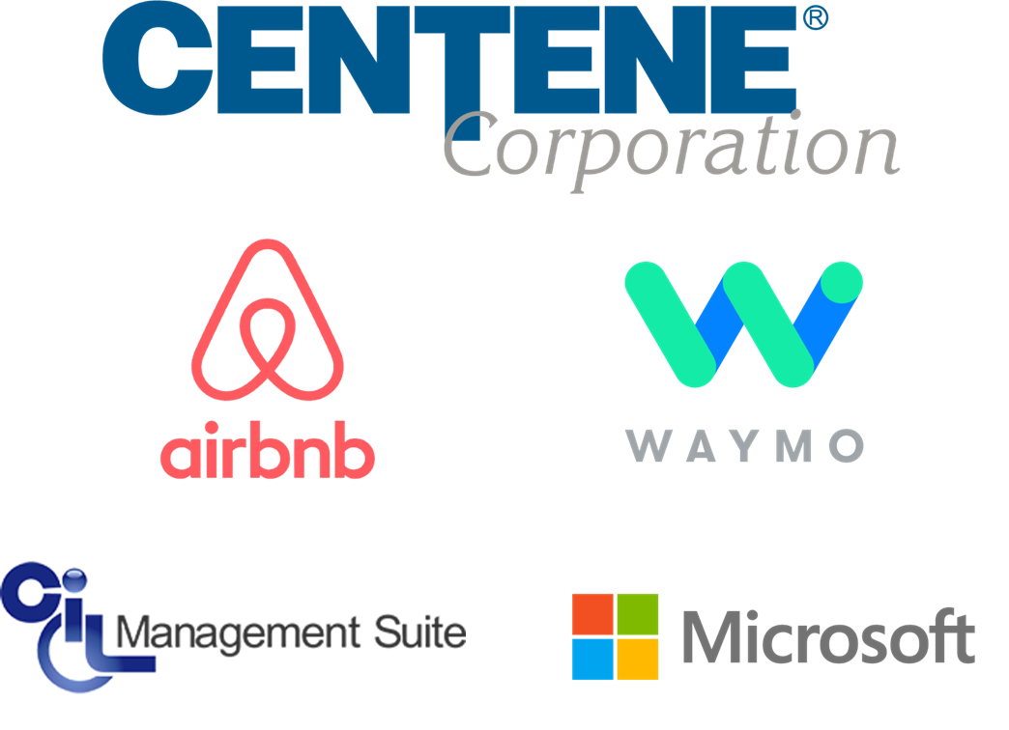

Exhibitors

ADA National Network
Insi
Maryland SILC
Matt Shedd | Podcast Producer & Writer
MiCIL
Mobility International USA
National Disability Institute (NDI)
National Ramp
Q90 / CIL Suite
Questco
Scomm
Relman Colfax PLLC

IL Training & Technical Assistance Center
American Association of People with Disabilities (AAPD)
Model Systems Knowledge Translation Center (MSKTC)

Advertisements

Insi: Clarity on Accessibility

Unlike accessibility overlays that temporarily mask issues without fixing them, Insi addresses problems at their source. Automatically scan website pages for both critical and potential accessibility violations, evaluate compliance with the latest WCAG standards, and resolve issues—all in WordPress.

Automated Accessibility Testing
Accurate Contrast Evaluation
Visualize Issues
Issue Resolution Guidance
Built-In Wordpress Integration

Be An Accessibility Leader
Insi’s unique approach delivers measurable improvements that benefit every visitor to your site.

Learn More
Visit insihub.com

A photo of a bald eagle on a pink background. A filter is applied and the photo comes into focus.

Placemakr: Don’t just visit DC - experience it like a local.

Whether you’re in DC for work, play, or a bit of both, Placemakr is the smarter way to stay. Our apartment-style suites blend the comforts of home with the perks of a hotel—like chef-ready kitchens, in-unit laundry, and contactless tech in all the right places. Even better, you’ll find us in the most desirable neighborhoods across the city.

Find your place in the middle of everything.

2500 Penn, a Placemakr Experience
Boutique charm near Georgetown and the Potomac River.

Coda on Half, a Placemakr Experience
Sleek, modern living just steps from Nationals Park.

Placemakr Buzzard Point
Waterfront access meets stadium energy at the edge of the Wharf.

Placemakr Dupont Circle
Historic character with easy access to one of the city’s most walkable areas.

Placemakr Marymount Ballston
Urban-meets-suburban comfort in Arlington’s buzzing Ballston neighborhood.

Images: Each of the above locations are shown on a map, and each location has a photo of a posh living space. A larger image shows Washington DC from above, with the Jefferson Memorial in the foreground.

Explore flexible stays by the night, week, month or more at placemakr.com.

Airbnb: Airbnb makes it possible for guests to experience the world in a more authentic, connected way. We are grateful for our partnership with NCIL and are delighted to sponsor this year’s annual conference.

Image: Three people talking and laughing just inside the entrance to a well-appointed apartment. Airbnb logo features a stylized letter A.

Centene: Centene is a proud sponsor of the 2025 NCIL Conference. We look forward to continued collaboration with Independent Living leaders to build a better tomorrow.

Centene.com

Images: Centene Corporation Logo; and colorful curved lines and dots.

Waymo: Waymo Logo features a blue and green letter w. www.waymo.com. Moving forward, together. Waymo is proud to support NCIL. A Waymo vehicle with technology attached to the roof is surrounded by five concentric circles and three people, including one person with a prosthetic leg and one person with a white cane and service dog.

Q90: Home of CIL Suite.

“…it makes our job so much easier.”
- Brenda, IL Specialist

We are honored to be a Tech Partner in Independent Living, empowering independence through innovation. QR Code: https://www.cilsuite.com/.

Visit us at our table! (Psst… we have a special gift just for you!)

Graphic features purple diagonal lines. Q90 logo is a stylized letter Q with diagonal lines. In the CIL Suite logo, the letter in CIL are arranged to resemble an icon of a person using a wheelchair.

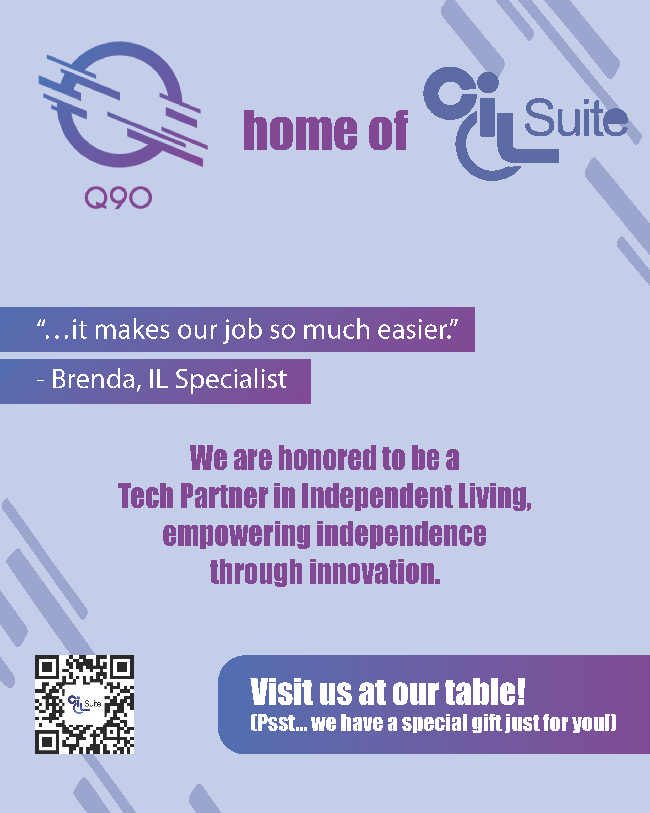
Advertisements
