
Invest in the Independent Living Program
A fact sheet on the impact and value of America’s Independent Living Program

Why Federal Investment Is Needed
The Independent Living Program – authorized under Title VII of the Rehabilitation Act and consisting of Centers for Independent Living (CILs) and State Independent Living Councils (SILCs) — has been chronically underfunded for decades. As a result:
- Many communities, particularly in rural areas, have no access to a CIL.
- Existing CILs lack the resources needed to expand services and meet growing community needs.
- Federal investments aren't keeping pace with the cost of operating programs. Living wages, employee benefits, and facilities expenses outpace the nominal increase in funding.
Federal investment is essential to sustain and grow the national Independent Living infrastructure – an established cost-effective system that keeps people working, housed, and living in their communities.

A Proven, Cost-Effective Infrastructure
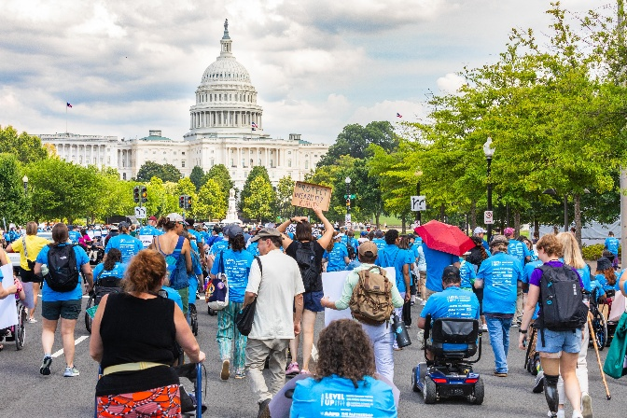
Increased funding for the Independent Living Program strengthens a nationwide network that:
- Reduces long-term federal expenditures
- Prevents and reduces institutionalization
- Supports employment and education
- Reduces reliance on SSI / SSDI, Medicaid, Medicare, emergency rooms, and long-term care systems

Investments in CILs replace crisis spending with prevention and independence, generating significant federal savings.

Program Impact
Education
- Students with disabilities who graduate high school have higher lifetime earnings and lower benefit dependency.
- CILs provide youth transition services that reduce dropout rates and help young people avoid early lifelong public assistance enrollment.

Employment & Workforce Participation
- Employment increases economic participation and reduces reliance on SSI / SSDI, increases tax contributions, and improves overall health outcomes.
- CILs help people with disabilities to enter or return to the workforce – even part time employment lowers federal costs and administrative burden.

Avoiding Institutionalization
- Institutional care is exponentially more expensive than community-based support.
- CILs actively support community-based housing options, which help move people out of nursing homes and keep people from entering them.

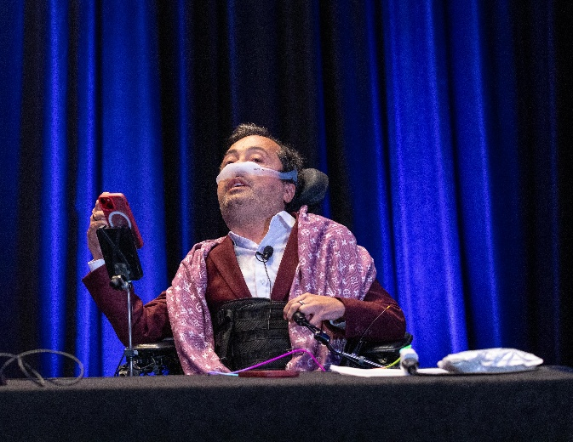
Benefits Reduction and Prevention
- Preventing unnecessary entry into federal benefit programs leads to substantial long-term savings.
- Many CILs offer work incentives / disability benefits counseling, which reduces overpayments and long-term dependency.

Increased Disability Employment – By Design
Federal IL funding directly supports both employment and essential services.
- CILs are among the most consistent disability employers nationwide but continue to struggle to pay competitive wages and offer meaningful employee benefits.
- CILs model inclusive hiring, retention, and leadership advancement.

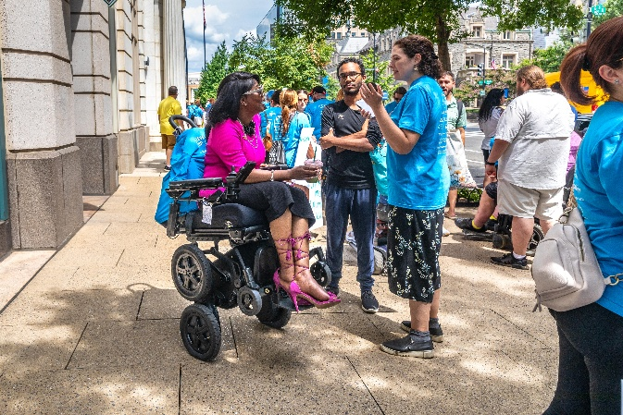
Unfunded and Underfunded Federal Mandates
CILs are federally required to:
- Serve individuals with disabilities of all ages and all disabilities across often large and disparate geographic regions
- Provide five core independent living services
- Conduct extensive federal compliance, data reporting, and program evaluation
- Fill gaps created by underfunded Medicaid, mental health, housing, long-term services, and workforce programs.
Despite these increasing mandates, appropriations have not kept pace with inflation and rising costs of providing services and demand.

Bipartisan Strengths of the Independent Living Program

Increased federal investment aligns with priorities across party lines:
- Fiscal responsibility: Community-based services cost significantly less than institutional care.
- Work & Independence: IL services support employment and self-sufficiency.
- Local Control: Services are community-driven and responsive to local needs
- Accountability: CILs track, audit, and publicly report outcomes.

Services Provided
In 2023, CILs transitioned 5,634 individuals from Institutional settings to the community. Based on information from the Kaiser Family Foundation, in 2024 the average cost of a semiprivate room in a nursing facility is roughly $111,325 each year, compared to home and community-based supports, which average approximately $36,000 per year. This equates to a savings of $202,824,000 annually or a 58% return on investment.

Successful Outcomes

In 2023, CILs with Part C grants had a total of 203,156 successful outcomes.
CILs provide a unique one-stop resource to people with disabilities. Most of our staff, board, and management are individuals with disabilities. This creates responsive, dynamic, and knowledgeable places for people to turn to.
In 2023, 67% of staff of CILs were people with disabilities, employing 3,745 individuals with disabilities with 618 in management of their CIL.

www.ncil.org / ncil@ncil.org
202.207.0334

