Expanding Our Movement: Ensuring Independent Living Access for (Im)migrant Communities
July 20, 2026
Maria Stepanyan Elham Youssefian
Kelsey Bell
Craig Towler



Workshop Purpose
- Explore the intersection of disability and (im)migration within the Independent Living movement.
- Understand systemic, cultural, and practical barriers faced by immigrants and refugees with disabilities.
- Identify strategies to improve outreach, trust, inclusion, and access to services.

Core Workshop Goals
- Identify at least three systemic barriers (im)migrants with disabilities face in accessing IL services.
- Understand how (im)migration systems and disability systems intersect.
- Learn practical outreach and partnership strategies.
- Leave with at least one actionable idea participants can implement.

Why This Matters Now
- (Im)migrants and refugees with disabilities often face overlapping barriers.
- Fear, language access, documentation concerns, and lack of culturally responsive services limit access.
- CILs have a critical role in advancing equity and inclusion.

Opening Reflection Question
- What barriers might prevent an (im)migrant with a disability from accessing independent living services?
- How can organizations unintentionally create barriers?

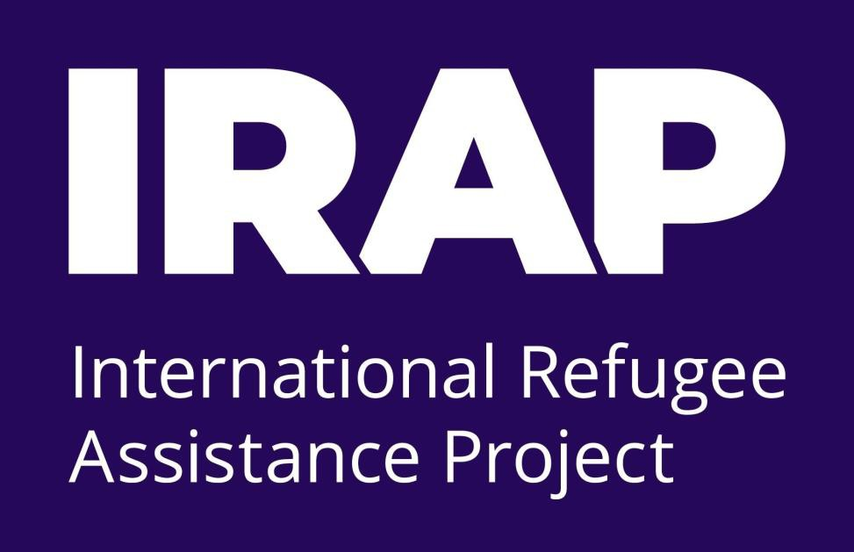
Panelists
Elham Youssefian
Director of Disability Inclusion and Accessibility
The International Refugee Assistance Project

Panelists
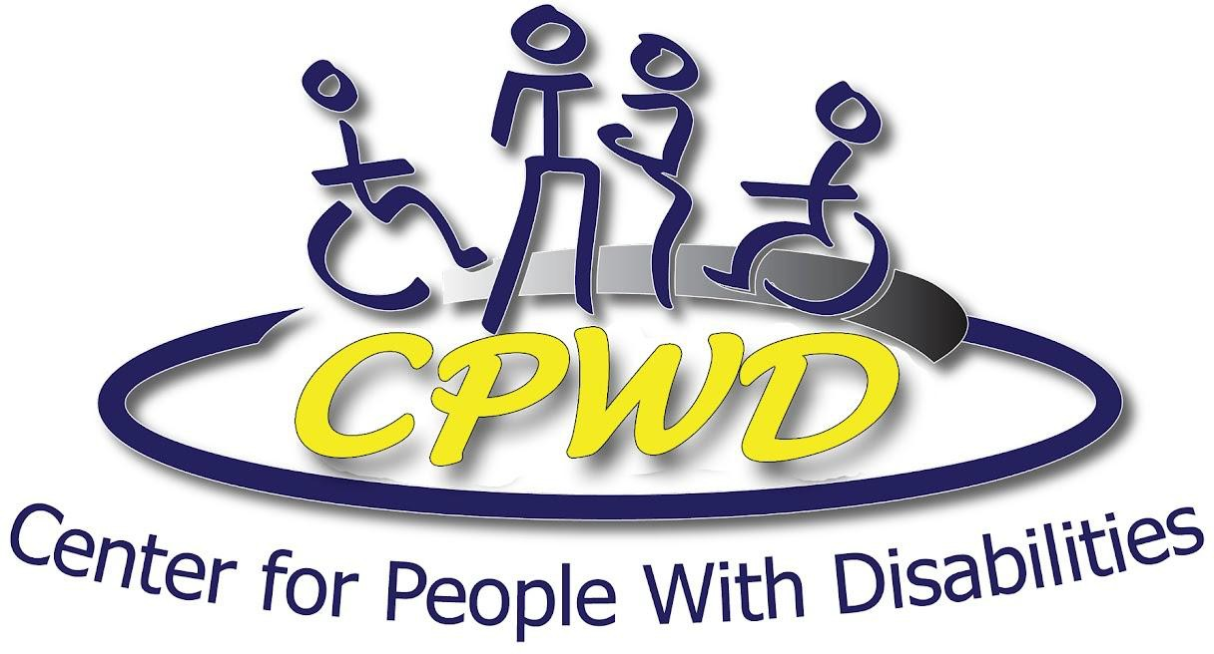
Maria Stepanyan Executive Director
Center for People With Disabilities

Craig Towler
Director of Public Policy and Advocacy
Center for People With Disabilities

Panelists

Kelsey Bell
Executive Director

Southwest Center for Independence

Understanding the Barriers
Who Are We Talking About?
(Im)migrant – a person who comes to live permanently in a foreign country (first generation, 1.5, or second generation) Includes other terms and categories such as:
- New Americans
- Naturalized Citizens
- Permanent Residents (PR)
- Refugees
- Asylees
- Migrants
- Twilight Status (DACA, TPS)
- Unauthorized/Undocumented

Understanding the Barriers
Who Are We Talking About?
Each category has different experiences, barriers, and opportunities. May also be described as:
- First generation (foreign born)
- Second generation (native-born with at least one immigrant parent), 1.5 generation (likely immigrated with parents as children or teens)

Understanding the Barriers
More than three-quarters of (im)migrants are in the United States lawfully, as:
- Naturalized citizens
- Legal permanent residents (aka green-card holders)
- Refugees and asylees, or
- Individuals on long-term temporary (aka nonimmigrant) visas

Understanding the Barriers
According to Pew Research Center, the foreign-born population in the U.S.A, 2022 includes

49% (23.4 million) naturalized citizens
24% (11.5 million) LPRs
23% (11.0 million) Unauthorized immigrants
4% (2.0 million) Temporary lawful residents

Systemic Barriers
- Eligibility restrictions and documentation requirements
- Public charge fears and misinformation
- Complex service systems and navigation challenges
- Limited accessibility in (im)migration-related systems

Community-Level Barriers
- Language access limitations
- Lack of trust in institutions
- Cultural stigma surrounding disability
- Limited awareness of IL services

Panelist Questions
What are some of the biggest barriers (im)migrants with disabilities face when trying to access services or supports?

Can you share an example or story that illustrates the challenges families or individuals face?

From your experience serving rural communities, what barriers make it difficult for people with disabilities to access services, and how might those challenges be even greater for (im)migrants or refugees living in rural areas?

>> SLIDE 16

Strengthening Connections &
Partnerships
- Building trust through consistency and cultural responsiveness
- Meeting communities where they are
- Centering lived experience in outreach and planning

Peer Engagement Strategies
- Use peer navigators and community ambassadors
- Offer workshops in trusted community spaces
- Build long-term relationships, not one-time outreach

Panelist Questions
What are effective ways organizations can begin building trust with (im)migrant communities?

What makes a partnership with an (im)migrant-serving organization successful?

Trust is often a key factor in whether people seek services. What have you learned about building trust with underserved communities in rural areas, and how might those lessons apply when working with (im)migrant communities?

Panelist Questions
How can CILs better meet communities where they already are instead of expecting communities to come to them?

What outreach strategies have actually worked well in your experience?

Audience Engagement
Raise your hand if your organization currently partners with an (im)migrant-serving organization.

Audience Engagement
What challenges have you experienced when trying to reach (im)migrant communities?

What is one thing your organization is doing well that others could learn from?

Steps Organizations Can Implement
- Build Community Partnerships.
  - Connect with (im)migrant-serving organizations,
  - Utilize cultural community groups
  - Partner with trusted local leaders to strengthen outreach, referrals, and long-term collaboration.

- Improve Accessibility & Trust.
  - Translate key materials,
  - review intake and accessibility practices, and
  - provide culturally responsive outreach in trusted community-based settings.
  - Equitable hiring practices to expand staff to include lived experience

Final Reflection
- What is one concrete action you can take within the next 30 days?

- How can your organization strengthen inclusion for immigrants with disabilities?

Thank You / Questions
Thank you for participating!

Questions, discussion, and continued collaboration

