From Inside the House: How Surveillance Tech Poses Risks to Independent Living
Presented by: Ariana Aboulafia & Henry Claypool
July 21, 2026

Independent Living Is Under Attack
- Recent Department of Justice Memo on Olmstead decision
- Cuts to Medicaid
- Executive order on institutionalization of people experiencing homelessness with mental health disabilities

What Role Does Technology Play?
- Some tools are being marketed as allowing us to stay at home
- But, many of them threaten our privacy.
- They collect a lot of information, and sometimes that information can be sold or accessed by third parties
  - Data brokers can sell information to lots of people, including the government.

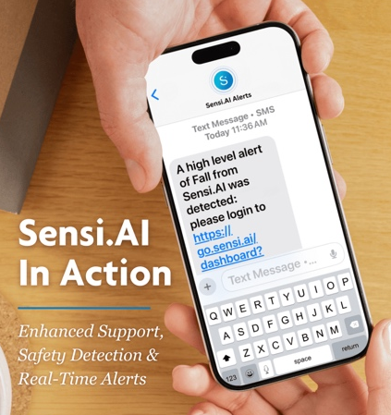
Types of Technologies
- Care apps like Sensi.AI – use “audio based trend analytics” to help caregivers make “data driven decisions”
  - Medication/safety management & monitoring tools
- Social agent robots (like ElliQ)
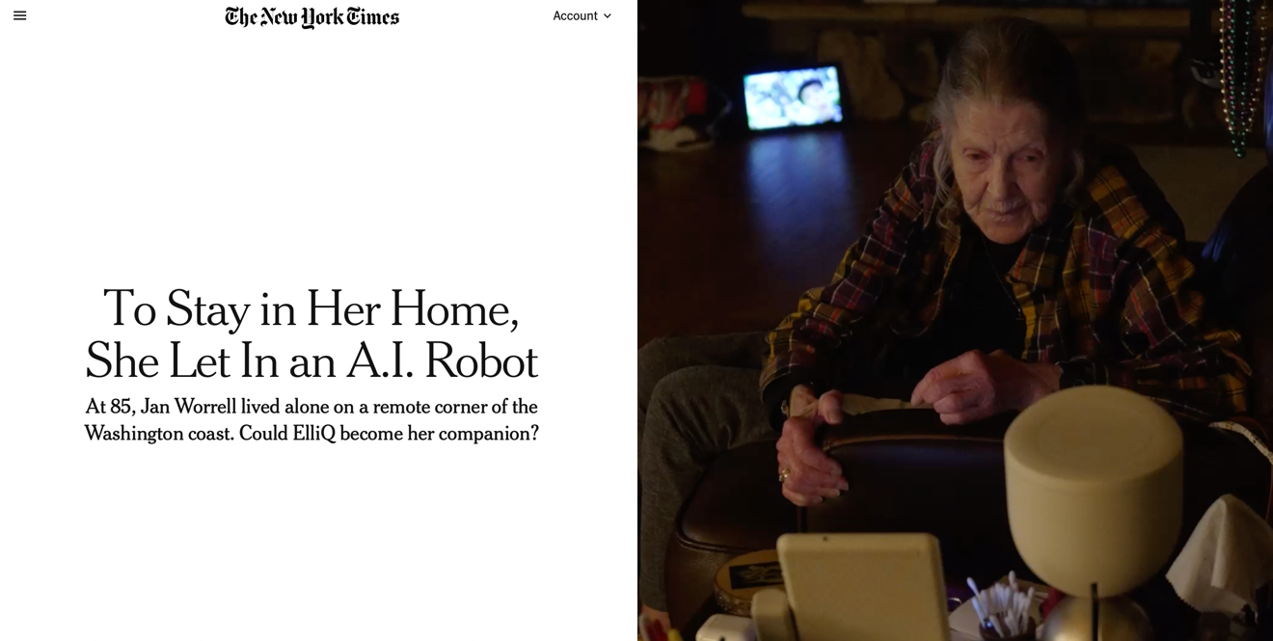

What Does Independent Living Really Mean?

- Freedom of choice
- Autonomy
- Agency

The Burrito Test
- Focuses not on what a home looks like, but whether the person who lives there is able to do what they want, when they want

- There’s no difference between not being able to microwave a burrito at 3AM because someone in-person prevented you from it, or because an AI tool warned your family about it who then prevented you from it.

Blurred Lines
- Technologies are blurring the lines between home and institution
- Our homes should be places where we can protect our privacy, and where we can choose what tech we want to use and when.
- Our commitment to independent living must include focusing on keeping disabled people at home and out of institutions, and keeping our homes free from unwanted surveillance.

Audience Q&A

Presenter Contact Information
- Ariana Aboulafia
  - ariana@cdt.org
  - cdt.org/disabilityrights
- Henry Claypool
  - Hclaypool80226@gmail.com

