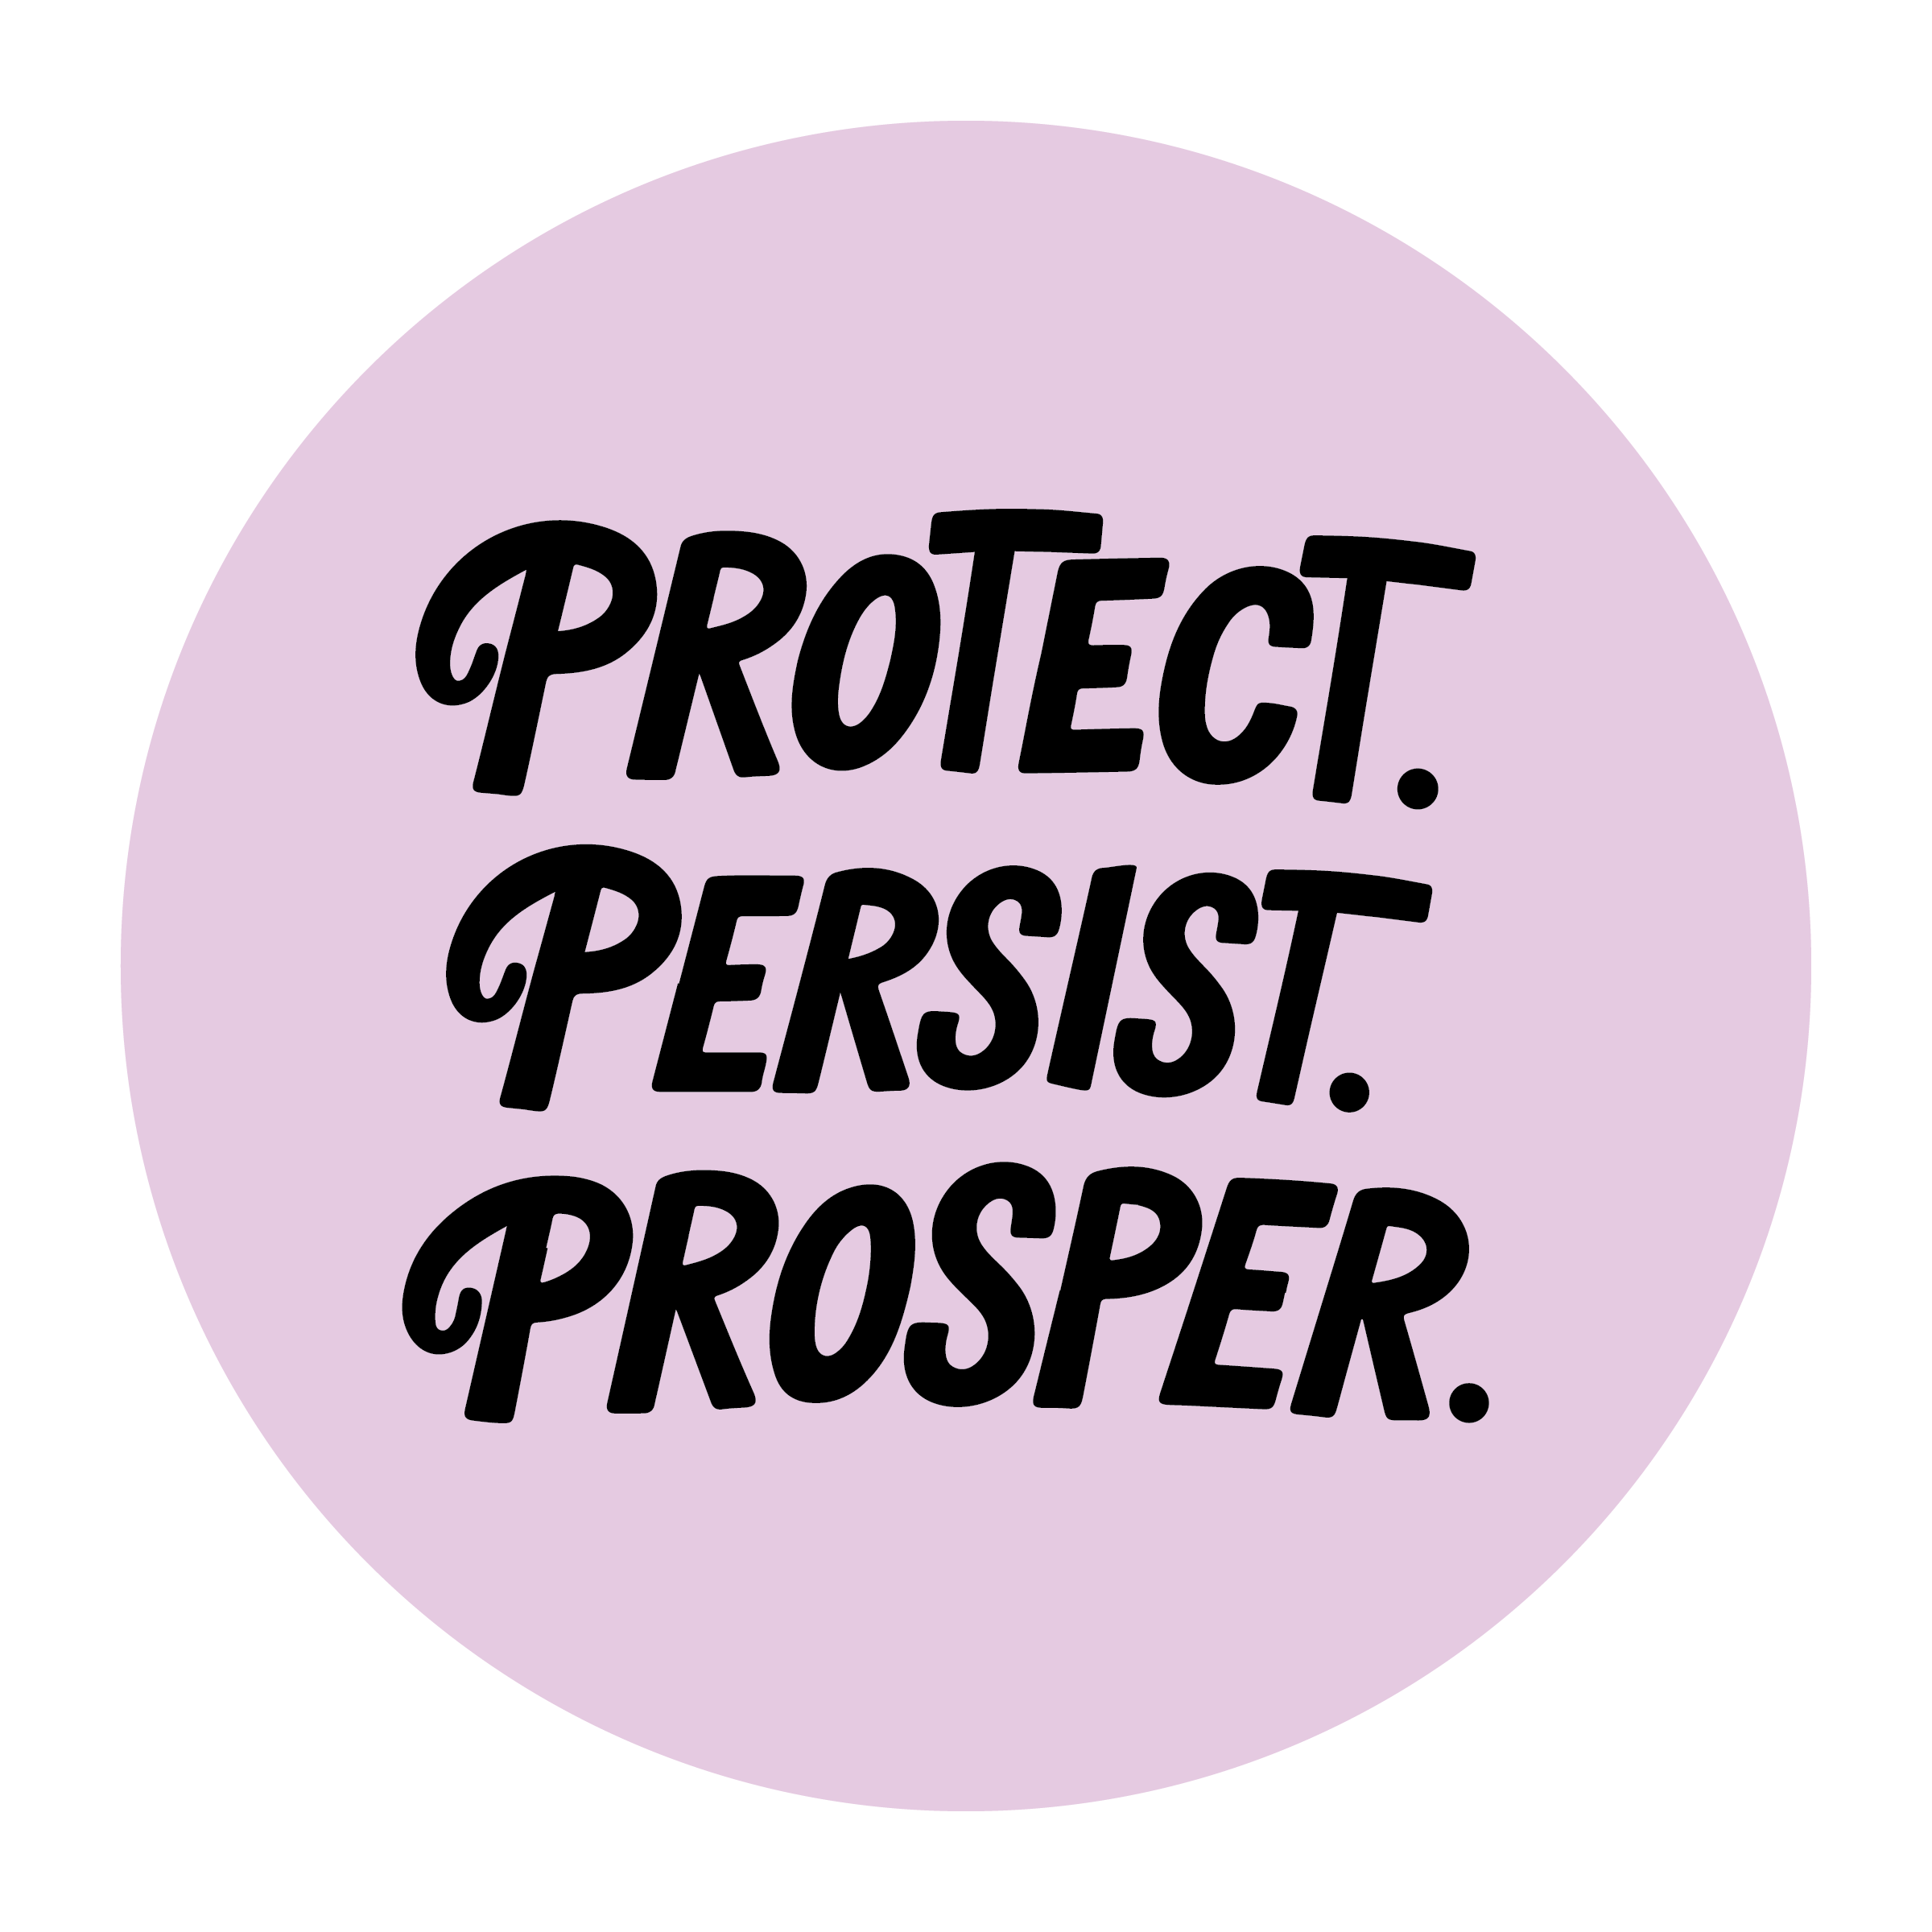

Annual Conference on Independent Living 2026

July 20-23 / Grand Hyatt / Washington, DC

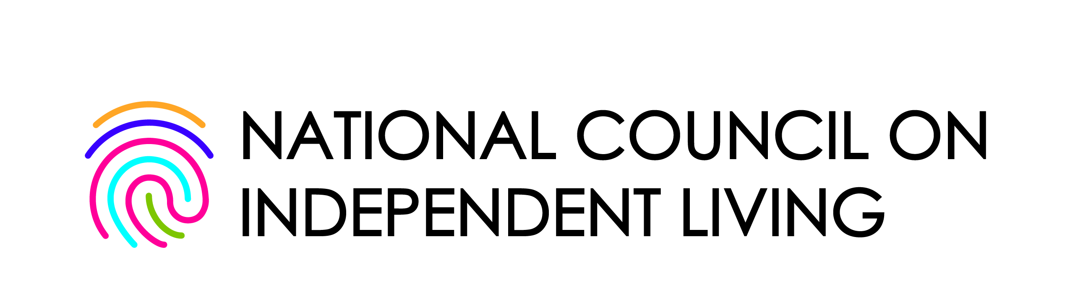
Presented by the National Council on Independent Living


Use our hashtag!

#NCIL2026


Table of Contents

Annual Conference on Independent Living 2026 1
Table of Contents 2
Sponsors 2
A Message from the Executive Director 3
Agenda 4
Access, Accommodations, and Resources 10
Map of Independence Level 5B 11

Sponsors

NCIL thanks our 2026 Annual Conference Sponsors: Centene, Microsoft, Waymo, Verizon, Airbnb, Inclusive Health Partners, Serve Robotics, Superior Van, New York State Independent Living Council, CIL Suite Powered by Q90, Caring Across Generations, New York Association on Independent Living, and Mitsubishi Electric America Foundation.

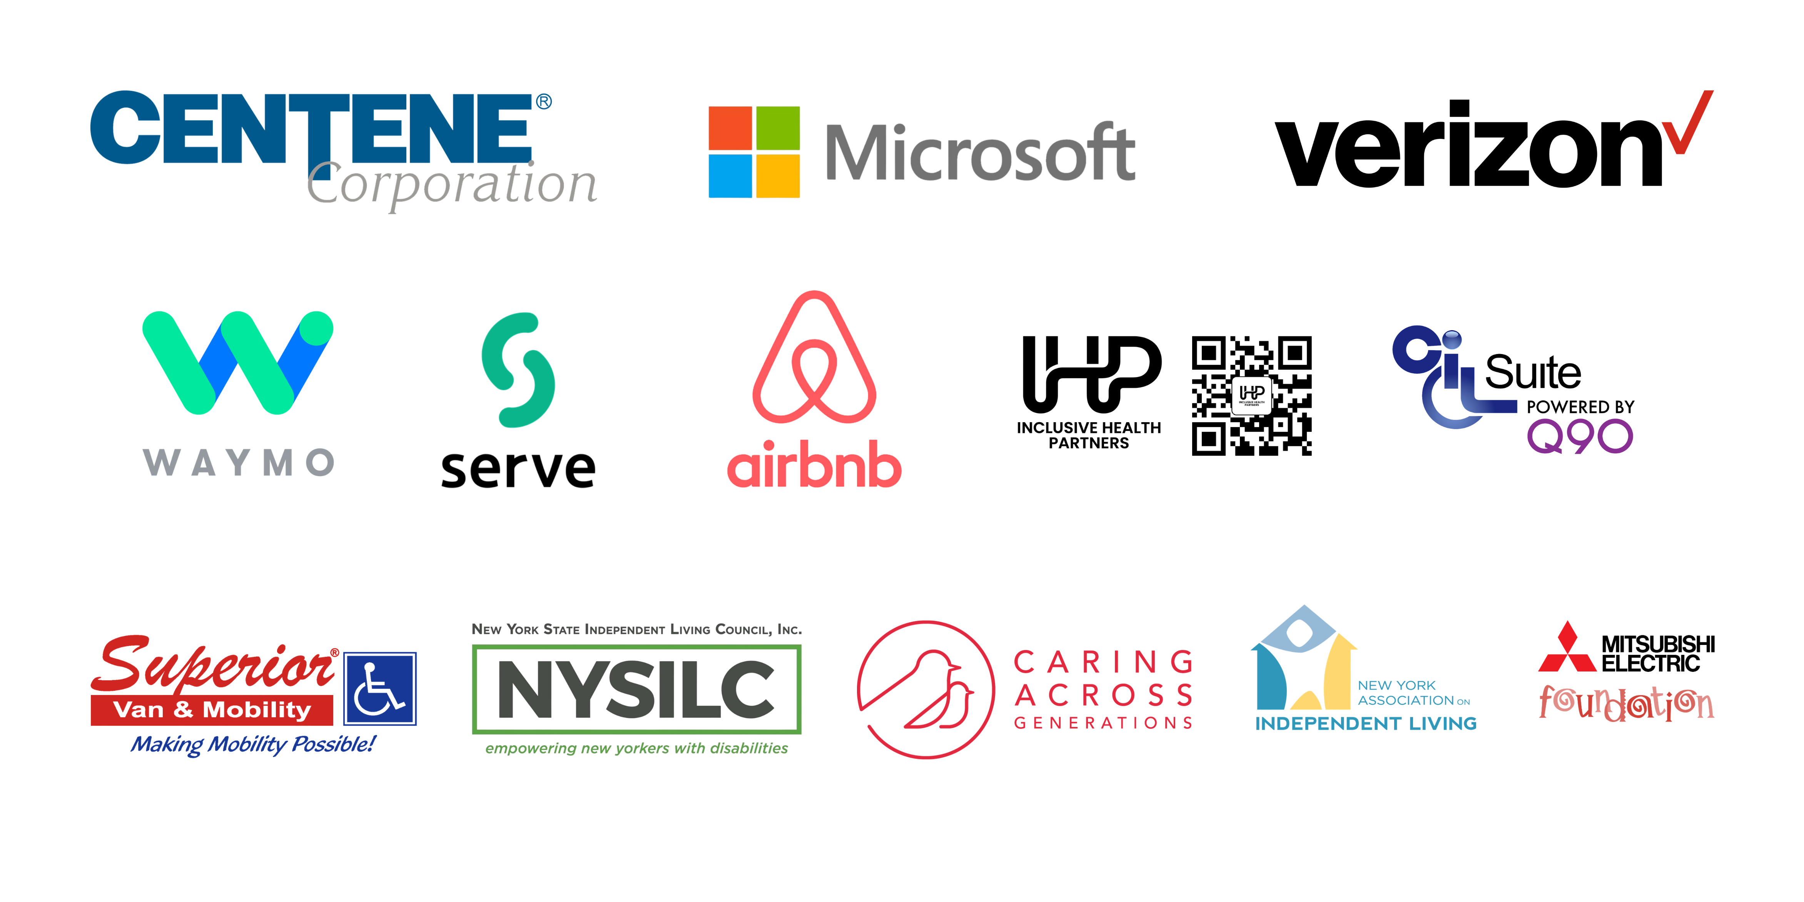

A Message from the Executive Director

It is my privilege to welcome each of you to this gathering of advocates, leaders, partners, and champions of the Independent Living Movement.

This year's theme is Protect, Persist, and Prosper. Three words that perfectly describe where we are today.

I have learned that the most important things in life rarely happen all at once. Progress comes little by little. And movements work the same way.

The Independent Living Movement didn't begin with thousands of people. It began with a few people who believed that people with disabilities deserved the same rights, opportunities, and freedoms as everyone else.

Little by little, they built something extraordinary: a nationwide network of Independent Living organizations in every state. Little by little, they built a movement. And they passed the baton to us.

Today, we are called to do three things: Protect what generations before us fought to build; Persist when the challenges seem overwhelming and progress feels slow; and Prosper by creating new opportunities, developing new leaders, and building a stronger future for people with disabilities.
It will happen the same way this movement has always moved forward.

One conversation; one relationship; and one action at a time. One victory at a time.

Over the next few days, I encourage you to learn from one another, challenge one another, and leave here energized for the work ahead.

Because together we are stronger. Together we are building the future. And together, we will protect, persist, and prosper.

Welcome to #NCIL2026.

Theo W. Braddy
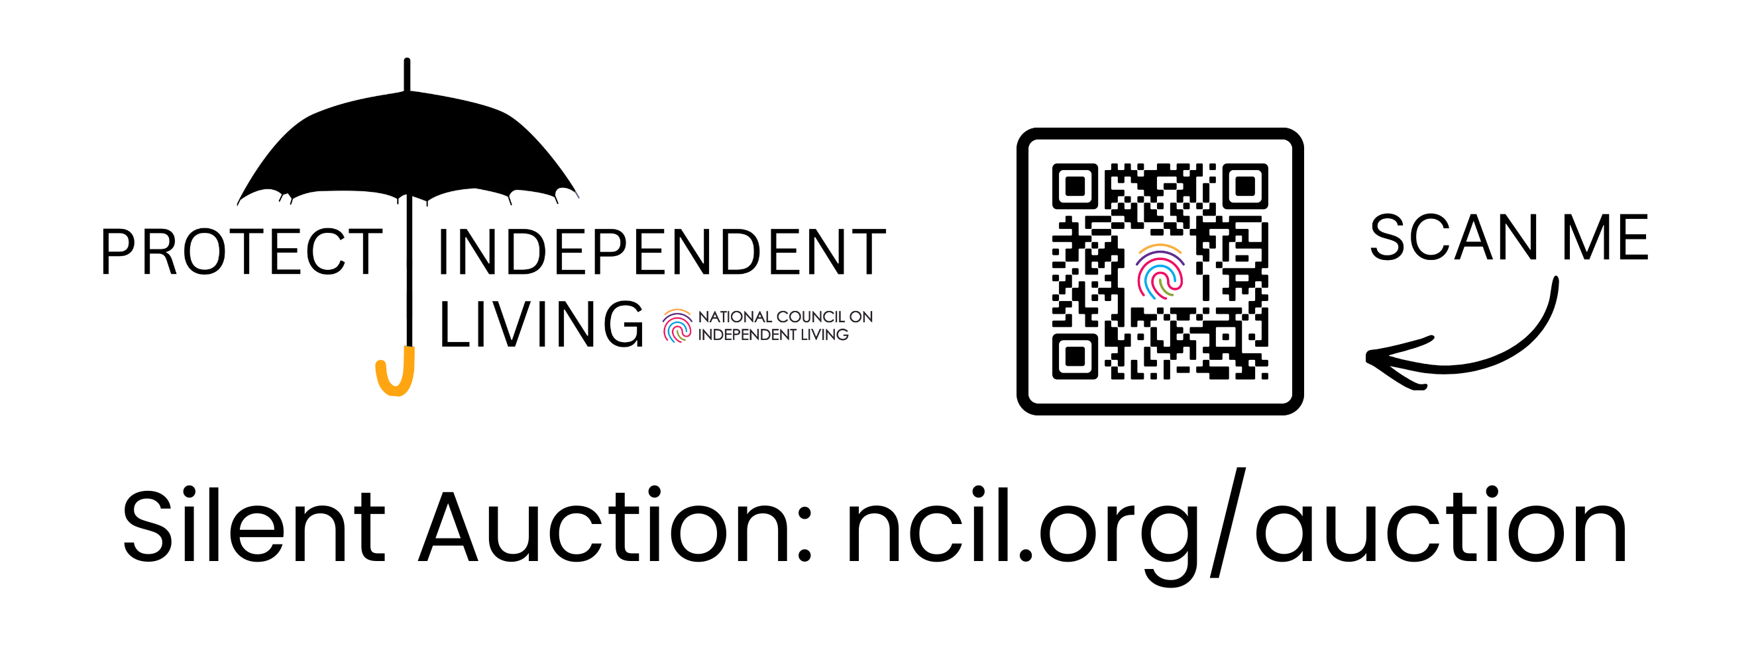

Agenda

Sunday, July 19, 2026

Registration Open

3:00 – 6:00 p.m. / Independence Foyer

Board Meeting

1:00 – 5:00 p.m. / Lafayette / Farragut

Board meetings are open to the public but not part of the formal conference agenda.

Monday, July 20, 2026

Registration + Exhibits Open

8:00 a.m. – 5:00 p.m. / Independence Foyer

Sensory Retreat / Quiet Space
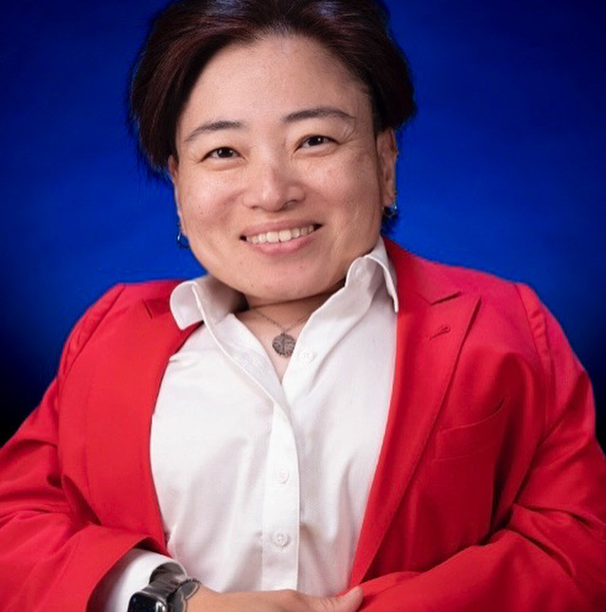
8:00 a.m. – 5:00 p.m. / Washington Boardroom (Constitution Level 3B)

Opening Plenary (Keynote by Mia Ives-Rublee)

9:00 – 10:00 a.m. / Independence A
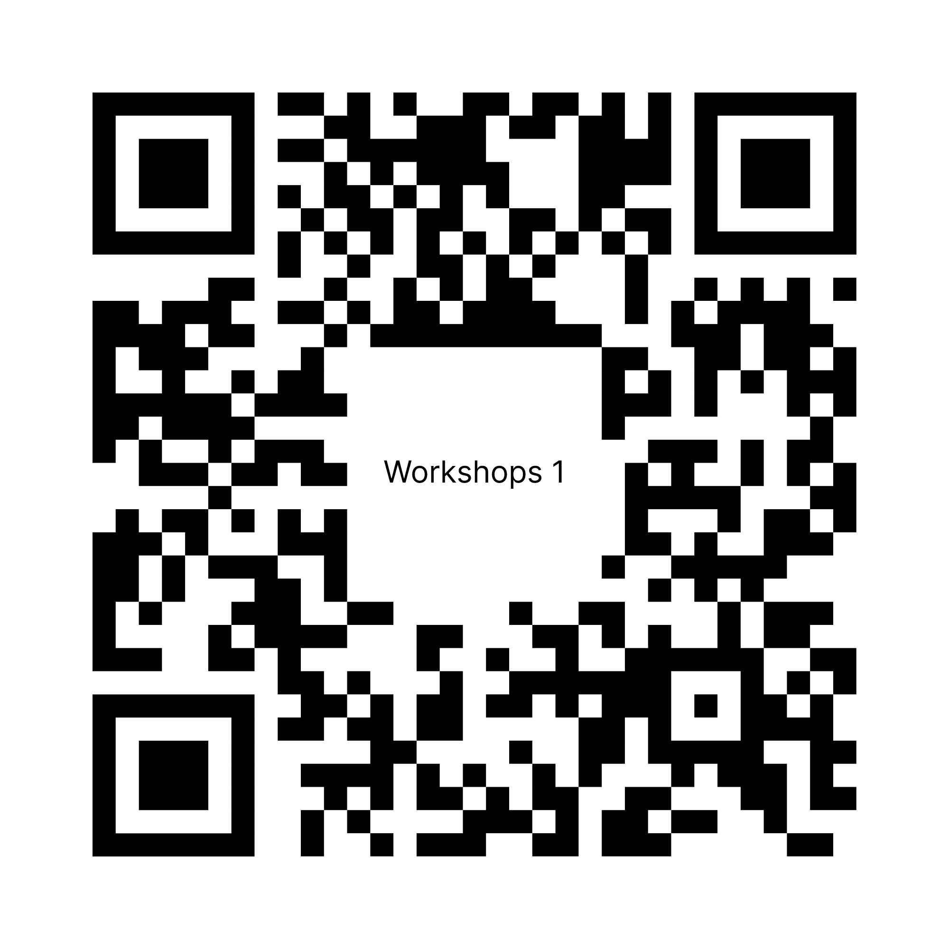

Concurrent Workshops 1

10:00 – 11:15 a.m. https://bit.ly/4peSbqr

1.1 Expanding Our Movement: Ensuring Independent Living Access for (Im)migrant Communities (Lafayette / Farragut)
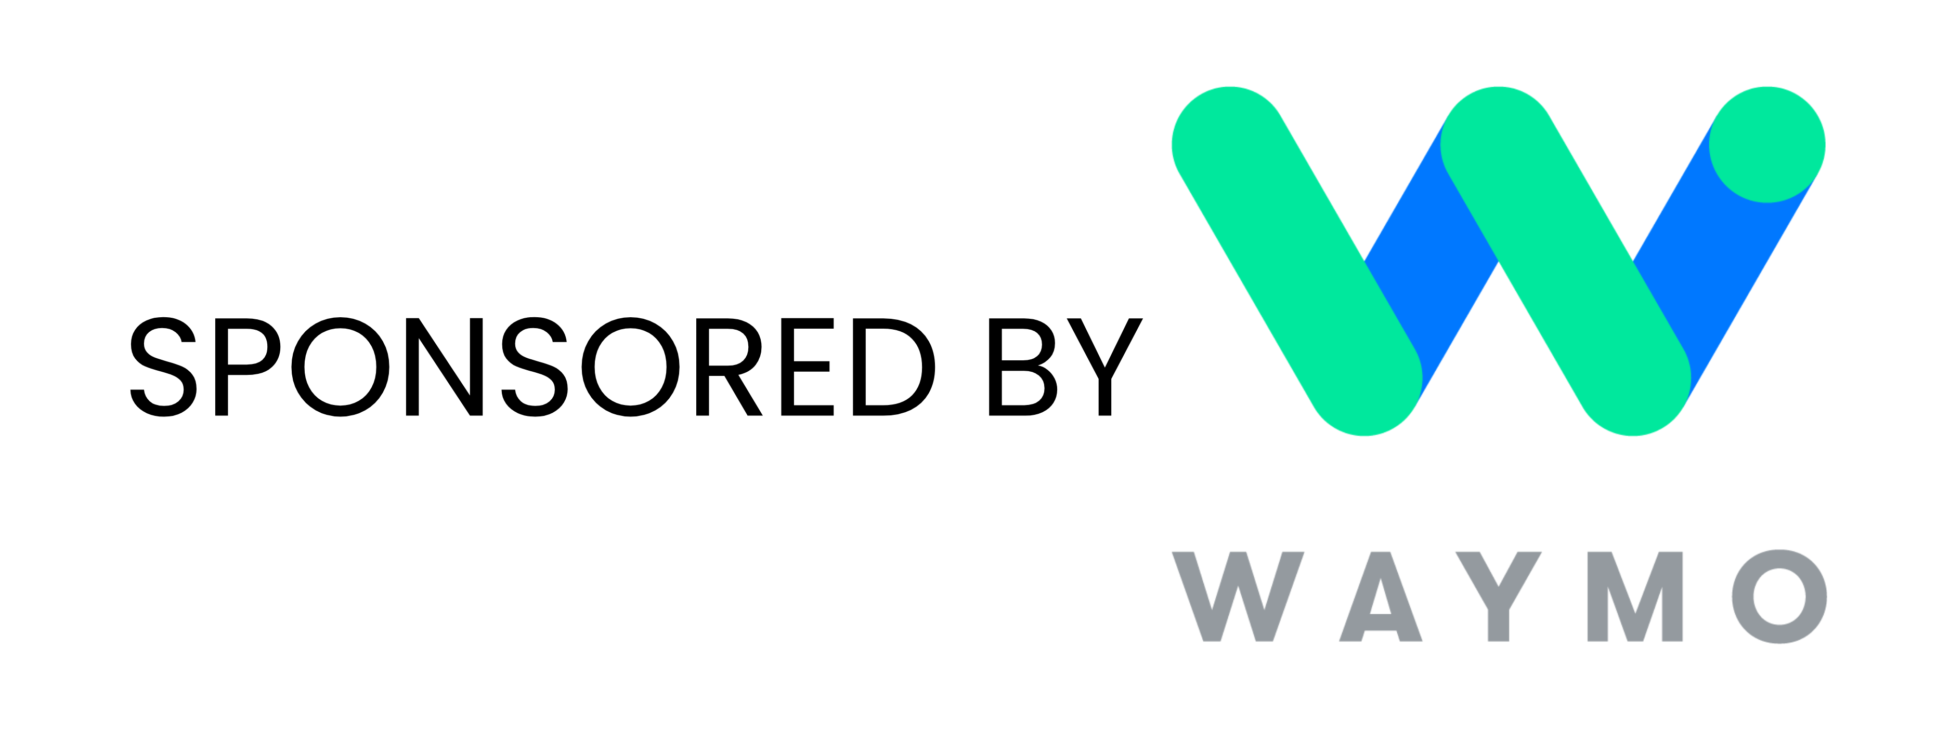
1.2 Supporting People with Intellectual and Developmental Disabilities (I/DD) at Local CILs (Franklin / McPherson)

Exhibit Fair 1

11:30 a.m. – 1:00 p.m. / Independence Foyer

Regional Caucus A: Regions 1 and 10

11:30 – 12:30 p.m. / Various Locations

Region 1 will meet in Lafayette / Farragut. Region 1 states are Connecticut, Maine, Massachusetts, New Hampshire, Rhode Island, and Vermont.

Region 10 will meet in McPherson. Region 10 states are Alaska, Idaho, Oregon, and Washington.

Awards Luncheon (Keynote by Kelly Buckland) & Annual Meeting

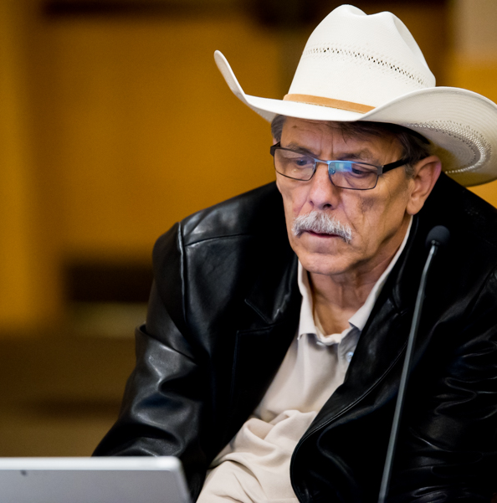
1:00 – 2:45 p.m. / Independence Ballroom

After the Awards Luncheon, attend the Annual Council Meeting to hear the results of the elections for Governing Board members.

Exhibit Fair 2

2:45 p.m. – 4:00 p.m. / Independence Foyer

Regional Caucus B: Regions 6 and 7

3:00 – 4:00 p.m. / Various Locations

Region 6 will meet in Lafayette / Farragut. Region 6 states are Arkansas, Louisiana, New Mexico, Oklahoma, and Texas.

Region 7 will meet in McPherson. Region 7 states are Iowa, Kansas, Missouri, and Nebraska.

Regional Caucus C: Regions 2, 4, and 5

4:00 – 5:00 p.m. / Various Locations

Region 2 will meet in McPherson. Region 2 states and territories are New Jersey, New York, Puerto Rico, and the Virgin Islands.

Region 4 will meet in Lafayette / Farragut. Region 4 states are Alabama, Florida, Georgia, Kentucky, Mississippi, North Carolina, South Carolina, and Tennessee.

Region 5 will meet in Independence Ballroom. Region 5 states are Illinois, Indiana, Michigan, Minnesota, Ohio, and Wisconsin.

Regional Caucus D: Regions 3, 8, and 9

5:00 – 6:00 p.m. / Various Locations

Region 3 will meet in Independence Ballroom. Region 3 states are Delaware, District of Columbia, Maryland, Pennsylvania, Virginia, and West Virginia.

Region 8 will meet in McPherson. Region 8 states are Colorado, Montana, North Dakota, South Dakota, Utah, and Wyoming.

Region 9 will meet in Lafayette / Farragut. Region 9 states are Arizona, California, Hawaii, Nevada, American Samoa, Guam, and Northern Mariana Islands.

Tuesday, July 21, 2026

Registration + Exhibits Open

8:00 a.m. – 5:00 p.m. / Independence Foyer

Sensory Retreat / Quiet Space

8:00 a.m. – 5:00 p.m. / McPherson
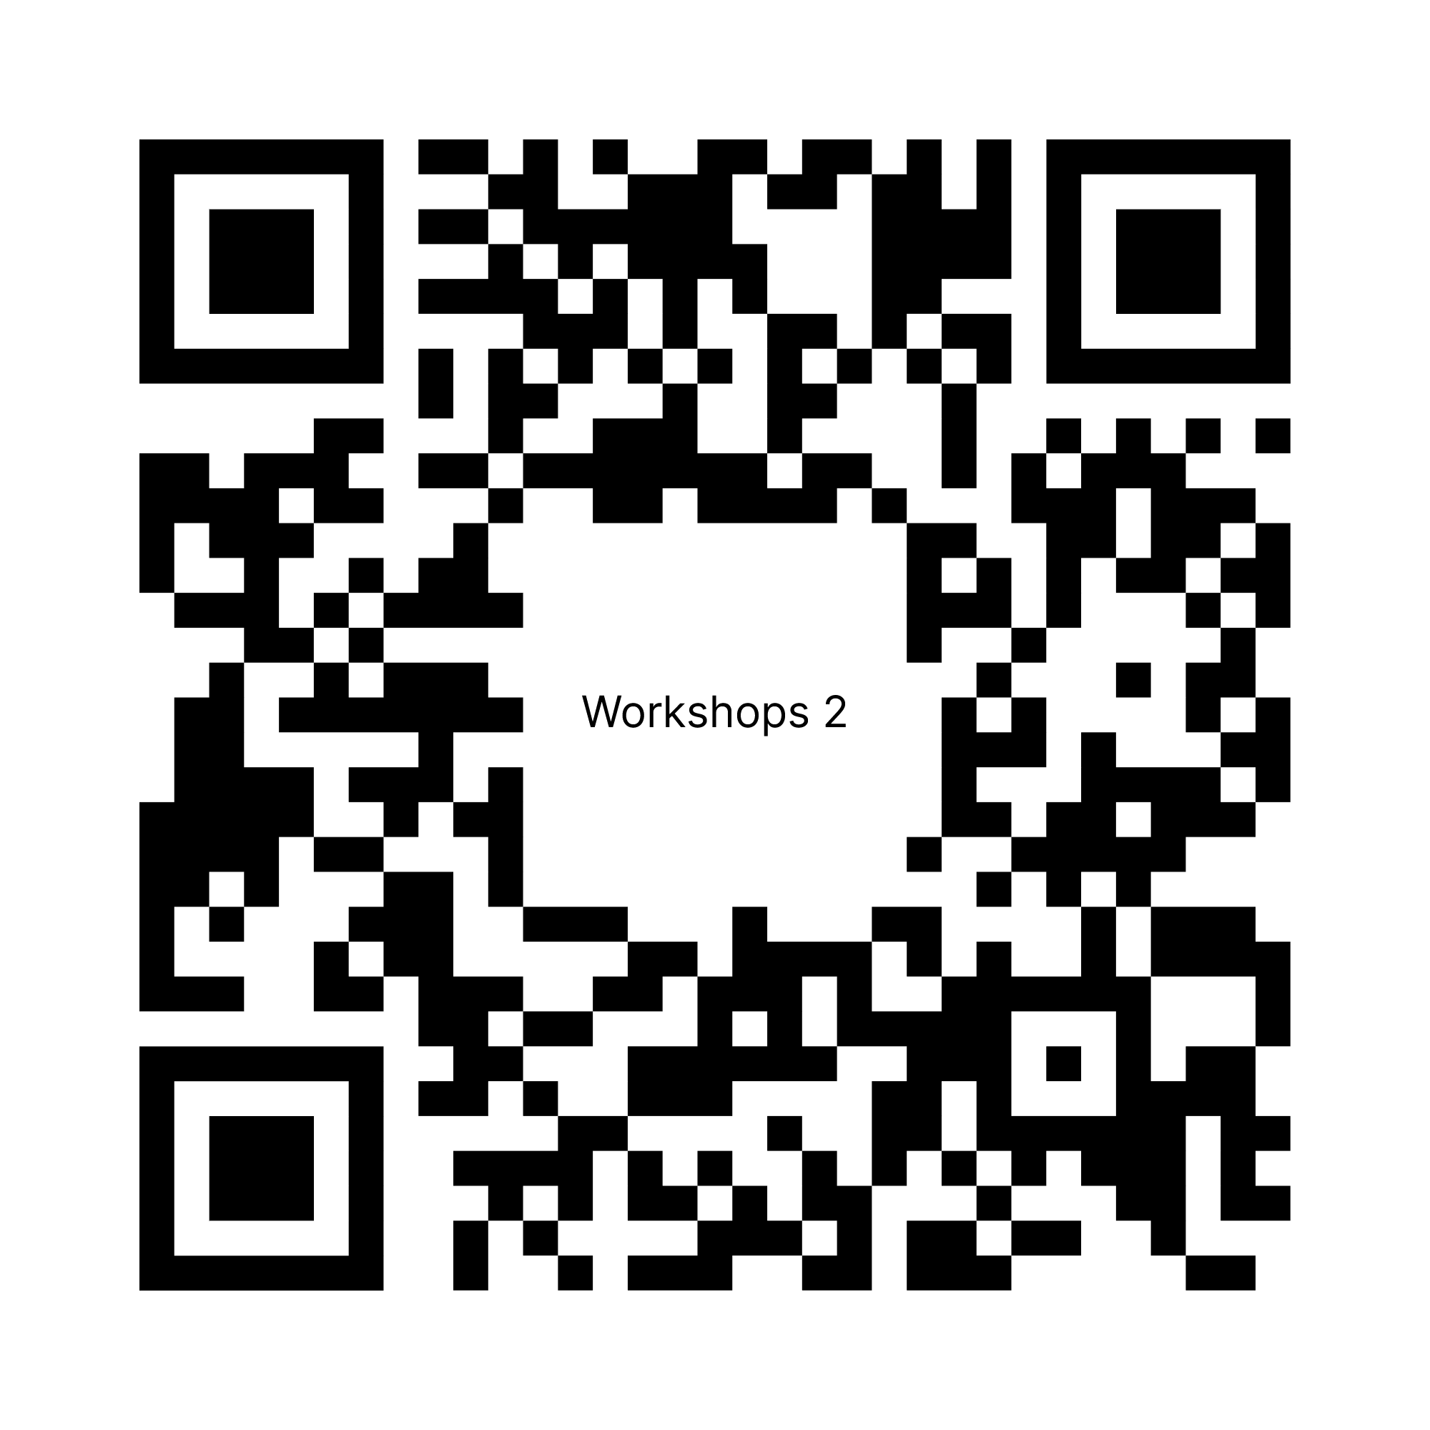

Concurrent Workshops 2

9:00 – 10:15 a.m. https://bit.ly/4wmhtVW

2.1 Navigating the Funding Landscape: Successful Philanthropic Engagement for the Disability Rights Movement (Independence A)


2.2 From Inside the House: How Surveillance Tech Poses Risks to Independent Living (Independence BCDE)

2.3 Everything I Learned About Self-Care I Learned from My Cat (Independence FGHI)

2.4 Project SHINE: Sexual and Reproductive Health Education Tools and Gaming for Youth with Disabilities (Lafayette / Farragut)

Advocacy Panel

10:30 – 11:30 a.m. / Independence A

This panel will provide a focused discussion on key priorities for upcoming Hill Visits and explore effective strategies for grassroots advocacy in today’s fast-changing policy environment.

After the Advocacy Panel, the Annual Conference closes for the day and the ADA36 March & Rally begins.

ADA36 March & Rally

Lunch (on your own)

11:30 – 2:00 p.m.

The March & Rally can be physically and emotionally taxing. We encourage you to take advantage of this lunch break to eat something.

March Assembly
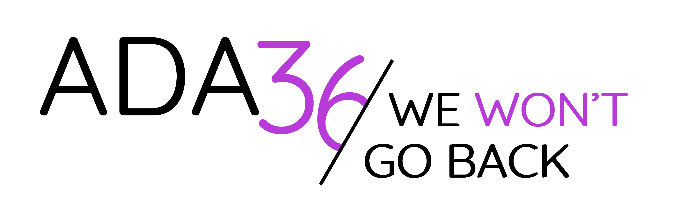
2:15 – 3:00 p.m. / 11th and G Streets NW

We will begin the March to the Capitol promptly at 3:00 p.m.

March to the Capitol

3:00 – 4:00 p.m. / Washington, DC

Complimentary Do-It-Yourself Sign Kits will be available on the conference floor the morning of Monday, July 20.

Rally at the Capitol

4:00 – 5:00 p.m. / U.S. Capitol

For more information about visiting Capitol Hill, please see NCIL’s Advocate’s Guide to the Hill (https://bit.ly/4wvQl71), which is included in your conference materials.

Wednesday, July 22, 2026

Registration + Exhibits Open

8:00 a.m. – 12:00 p.m. / Independence Foyer

Sensory Retreat / Quiet Space

8:00 a.m. – 5:00 p.m. / McPherson
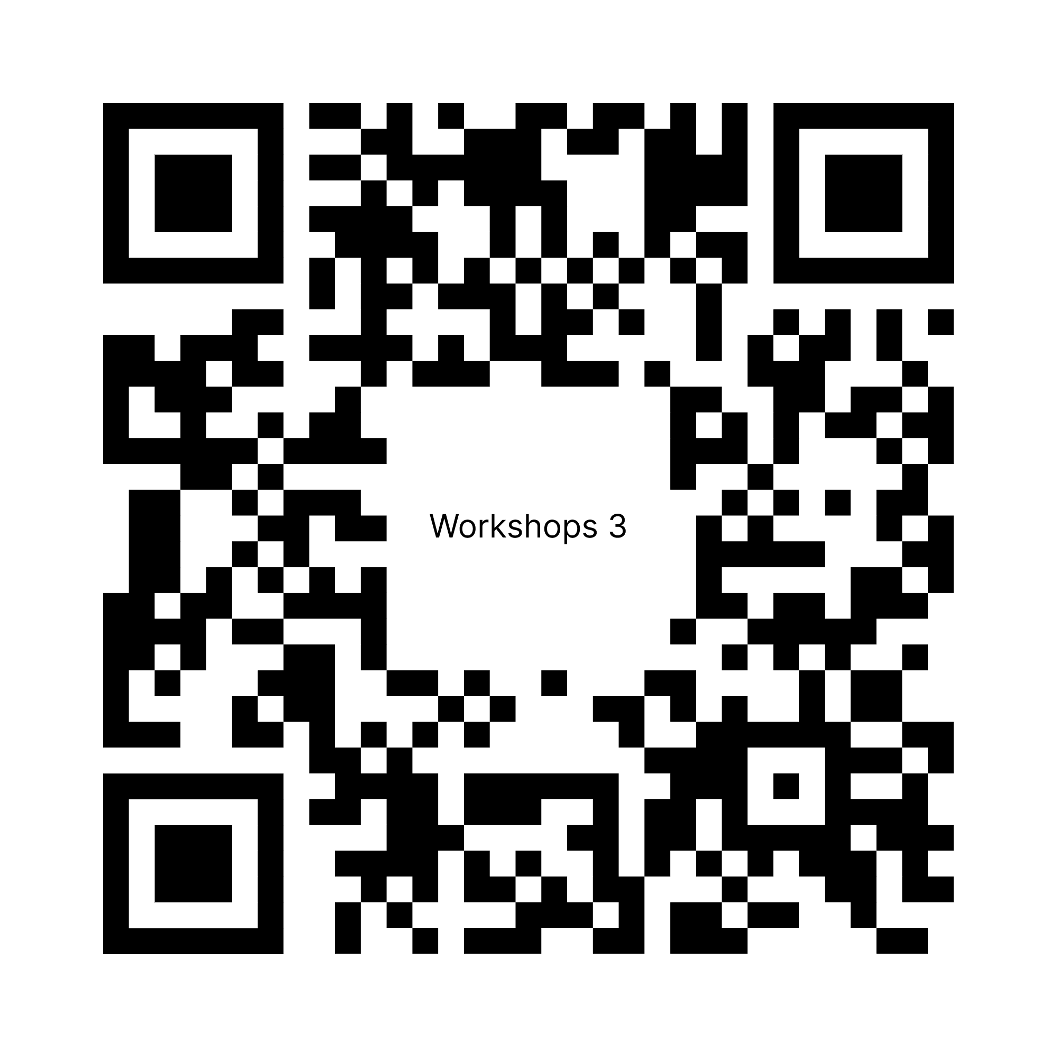

Concurrent Workshops 3

9:00 – 10:15 a.m. https://bit.ly/4p2fGTw

3.1 Defending Civil Rights at the Intersection of Disability and Immigration Under Escalating Federal Enforcement (Independence A)

3.2 Centers for Independent Living and Veteran-Directed Care: A Match Made in IL Heaven (Independence BCDE)

3.3 Bringing Bipartisanship Back to Disability Rights: Working Across the Aisle (Independence FGHI)
3.4 Beyond the Checklist: Student-Centered Advocacy in Action (Lafayette / Farragut)
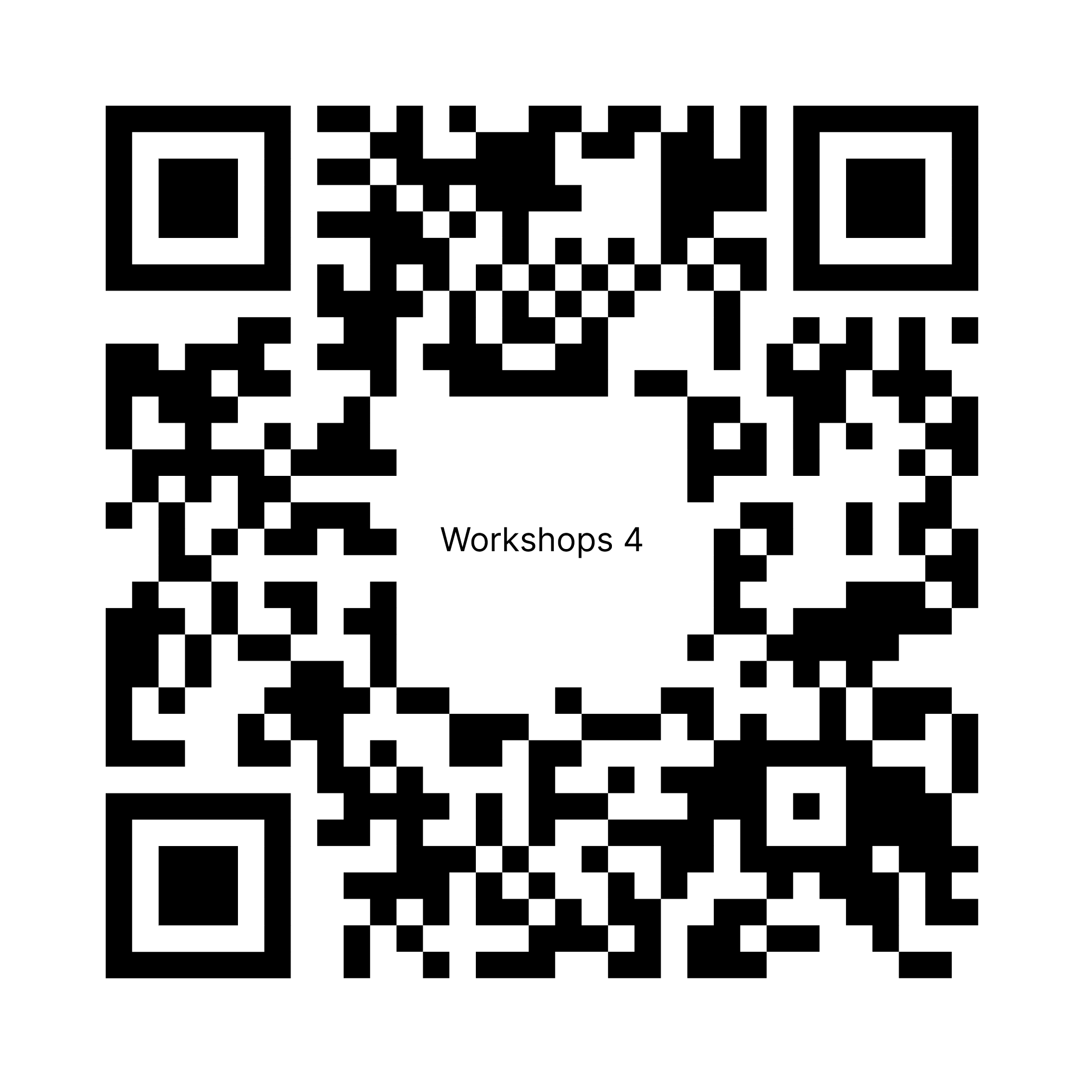

Concurrent Workshops 4

10:30 – 11:45 a.m. https://bit.ly/4va5M3B

4.1 Addressing the Direct Care Crisis: Creating an Advocacy Campaign around Direct Care (Independence A)

4.2 Shared Stewardship: A Lab for Emerging and Legacy Leaders (Independence BCDE)

4.3 Architects of Resilience: Designing a Cross-Disability Emergency Infrastructure (Lafayette / Farragut)

After Concurrent Workshops 4, the Annual Conference closes and Hill Visits begin. Conference activities resume at 4:00 p.m. with Professional Headshots.

Hill Visits & Hill Report Form

12:00 – 4:00 p.m. / Congressional Buildings
NCIL members are strongly encouraged to go and meet with their elected officials to discuss issues impacting people with disabilities and Independent Living nationwide. After your visit, fill out the Hill Report Form (ncil.org/report).

Professional Headshots

4:00 – 6:00 p.m. / Franklin

Have your headshot taken with NCIL’s professional photographer, Andrew Robertson. Donations are appreciated and will be split 50/50 between NCIL and the photographer. By participating in this event, you agree to allow NCIL to use the photos taken on NCIL’s website and other marketing materials.

Celebration of Community

7:00 – 11:00 p.m. / Independence Ballroom

We’ll open the dance floor and celebrate our community and the connections that keep us strong. For attendees who would like a quieter space, we will open Lafayette + Farragut for networking and games.

Thursday, July 23, 2026

Registration Open

8:00 a.m. – 12:00 p.m. / Independence Foyer

Sensory Retreat / Quiet Space

8:00 a.m. – 2:00 p.m. / McPherson
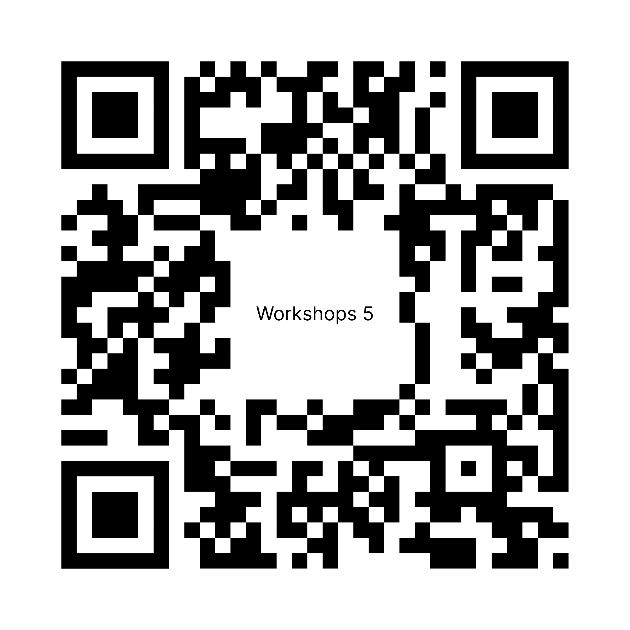

Concurrent Workshops 5

9:00 – 10:15 a.m. https://bit.ly/4wmmxtj

5.1 National Council on Disability (NCD) 2027 Policy Projects and Town Hall (Independence A)
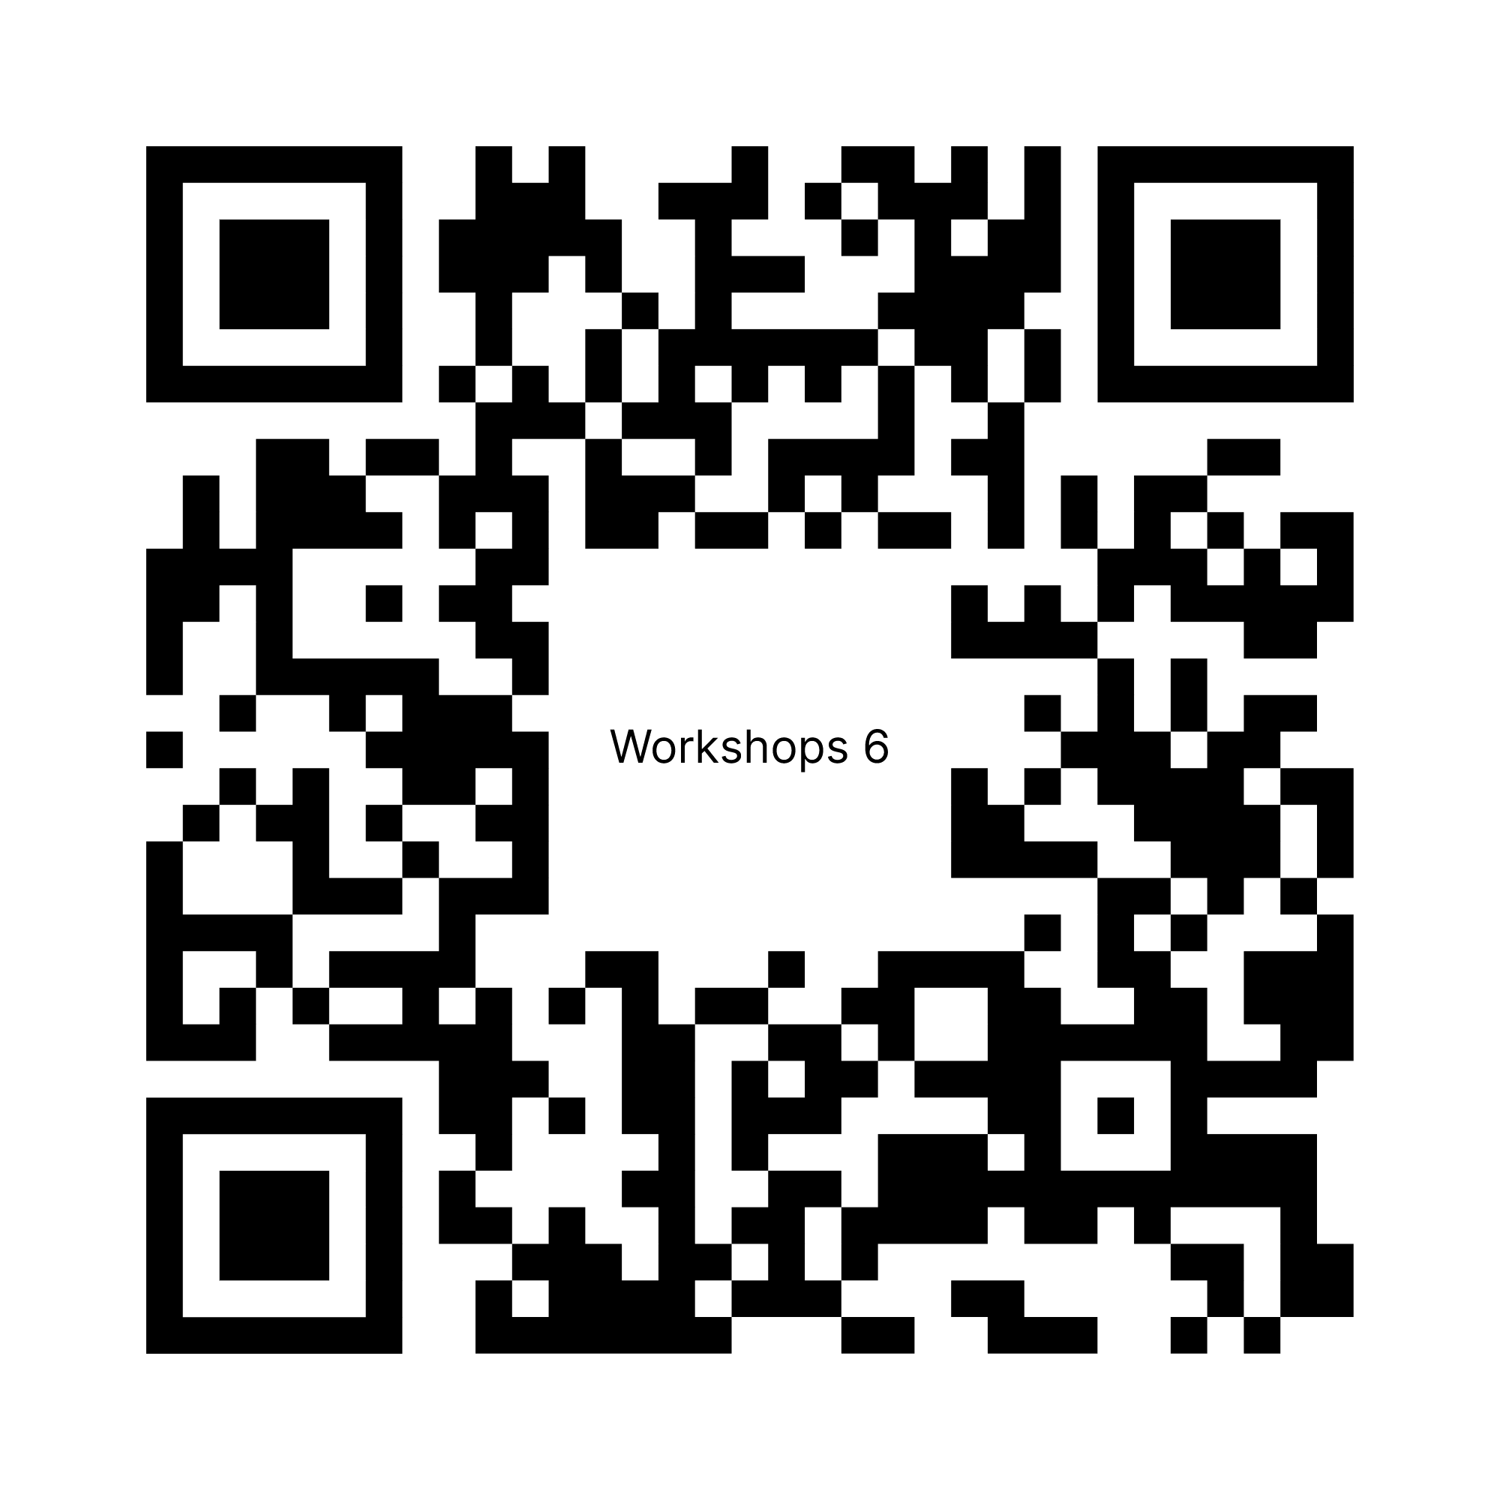

Concurrent Workshops 6

10:30 – 11:45 a.m. https://bit.ly/3SJFHLm

6.1 Assisted Suicide Panel (Independence A)

6.2 Advocacy: From Barriers to Breakthrough (Lafayette / Farragut)

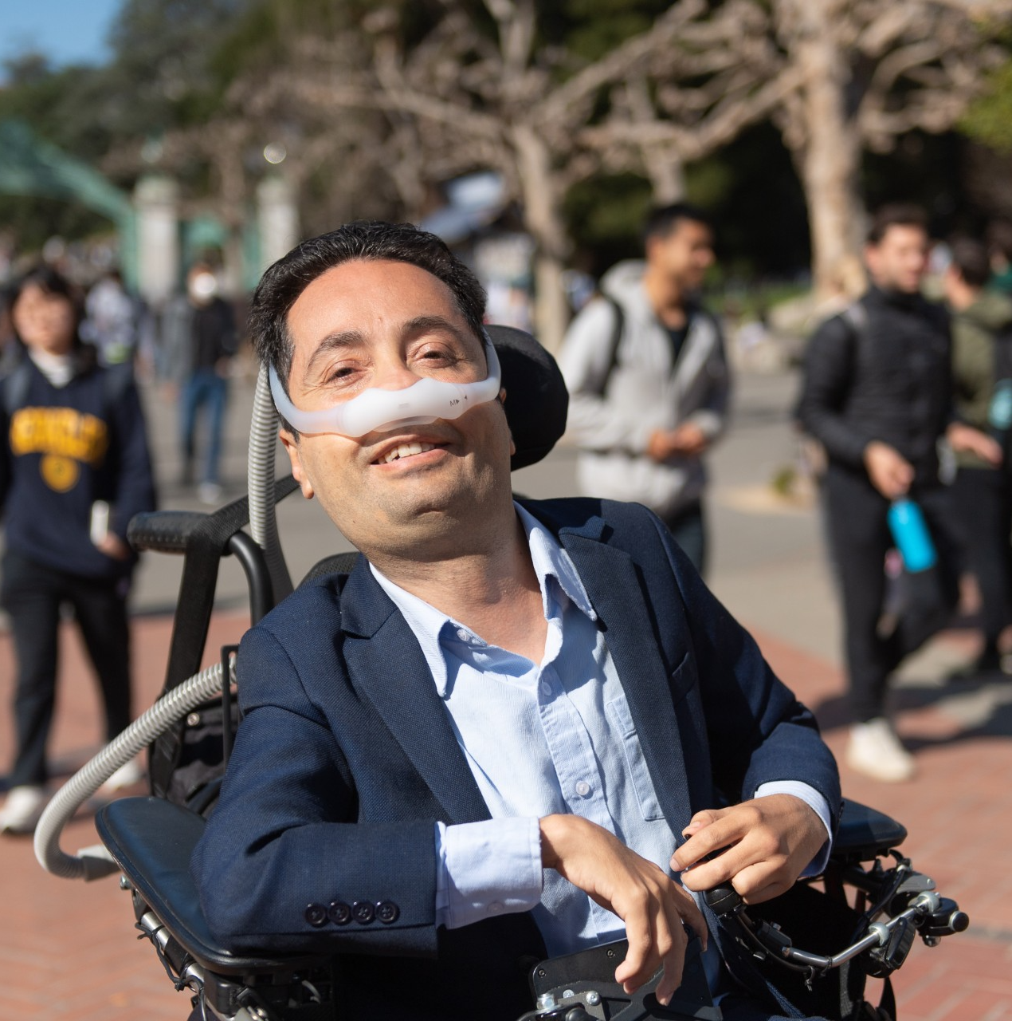
Lunch (on your own)

11:45 a.m. – 1:00 p.m.

Closing Plenary (Keynote by Dr. Victor Pineda)

1:00 – 2:00 p.m. / Independence A

Access, Accommodations, and Resources

Service Dog Relief Area
A boxed area with artificial turf is available on 10th Street NW from July 19-25.

Restrooms
All restrooms on Independence Level (5B) will be gender inclusive for the duration of the conference. Additional restrooms are available on Declaration Level (1B) and Constitution Level (3B).

Environmental / Chemical Sensitivities
NCIL requests that you come fragrance free. Please refrain from wearing any scented products or washing with them. This includes clothing that has been laundered with fragranced detergent or fabric softening products. Please completely air out any dry-cleaned clothing before wearing it to the conference. If you smoke, please use the designated smoking area located outside the Hyatt. Please refrain from smoking near any other doorways or paths of travel.

Parking
The maximum vehicle height for the garage at the Grand Hyatt is 6’ 6”. Taller vehicles (up to 8’ 2”) may park in the City Center complex, directly across the street from the Grand Hyatt.

Sensory Retreat / Quiet Room
During conference hours, a space is reserved as a quiet zone / sensory retreat. This is provided for individuals who need a break from overstimulation and / or the large group environment of the conference. Please do not use this space to hold conversations or meetings.

Language Translation
Powered by TranslateLive, NCIL will again offer a language translation app for conference attendees. This app uses an AI integration to translate many languages. If you would like complimentary access to this app for the entirety of the Conference, please contact jenny@ncil.org.
All conference documents are available on the conference website. To change the language settings, look for the drop-down menu at the top of any page and select the language you’d like to use.

Alternate Formats
Braille, Large Print, and plain text copies of NCIL materials are available at the registration desk.

Auxiliary Aids & Services
CART captioning, sign language interpreters, assistive listening devices, accessible materials, and other services will be provided for all Conference activities. However, participants must arrange their own services for Hill Visits. Congress is responsible for providing interpreters for Hill Visits upon request. Email contact: interpreters@saa.senate.gov.


Map of Independence Level 5B

Read a description of the conference floor map: https://bit.ly/4vicULo

