Shared Stewardship

A Lab for Emerging and Legacy Leaders


Brittany Boyd-Chisholm, CEO, Thrive CIL
NCIL 2026 Annual Conference


Protecting Disability-Led Leadership

- How do we ensure the Independent Living movement remains led by those with the deepest lived experience?
- Lived experience is not a baseline credential — it is an executive competency.
- Traditional professional paths create unnecessary barriers to executive advancement.

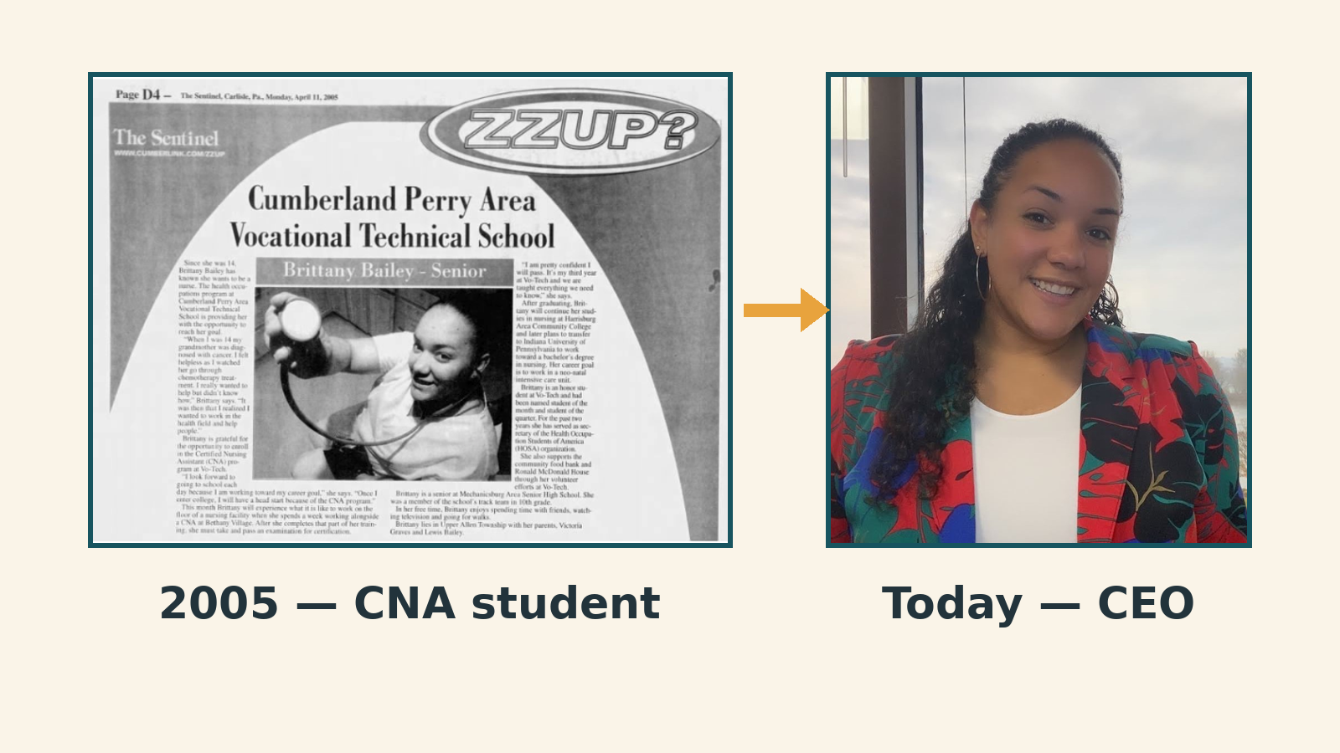
From the Front Lines to the Executive Office

- 20-year journey: CNA → CEO (2005-present)
- Frontline experience = direct insight into community barriers and consumer control
- The reality: one-week handoff and learning on the fly
- We must build intentional transitions, not survival by trial-by-fire


Defining Community Wisdom

- Unwritten History: Narrative of systemic advocacy battles and local policy wins
- Strategic Memory: The philosophical 'why' behind our operational choices
- When legacy leaders leave without transition plans, their wisdom walks out the door
- Our unwritten history keeps us rooted in consumer control


The Learning Roadmap

PROTECT — Organizational Stability — Transfer unwritten history before transition occurs
PERSIST — Lived Experience — Use a shared framework to validate frontline tenure
ADVANCE — Professional Growth — Build concrete 'Step Up' pathways into high-level spaces
STRENGTHEN — Leadership Pipelines — Legacy leaders create 'Intentional Voids' for rising leaders


Part 1: The Stewardship Audit

- Identify where power is held in your organization
- Emerging Leaders: Map your target growth spaces
- Map the unique frontline assets you bring
- Legacy Leaders: Identify your 'intentional voids'
- Where can you safely step back to create mentorship room?

Part 2: Reciprocal Wisdom Exchange

- Pair up across state lines and organization types
- Rising Voice: Share modern community barriers and grassroots pulse
- Veteran Voice: Share historical movement context and institutional strategy
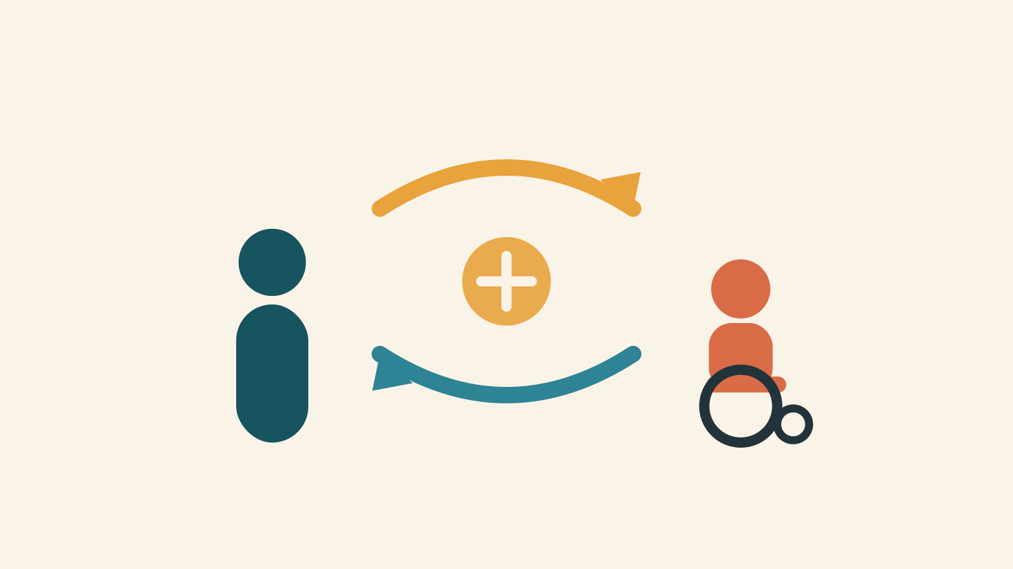
- Trade value for value — both have something essential to teach
- Cross-pollinating frontline grit with systemic memory


Part 3: Peer-Consulting Lab

Translate grassroots service into high-level organizational value
Emerging Leaders: Practice your Step-Up Pitch
Legacy Leaders: Act as executive consultants
Map how frontline expertise becomes systemic competency
Refine your ask — make it undeniable to a board or CEO


The Pledge of Stewardship

We pledge to protect the unwritten history of our movement.
We pledge to build intentional pipelines for disability-led leadership.
We pledge to share stewardship by design, not by accident.
We pledge to bring one concrete transition action back to our home community.
We pledge to ensure that no rising leader has to learn executive functions on the fly.
We are the keepers of Community Wisdom. And we choose to pass it forward.

Questions & Contact


Brittany Boyd-Chisholm
CEO, Thrive CIL
bchisholm@thrivecil.org
www.thrivecil.org
Let's build the bridge together

