>> SLIDE 1
Architects of Resilience:
Designing a Cross-Disability
Emergency Infrastructure
Presented by: Washington Statewide Independent Living Council (WASILC)
July 20, 2026
National Council on Independent Living (NCIL) 2026 Annual Conference
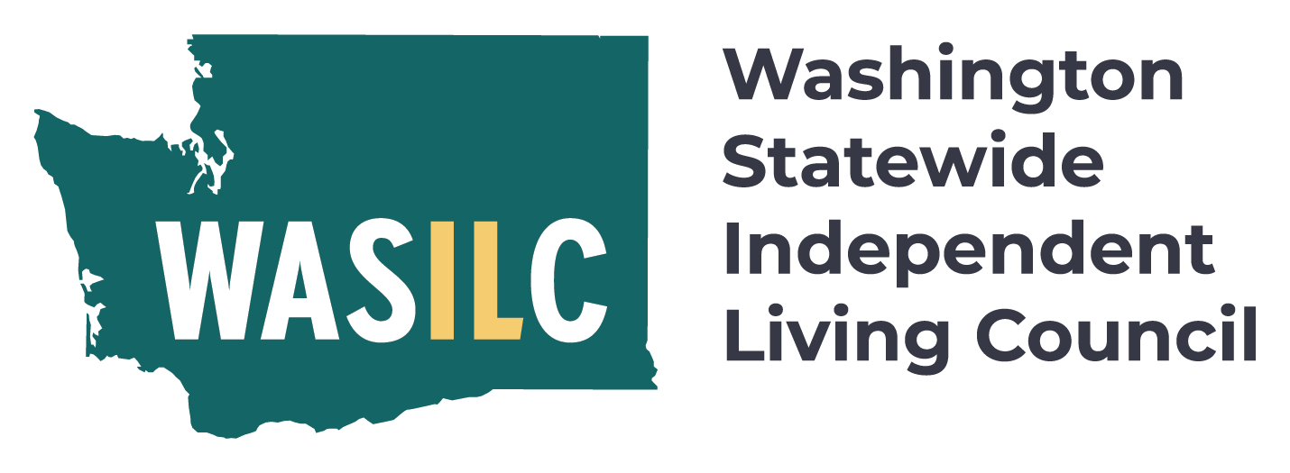
Image: Logo featuring a teal silhouette of Washington state with the acronym "WASILC" in bold white and yellow letters. Text to the right reads "Washington Statewide Independent Living Council".
>> SLIDE 2
Presenters (Introduction)
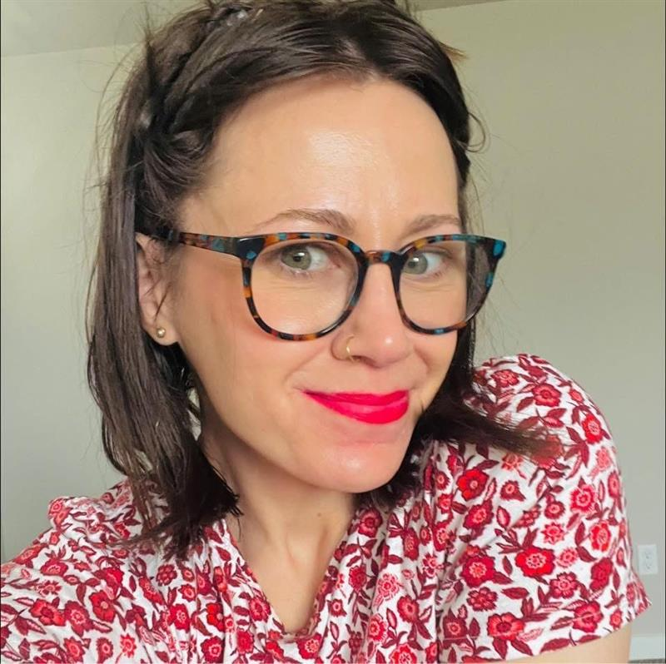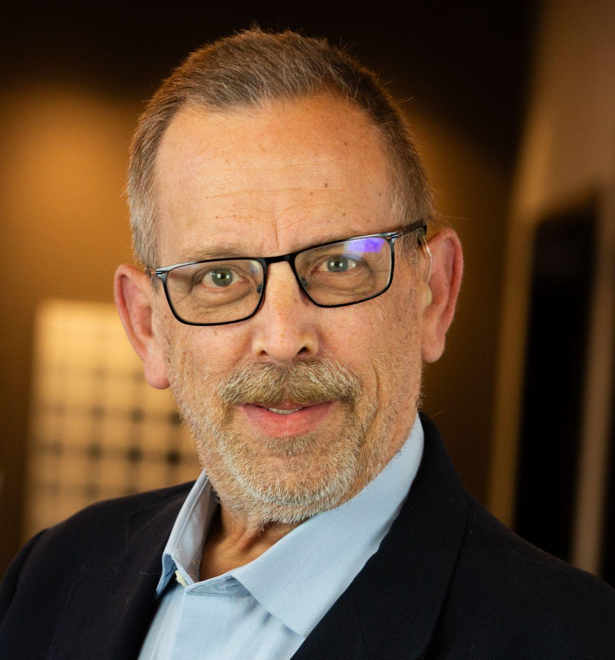
Image: Courtney Williams and Jim House
Courtney: I am a strategic leader, policy advocate, and the Executive Director of the Washington Statewide Independent Living Council (WASILC). Dedicated to advancing cross-disability equity, I leverage my expertise in legislative advocacy and negotiation to drive systemic change. My background includes serving as Director of Government Affairs at the Adult Family Home Council, where I was instrumental in eliminating Washington's subminimum wage and establishing a statewide school-to-work initiative.
As a recognized expert in the CMIST emergency management framework, I currently lead the WA-REACH Pilot to integrate disability perspectives into state emergency systems. Named one of South Sound Magazine’s 40 Under 40 in 2023, I am a published researcher and speaker with an MPA and a BA in Social Work and Civic Intelligence from The Evergreen State College. I remain deeply committed to building the coalitions and collaborations necessary to foster truly inclusive, resilient communities.
Jim: As the Disability and Access and Functional Needs (AFN) Integration Manager for the Coalition on Inclusive Emergency Planning (CIEP) with WASILC, I forged partnerships with state agencies and community-based nongovernmental organizations and Nationally recognized by other disability advocacy groups, implemented several innovative solutions to remove barriers in emergency planning for people with disabilities before, during, and after disasters. CIEP gesture training and the recent AFN Review After-Action Report highlighting best practices and areas needed for improvement during the atmospheric river storms in December 2025. As a subject matter expert, Jim participates in several forums and coalitions covering access issues with emergency notifications, captioning, and mobile, text, and video telecommunications.
Previously, as the former board member and public relations director with TDIforAccess, Inc. (TDI) for many years. Some of my accomplishments are co-authoring “A PATH TOWARD AN ACCESSIBLE WORLD," a book that documents TDI's first 50 years of advocacy, culminating with the Communications and Video Accessibility Act of 2010 through systemic advocacy, pushing for improvements in captioning on TV and the internet. I wrote some successful grant proposals, including a $1.5M federal grant to develop emergency preparedness training programs and planned publications, conferences, and workshops.
In 2015, because of my ongoing community leadership, Portland, Oregon, passed the first captioning display ordinance requiring all television sets in public places to show captions during business hours. The idea behind this was to ensure access to breaking news and weather reports away from home. This ordinance has been emulated in cities around the country, and in 2021, Washington became the first to enact this law statewide.
In 1987, I was a key player in establishing the first real-time local news captioning service in Washington, DC, on its ABC affiliate, WJLA TV-7. Less than a year later, as an alumnus of Gallaudet University, I worked with its news team in producing comprehensive and accessible coverage of its landmark DEAF PRESIDENT NOW (DPN) movement in 1988, with captions and ASL. DPN was one of many disability rights events that directly led to the enactment of the Americans with Disabilities Act in 1990.
>> SLIDE 3
Welcome & The Blueprint (Introduction)
Welcome to Architects of Resilience. As advocates leading systemic strategy, our core premise is absolute: Effective emergency management must be built from the ground up, not imposed from the top down. "Disability" is not a single checkbox—it is a vast, beautiful, and complex spectrum of entirely different, individualized needs. Traditional emergency systems are failing because they lack this design perspective. Today, we look at the blueprint to change that.
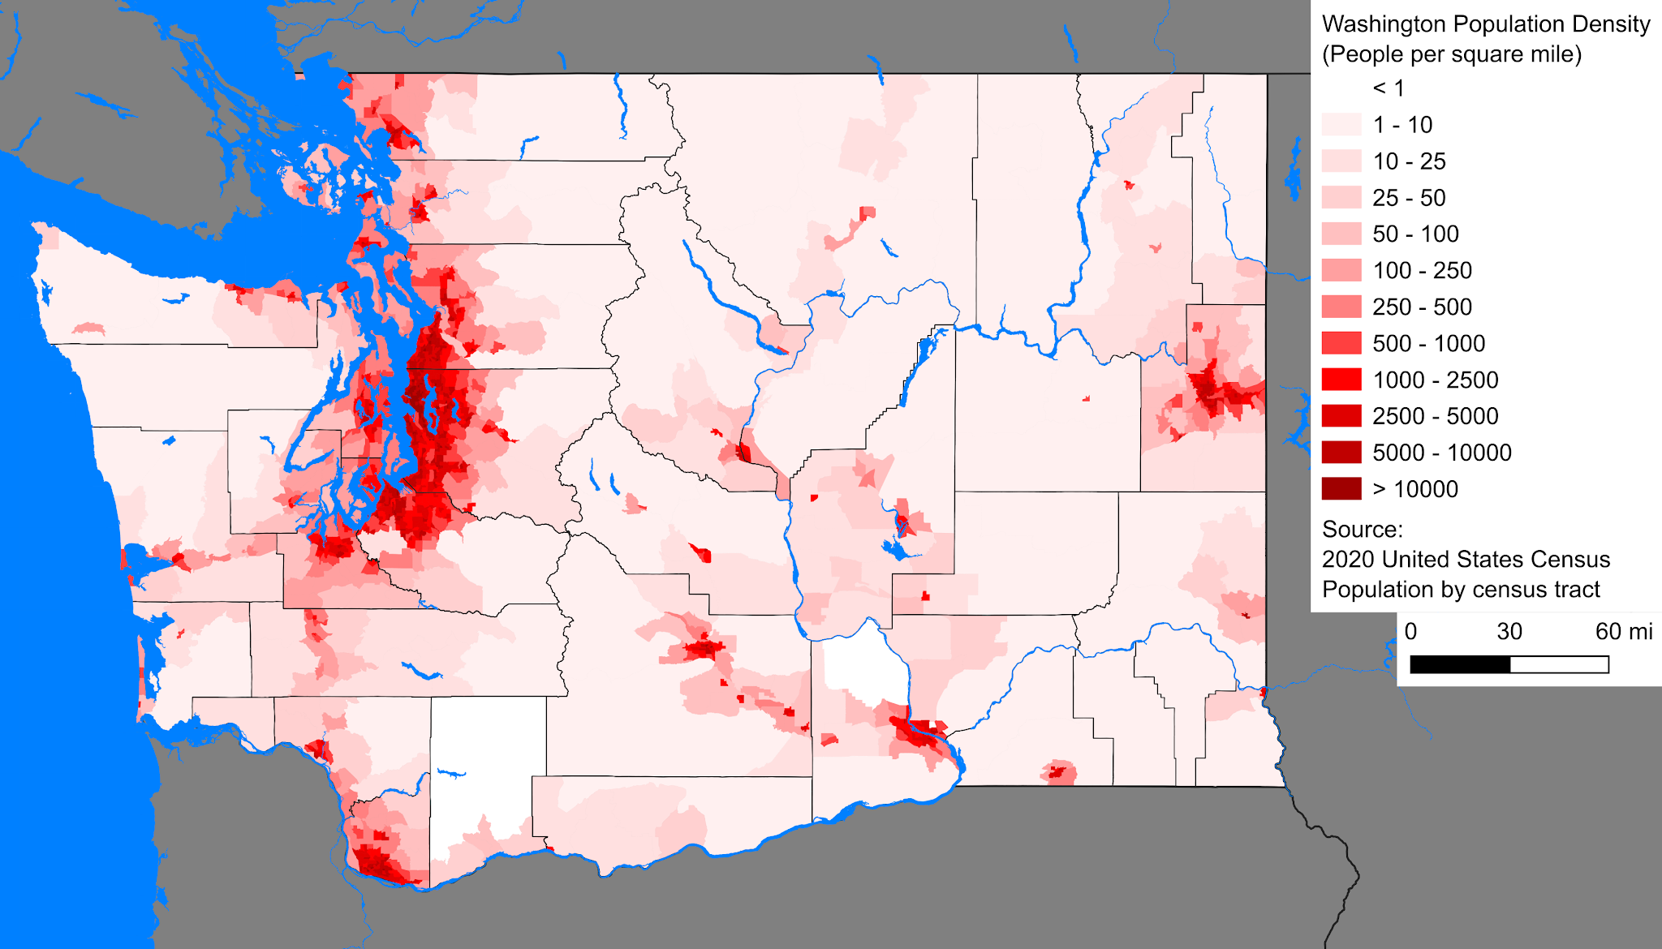
Image: A clean, minimalist architectural blueprint graphic overlaying a crisp outline map of Washington State.
>> SLIDE 4
Shifting the Paradigm: Advocate-Led Discussions
Emergency management structurally crumbles the moment it treats disabled people as a single, uniform block. We are completely flipping the script and shifting the power dynamic. By putting planning authority directly into the hands of grassroots advocates, we replace bureaucratic guesswork with the undeniable reality of lived experience. We aren't asking for a seat at their table anymore; we are building our own.


Image: Photograph of a diverse group of four business professionals smiling and holding up a large yellow trophy cutout, symbolizing achievement or success. The group is dressed in business attire, standing under a bright, modern architectural structure, highlighting teamwork and celebration.
>> SLIDE 5
Defining the Cross-Disability Spectrum: Everyone Needs Something Different
In the world of emergency preparedness, true "cross-disability" means planning for total variance, not a convenient average. A single crisis event creates entirely conflicting needs across our community—what saves one person could trap another. We must structurally design systems that anticipate absolute differences in communication, mobility, sensory, and medical requirements. If your plan doesn't account for total variance, it isn't a plan; it's a hazard.
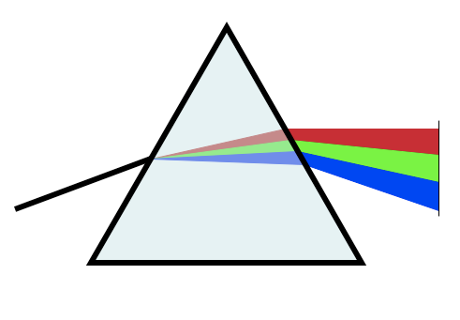
Image: Diagram of light dispersion through a triangular prism showing white light entering from the left and splitting into red, green, and blue beams exiting on the right. The prism is outlined in black with a light blue fill, and the separated colors are displayed as distinct colored bands.
>> SLIDE 6
Redefining "Emergency": Natural vs. Personal Crises
Catastrophes don’t always wait for a headline-grabbing natural disaster to strike an entire city at once. For our community, devastating personal, isolated emergencies happen in silence every single day—a sudden power outage that cuts off life-sustaining equipment, or an agency failure that leaves an individual without a critical personal care provider. Our city and county systems must be architected to withstand both regional disasters and individual, everyday crises.

Image: A stereoscopic VR scene showing numerous floating cubes scattered across a bright, open environment with a glowing light source in the center. The view is split into two nearly identical circular frames with slight chromatic aberration, designed for immersive 3D visualization.
>>SLIDE 7
The SPIL as our Foundation
We refuse to treat the State Plan for Independent Living (SPIL) as a dusty, bureaucratic box-checking exercise. In Washington, we have weaponized the SPIL, transforming it into a rock-solid structural foundation. We use it to legally mandate and aggressively fund advocate-led emergency preparedness initiatives. This ensures our statewide infrastructure is legally bound to protect the cross-disability community through every tier of crisis.
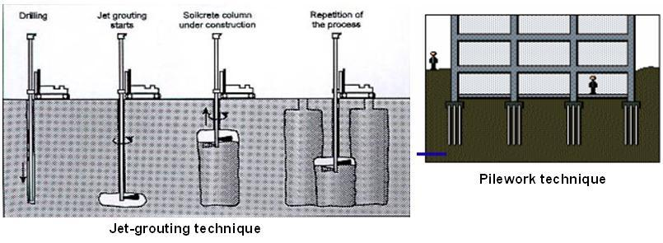
Image: A structural blueprint diagram showing a solid concrete foundation labeled "State Plan for Independent Living (SPIL)" supporting community infrastructure.
>> SLIDE 8
Data to Counties – Mapping Individual Realities
High-level state numbers are too abstract to save lives on the ground. We are driving hard data down to the exact county level, putting undeniable human realities right on the desks of local emergency managers. You cannot plan for needs you refuse to see. By mapping the precise cross-disability demographics of each jurisdiction, we remove ignorance as an excuse and force local coordinators to plan for the actual people who live there.
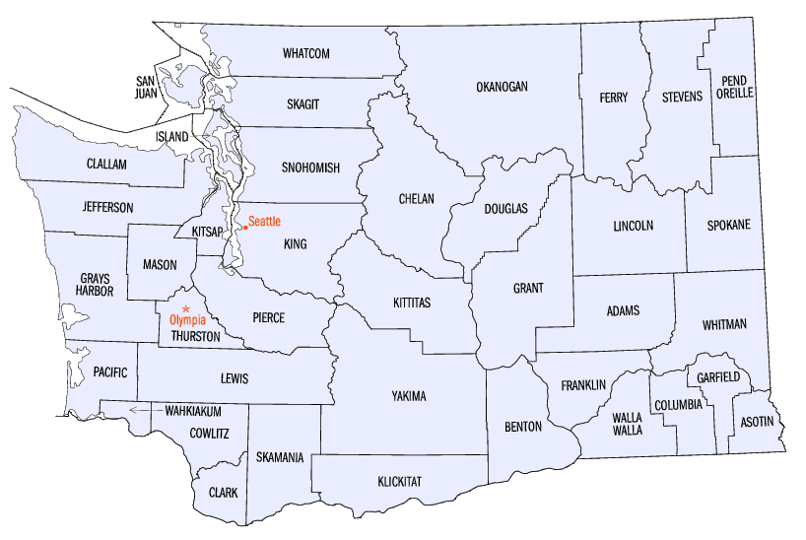
Image: A detailed map of Washington State broken down clearly by individual county jurisdictions and boundaries.
>> SLIDE 9
Self-Preservation: Helping Individuals Map Their Needs
Systemic advocacy is only half the battle; true resilience requires individual empowerment. We are putting the power of self-preservation directly back into the hands of our community members. By providing accessible, deeply customizable toolkits, we assist individuals in auditing their own environments and engineering personal, highly specific emergency blueprints that reflect their exact daily survival needs.
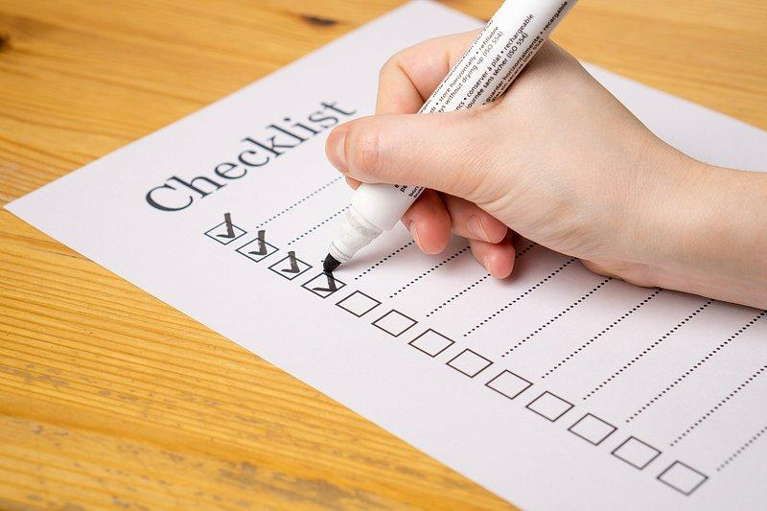
Image: Photograph of a hand holding a white marker and marking checkboxes on a printed checklist sheet placed on a wooden surface. The checklist has multiple empty checkboxes with some already checked, indicating progress or task completion.
>> SLIDE 10
Bridging the Gap: Training First Responders
When chaos hits, communication gaps can be fatal. We are actively bridging the divide from both sides. We give disabled individuals the targeted tools and training to articulate their exact, highly specific needs to personnel under extreme stress. Simultaneously, we are putting our advocates face-to-face with first responders, training them how to listen, slow down, and properly respond to the cross-disability community during an active crisis.
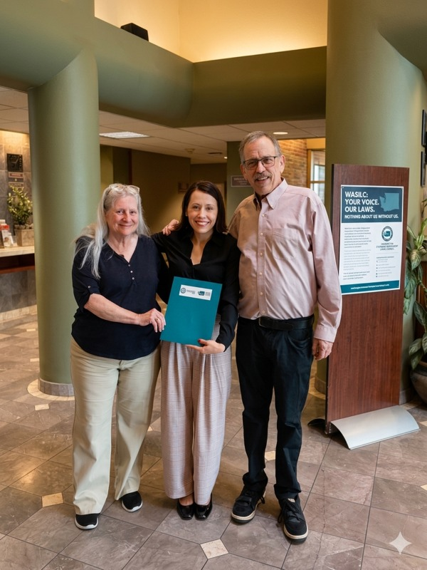

Image: Photograph of three people standing indoors in a lobby area, smiling and posing for the camera. One person in the center holds a blue folder, while a signboard nearby displays text about "WASILC" and encourages voicing opinions on laws.
>> SLIDE 11
Building the Network & Designing for Budget Droughts
Budgets fluctuate, political climates shift, and funding dries up—but emergencies never take a day off. To survive fiscal droughts, we are weaving an unbreakable, lateral, human-to-human web across Washington's diverse urban and rural landscapes. By directly connecting local advocates and peers, we create a self-sustaining network that shares mutual aid, trades emergency resources, and steps in to ensure an isolated personal crisis doesn't turn fatal when the system fails.
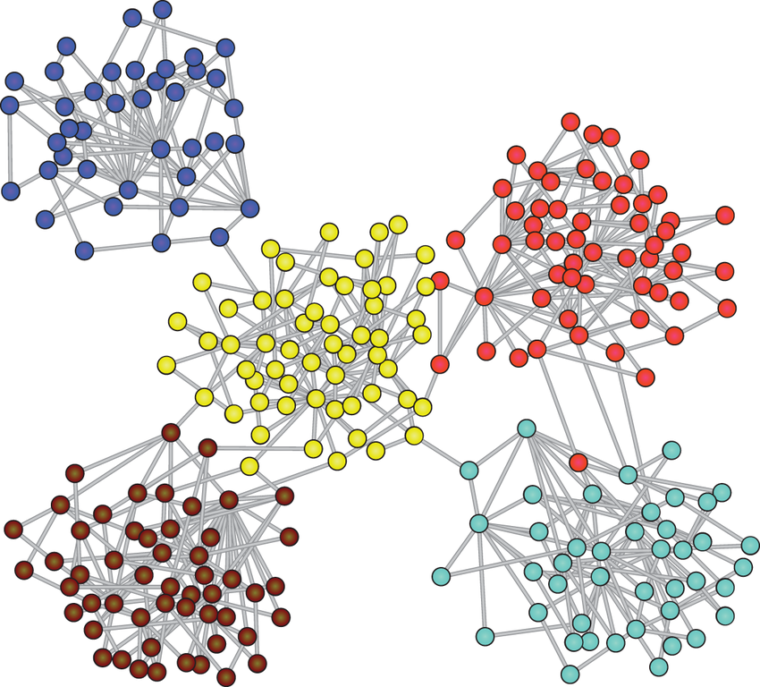
Image: A resilient network node graphic displaying interconnected, glowing geometric points across a landscape, representing a lateral human-to-human communication web.
>> SLIDE 12
The Top Floor – Executive & Legislative Systems Change
True, permanent resilience cannot survive on grassroots passion alone—it demands top-floor statutory power. We take our localized county data and the undeniable, raw lived experiences of our community directly into the halls of power to reshape state policy. We use real-world stories as political leverage to force systemic changes in executive directives and legislative budget mandates.
Key Advocacy Deliverables
- The Governor’s Office: Securing a permanent, unshakeable seat on the Governor's Emergency Management Advisory Council (EMAC) to structurally hardwire cross-disability protections directly into state-level disaster response plans.
- State Legislators: Educating and confronting lawmakers on why emergency management is a fundamental, non-negotiable civil rights and independent living issue, keeping the high stakes front and center throughout the legislative session.
- Supporting and Funding CILs: Weaponizing our local data to demand explicit legislative line-item funding for Centers for Independent Living (CILs) to scale up regional emergency programs. CILs are our frontlines, and they cannot protect the community if the state leaves them underfunded.
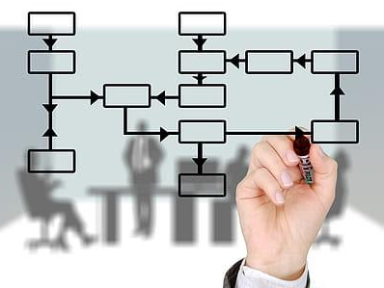
Image: Flowchart diagram overlaid on a blurred office background showing a hand drawing interconnected rectangular nodes with arrows indicating process flow. The diagram uses black outlines and arrows to represent sequential and branching steps.
>> SLIDE 13
The Blueprint in Action (Statewide Advocacy & Scale)
This is what the blueprint looks like in motion: a fierce, continuous statewide machine. True resilience is not passive waiting; it is an active architecture built from the ground up, honoring the distinct individuality of every single person, and backed by unyielding state-level political power. To our national peers at NCIL: Take this blueprint back to your states. Weaponize your data, solidify your peer networks, demand your line-item funding, and force your way to the executive table.


Image: A unified, circular ecosystem flow graphic showing how localized data, regional networks, CIL infrastructure, and state leadership feedback loops create a cohesive advocacy machine.
>> SLIDE 14
Q&A / Discussion
Presenter Contact Information
Courtney Williams, Executive Director, WASILC
Jim House, Disability/AFN Integration Manager
Washington Statewide Independent Living Council (WASILC)
Let’s design a resilient future together. Thank you.

Image: WASILC logo features a silhouette of Washington state with the acronym "WASILC" in bold white and yellow letters.
Image: National Council on Independent Living logo features a multi-colored fingerprint.

ARCHITECTS OF RESILIENCE: COMPREHENSIVE RESOURCE INDEX
Statutory Plans, Inclusive Networks, and Washington State Disability Data
Part 1: Core State Plans & Legislative Framework
- Washington State Plan for Independent Living (SPIL): The 2025–2027 SPIL establishes Inclusive Emergency Planning as a top three systemic goal, ensuring access and functional needs are central to state emergency response.
  - Link: https://www.wasilc.org/post/spil-is-open-for-public-comment
- The Rehabilitation Act, Section 704(a): Federal authority requiring comprehensive review, implementation, and public tracking of independent living services on a three-year cycle.
  - Link: https://acl.gov/programs/aging-and-disability-networks/statewide-independent-living-councils
- Administration for Community Living (ACL) Program Regulations: Federal oversight regulations ensuring statutory requirements align with cross-disability equity.
  - Link: https://acl.gov/programs/aging-and-disability-networks/statewide-independent-living-councils
Part 2: Emergency Management & Inclusive Advocacy Networks
- Coalition on Inclusive Emergency Planning (CIEP): A statewide cross-disability coalition hosting program updates, access and functional needs (AFN) assets, and toolkits.
  - Link: https://www.wasilc.org/what-we-do
- Center for Independence (CFI) Emergency Preparedness: Training resources and individual planning frameworks mapped directly to the Independent Living Philosophy.
  - Link: https://www.cfi-wa.org/emergency-preparedness
- Federal Emergency Management Agency (FEMA) & Ready.gov: National emergency readiness standards and downloadable multi-modal toolkits curated for individuals with disabilities.
  - Link: https://www.cfi-wa.org/emergency-preparedness
Part 3: Emergency Planning Compliance & Contact Infrastructure
- EPA State Emergency Response Commissions (SERC): Statutory contact directories for cross-agency alignment on hazardous materials and unified emergency planning boundaries.
  - Link: https://www.epa.gov/epcra/state-emergency-response-commissions-contacts
Part 4: Washington State Demographics & Core Disability Data Hubs
- Cornell University Disability Statistics Nexus: Aggregates U.S. Census Bureau ACS metrics for Washington's 1.03 million individuals with disabilities, including poverty and labor participation rates.
  - Link: https://www.disabilitystatistics.org/
- DSHS Developmental Disabilities Administration (DDA) Reporting Platform: Tracks active state client caseload profiles and publishes legislative updates regarding state-funded long-term community supports.
  - Link: https://www.dshs.wa.gov/dda/publications/dda-reports
- DSHS Research and Data Analysis (RDA) Division: Hosts cross-agency analytical studies, regional trend reports, and deep-dive risk mapping for co-occurring profiles (IDD and mental health diagnoses).
  - Link: https://www.dshs.wa.gov/ffa/research-and-data-analysis
- Washington State Department of Health (DOH) Behavioral Health Data Hub: Compiles epidemiological dashboards tracking adult and youth behavioral trends, anxiety, and depression across counties.
  - Link: https://doh.wa.gov/data-and-statistical-reports/health-behaviors/behavioral-health

