National Council on Disability

2027 Policy Projects and Town Hall
Presented by:
Amged Soliman and Joy Welan
Senior Attorney Advisors
National Council on Disability (NCD)

July 23, 2026

What is the National Council on Disability?
NCD is an independent federal agency.
NCD’s mission is to be a trusted advisor, in collaboration with people with disabilities to:
- The President
- The Congress
- Federal entities
- State, tribal communities, and local governments; and
- Other entities and organizations

What does NCD do?
Some of the things that the law requires NCD to do are:
- Assess the extent to which policies, programs, practices, and procedures facilitate or impede the promotion of equal opportunity for all individuals with disabilities, and their economic self-sufficiency, independent living, inclusion, and integration into all aspects of society.
- Review and evaluate, on a continuing basis, new and emerging disability policy issues affecting people with disabilities at the federal, state, and local levels and in the private sector.

How does NCD do its work?
NCD fulfills its advisory roles regarding disability policies, programs, procedures, and practices by:
- Convening stakeholders to acquire timely and relevant input for recommendations and action steps
- Gathering and analyzing data and other information
- Engaging and influencing current debates and agendas with current research
- Identifying and formulating solutions to emerging and long-standing challenges; and providing tools to facilitate effective implementation.

NCD’s Projects for FY 2027
- Medicaid and Home and Community-Based Services Portability
- Artificial Intelligence (AI)
- Assisted Suicide

Medicaid Portability – Part 1
- Examining systemic barriers caused by the lack of interstate portability within Medicaid and Home and Community-Based Services (HCBS) programs
- Considering the burden of re-establishing disability eligibility when moving between states—even if the disability is lifelong and medically documented
- Looking at how state-by-state eligibility decisions, waiting lists, and re-certification requirements limit mobility, employment opportunities, and family stability for Americans with disabilities.

Medicaid Portability – Part 2
- Our goal is to highlight the economic and human effects of these policies, evaluate the roles of federal and state policies that contribute to fragmentation, and suggest policy solutions to enable individuals with disabilities to move, work, and live across state lines without losing access to essential supports.
- We want to identify the main systemic barriers preventing states from adopting interstate portability for HCBS programs and suggest ways federal policies can help remove them.

Thoughts or stories you want to share?

Things we should know?

Artificial Intelligence – Part 1
- AI and other technology have the potential to reduce accessibility barriers and improve the lives of people with disabilities. However, to do so, they must be developed and implemented with care to ensure accessibility and nondiscrimination.
- One goal is to warn policymakers about the susceptibility of AI to learn or develop biases and misconceptions about the abilities of people with disabilities, which could significantly undermine decision-making processes.
- This can have implications for employment, healthcare, and many other areas.

Artificial Intelligence – Part 2
- We want to advise policymakers about needed legislative or regulatory guardrails on the development of AI to prevent discrimination against people with disabilities.
- We also want to investigate whether AI can help address the shortage of direct care workers by taking over some routine tasks, which might free up some workers to focus on hands-on personal care.

Thoughts or stories you want to share?

Things we should know?

Assisted Suicide – Part 1
- NCD has opposed assisted suicide laws since 1997, when NCD conducted an in-depth examination of the issue.
- Biased assumptions in healthcare often form the basis of life and death decisions.
- These laws can create a two-tiered system that results in death to people with disabilities, who are socially devalued and thought to have lower quality of life, while ignoring the social determinants of health and well-being (like a lack of HCBS) that can influence people with disabilities to experience situational hopelessness or despair.

Assisted Suicide – Part 2
- Since NCD’s most recent 2019 report on this issue, six states have legalized assisted suicide, while other states and Canada are expanding their laws.
- We plan to look at the consequences of expansion and any lessons that can be learned.
- We also plan to examine whether people with disabilities remain uniquely vulnerable in the legalized assisted suicide framework in the U.S., and if meaningful choice exists for people with disabilities.

Assisted Suicide – Part 3

Thoughts or stories you want to share?

Things we should know?

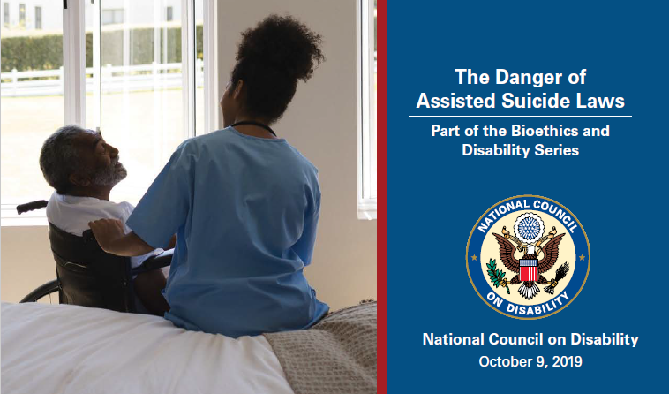

NCD’s Strategic Plan

Under Construction!

What should we include?

Open Public Comment Period
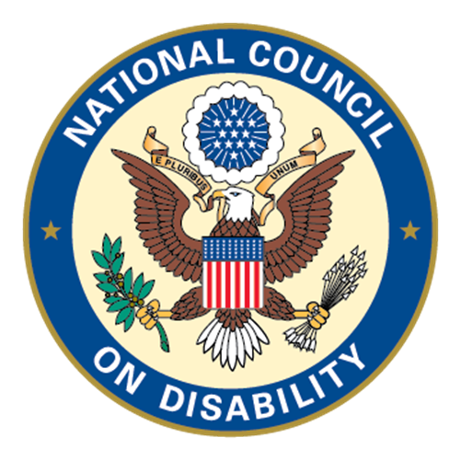

What do you want NCD to know?

Contact Information

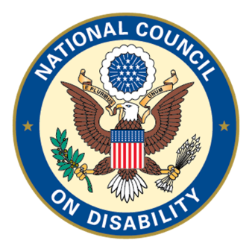
Amged Soliman: asoliman@ncd.gov
Joy Welan: jwelan@ncd.gov
https://www.ncd.gov/
Phone: 202-272-2004

